Lesson 14 Practice Problems
- Jada is finding the area of a sector with an angle $\frac{π}{4}$ radians and radius 8 units. She found the area of the whole circle, then found the fraction represented by the sector by dividing $\frac{π}{4}$ by 360. She multiplied this fraction by the total circle area.
  - Do you agree with Jada’s strategy? Explain your reasoning.
  - Find the area of the sector.
- (From Unit 7, Lesson 13.)
- Which of these pizza slices gives the best value (the most pizza per dollar spent)?
  - a slice with a radius of 12 inches, central angle of 30$​^{∘}$, and a cost of $3 per slice
  - a slice with a radius of 8 inches, central angle of 45$​^{∘}$, and a cost of $2 per slice
  - a slice with a radius of 6 inches, central angle of $\frac{π}{3}$ radians, and a cost of $2 per slice
  - a slice with a radius of 6 inches, central angle of $\frac{π}{4}$ radians, and a cost of $1 per slice
- (From Unit 7, Lesson 13.)
- The circle in the image has been divided into congruent sectors. What is the measure of the central angle of the shaded region in radians?
- 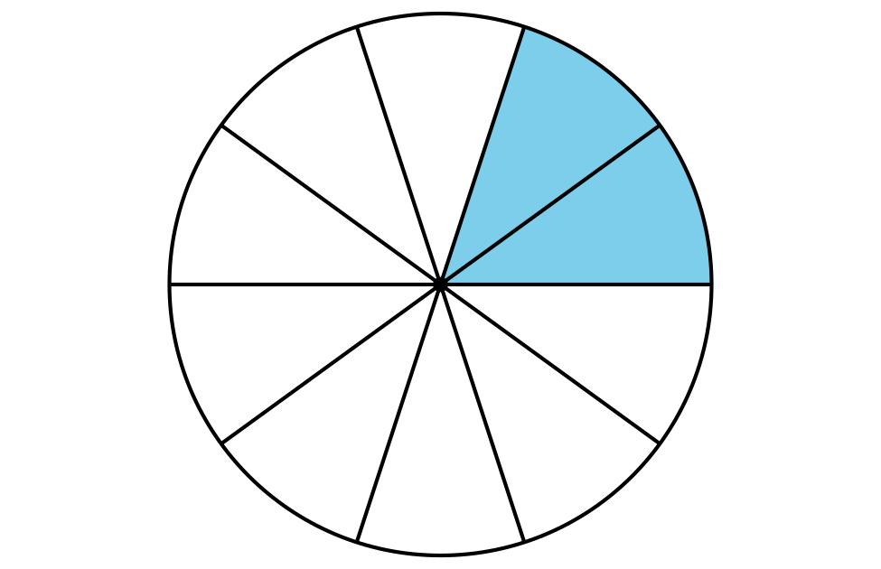
- (From Unit 7, Lesson 12.)
- In the circle, sketch a central angle that measures $\frac{5π}{3}$ radians.
- (From Unit 7, Lesson 12.)
- The image shows a circle with radius 5 units.
  - Draw a 180 degree central angle (a diameter) in the circle. What is the length of the arc defined by this angle?
  - Use the arc length and the radius to calculate the radian measure of 180 degrees.
  - Calculate the radian measure of a 360 degree angle. Explain or show your reasoning.
- 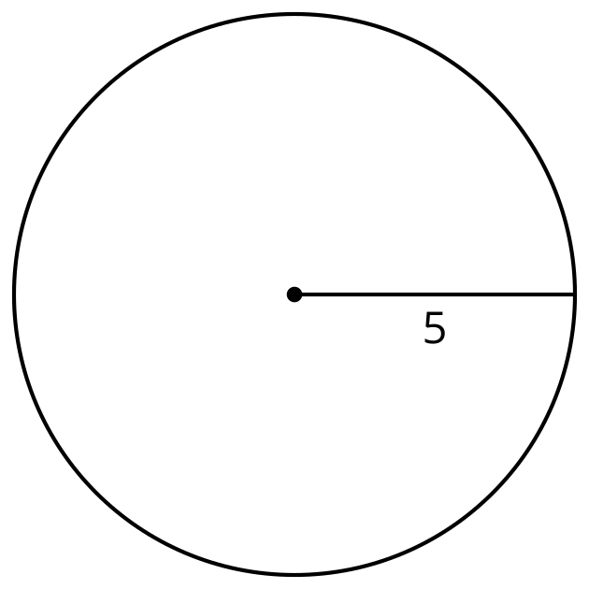
- (From Unit 7, Lesson 11.)
- Complete the table. Each row represents a circle with a defined sector.
- sector area | - radius | - central angle
- $5π$ cm² | - 5 cm
- $12π$ cm² |  | - 270 degrees
 | - 12 cm | - 15 degrees
- (From Unit 7, Lesson 9.)
- Several circles with central angles are described. Select all the circles for which the central angle defines arcs that have length $6π$ units.
  - radius 6 units, central angle 180 degrees
  - radius 18 units, central angle 60 degrees
  - radius 12 units, central angle 90 degrees
  - radius 3 units, central angle 120 degrees
  - radius 4 units, central angle 270 degrees
- (From Unit 7, Lesson 8.)
- Triangle $ABC$ is shown with its incenter at $D$. The inscribed circle’s radius measures 2 units. The length of $AB$ is 9 units. The length of $BC$ is 10 units. The length of $AC$ is 17 units.
- 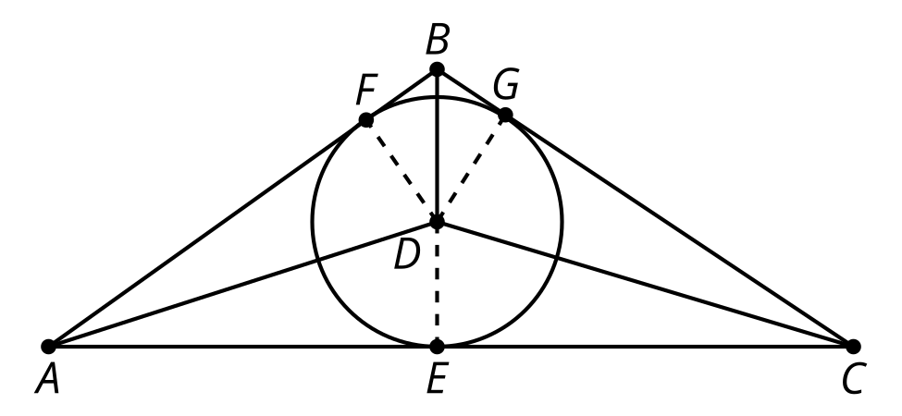
  - What is the area of triangle $ABD$?
  - What is the area of triangle $BCD$?
- (From Unit 7, Lesson 7.)
- Noah makes 3 statements about the incenter of a triangle.
  - To find the incenter of a triangle, you must construct all 3 angle bisectors.
  - The incenter is always equidistant from the vertices of the triangle.
  - The incenter is always equidistant from each side of the triangle.
- For each statement, decide whether you agree with Noah. Explain your reasoning.
- (From Unit 7, Lesson 6.)
- Elena is writing notes about central angles in circles. Help her finish her notes by answering the questions.
  - Where is the vertex of a central angle located in relation to the circle?
  - What line segments related to circles are contained in the rays that form a central angle?
  - How does the measure of a central angle relate to the measure of the arc it is associated with?
- (From Unit 7, Lesson 1.)
© CC BY 2019 by Illustrative Mathematics®

