Lesson 2: How Does it Change?
- Let’s describe some patterns of change.

2.1: Squares in a Figure
How does each expression represent the number of small squares in the figure?
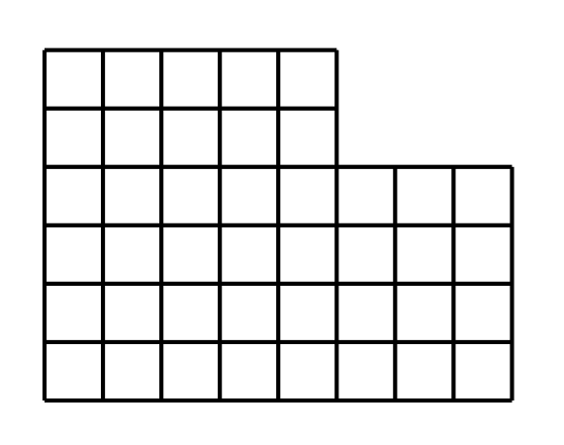
- Expression A: $6⋅8−2⋅3$
- Expression B: $4⋅8+2⋅5$
- Expression C: $8+8+8+8+5+5$
- Expression D: $5⋅6+3⋅4$

2.2: Patterns of Dots

Pattern 1
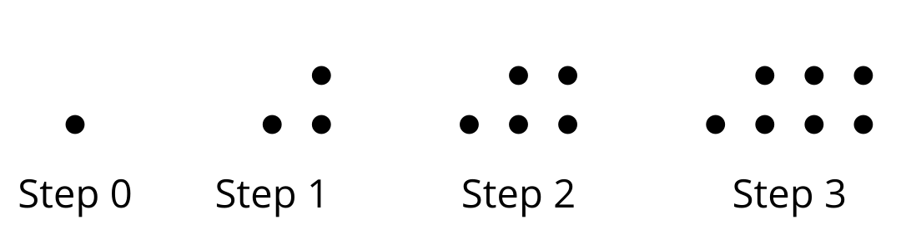

Pattern 2
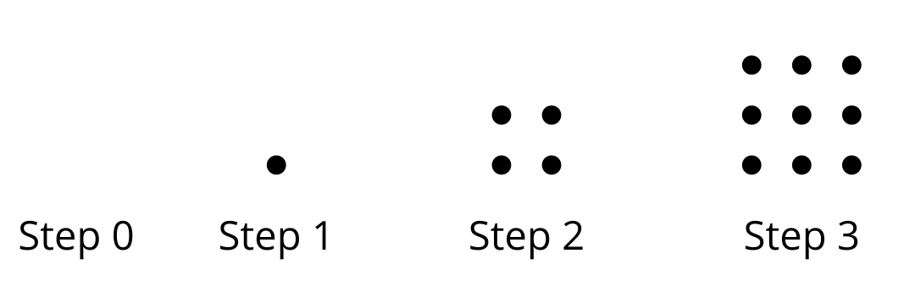
- Study the 2 patterns of dots.
  - How are the number of dots in each pattern changing?
  - How would you find the number of dots in the 5th step in each pattern?
- Complete the table with the number of dots in each pattern.
- step | - number of dots in Pattern 1 | - number of dots in Pattern 2
- 0
- 1
- 2
- 3
- 4
- 5
- 10
- $n$
- Plot the number of dots at each step number.

- Pattern 1
- 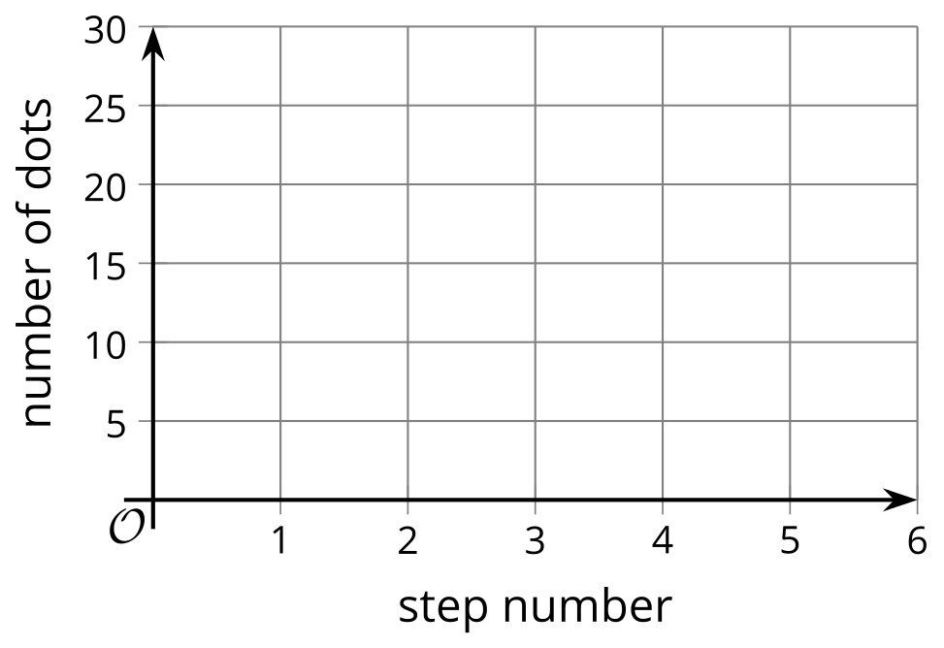

- Pattern 2
- Explain why the graphs of the 2 patterns look the way they do.

2.3: Expressing a Growth Pattern
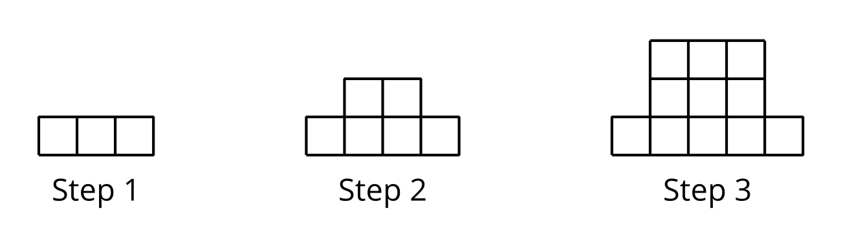
Here is a pattern of squares.
- Is the number of small squares growing linearly? Explain how you know.
- Complete the table.
- step | - number of small squares
- 1
- 2
- 3
- 4
- 5
- 10
- 12
- $n$
- Is the number of small squares growing exponentially? Explain how you know.

Are you ready for more?
Han wrote $n\left(n+2\right)−2\left(n−1\right)$ for the number of small squares in the design at Step $n$.
- Explain why Han is correct.
- Label the picture in a way that shows how Han saw the pattern when writing his expression.

Lesson 2 Summary
In this lesson, we saw some quantities that change in a particular way, but the change is neither linear nor exponential. Here is a pattern of shapes, followed by a table showing the relationship between the step number and the number of small squares.
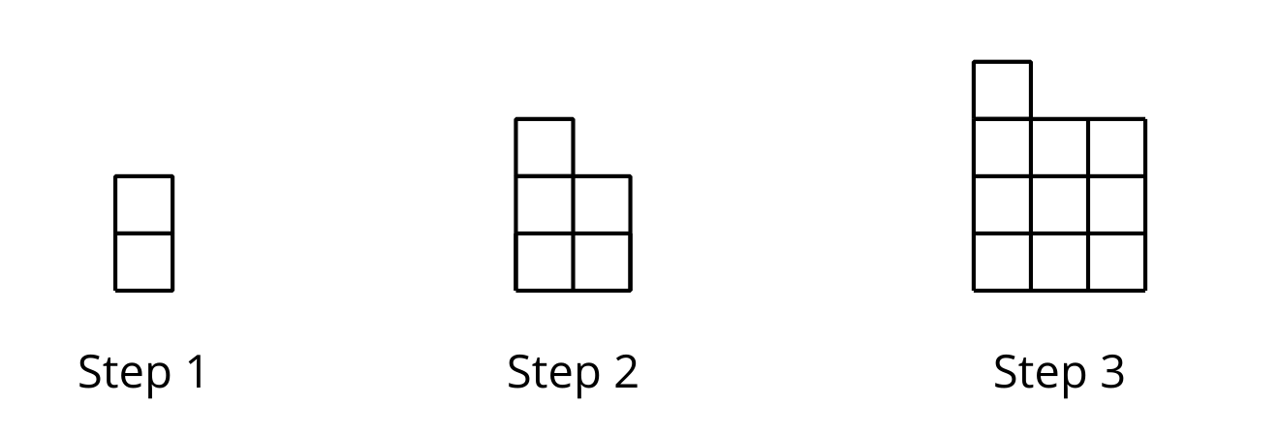
step | total number of small squares
1 | 2
2 | 5
3 | 10
$n$ | $n^{2}+1$
The number of small squares increases by 3, and then by 5, so we know that the growth is not linear. It is also not exponential because it is not changing by the same factor each time. From Step 1 to Step 2, the number of small squares grows by a factor of $\frac{5}{2}$, while from Step 2 to Step 3, it grows by a factor of 2.
From the diagram, we can see that in Step 2, there is a 2-by-2 square plus 1 small square added on top. Likewise, in Step 3, there is a 3-by-3 square with 1 small square added. We can reason that the $n$th step is an $n$-by-$n$ arrangement of small squares with an additional small square on top, giving the expression $n^{2}+1$ for the number of small squares.
The relationship between the step number and the number of small squares is a quadratic relationship, because it is given by the expression $n^{2}+1$, which is an example of a quadratic expression. We will investigate quadratic expressions in depth in future lessons.
© CC BY 2019 by Illustrative Mathematics®

