Lesson 9 Practice Problems
- Here is triangle $ABC$.
- 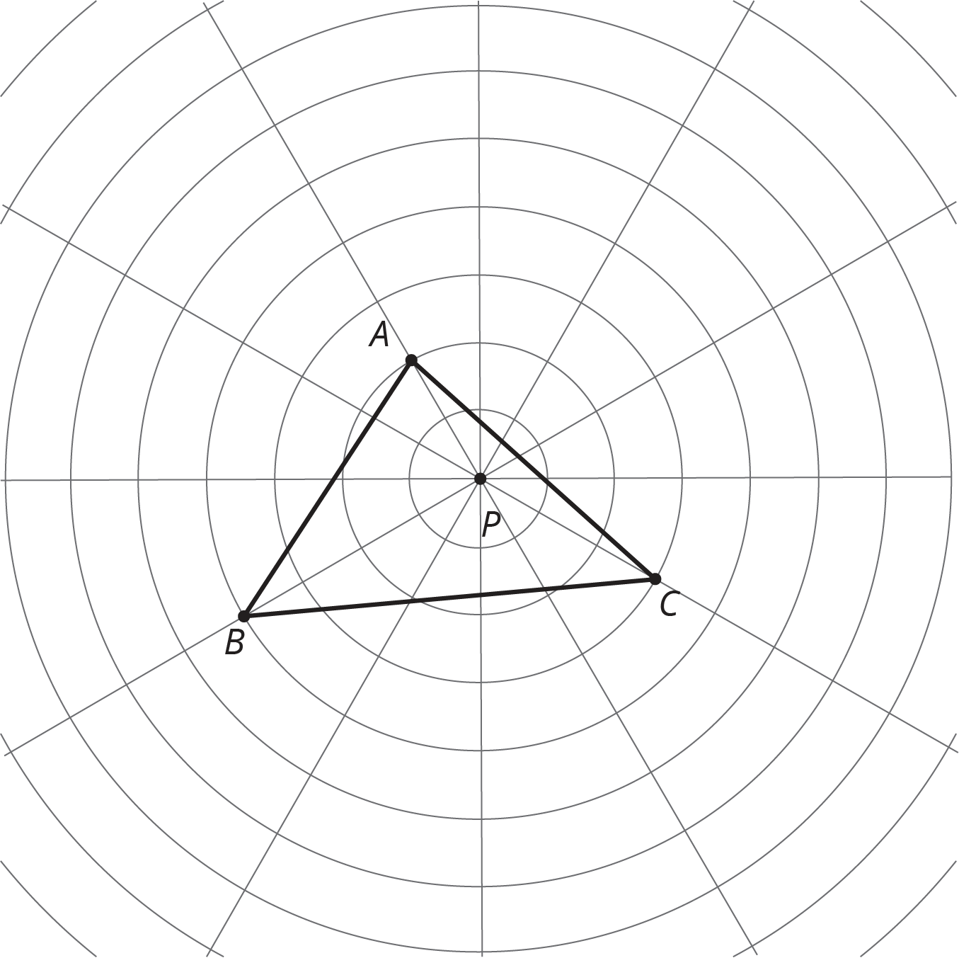
  - Dilate each vertex of triangle $ABC$ using $P$ as the center of dilation and a scale factor of 2. Draw the triangle connecting the three new points.
  - Dilate each vertex of triangle $ABC$ using $P$ as the center of dilation and a scale factor of $\frac{1}{2}$. Draw the triangle connecting the three new points.
  - Measure the longest side of each of the three triangles. What do you notice?
  - Measure the angles of each triangle. What do you notice?
- Segment $AB$ measures 3 cm. Point $O$ is the center of dilation. How long is the image of $AB$ after a dilation with . . .
  - Scale factor 5?
  - Scale factor 3.7?
  - Scale factor $\frac{1}{5}$?
  - Scale factor $s$?
- Here are points $A$ and $B$. Plot the points for each dilation described.
  - $C$ is the image of $B$ using $A$ as the center of dilation and a scale factor of 2.
  - $D$ is the image of $A$ using $B$ as the center of dilation and a scale factor of 2.
  - $E$ is the image of $B$ using $A$ as the center of dilation and a scale factor of $\frac{1}{2}$.
  - $F$ is the image of $A$ using $B$ as the center of dilation and a scale factor of $\frac{1}{2}$.
- Make a perspective drawing. Include in your work the center of dilation, the shape you dilate, and the scale factor you use.
© CC BY Open Up Resources. Adaptations CC BY IM.

