Lesson 5: Working with Ratios in Right Triangles
- Let’s solve problems about right triangles.

5.1: Launch Pad
When a rocket is launched, it climbs 50 feet for every 13 feet it travels horizontally. Draw a diagram to represent the situation. Then estimate the rocket’s launch angle.

5.2: Pythagorean Triples
- Sketch the triangle with side lengths 7, 24, and 25 units. Label the smallest angle $A$.
- Find the 3 ratios of side lengths for angle $A$.
- Estimate the acute angles in this triangle.

Are you ready for more?
- Find another Pythagorean triple.
- Estimate the acute angles in that triangle. Explain how you know.

5.3: Solve All the Triangles
- What is the length of segment $AB$?
- 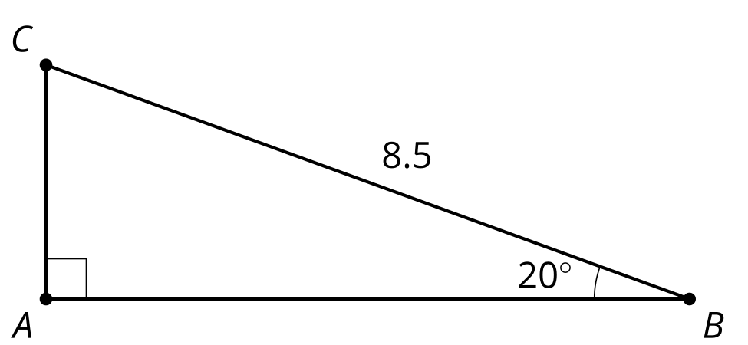
- In a right triangle with one angle measuring 40 degrees, the leg opposite the 40 degree angle is 5 cm. What is the length of the hypotenuse?
- What is the length of segment $DE$?
- 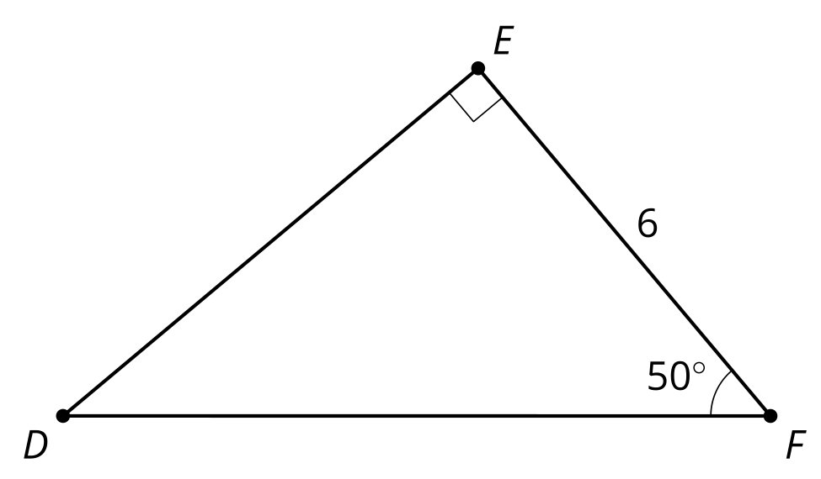
- In a right triangle with one angle measuring 70 degrees, the leg opposite the 70 degree angle is 12 cm. What is the length of the leg adjacent to the 70 degree angle?

Lesson 5 Summary
All right triangles that contain the same acute angle are similar. This means that the ratios of corresponding side lengths are equal for all right triangles with the same acute angles. Using the ratios calculated in the previous lesson and properties of similar triangles, we can calculate and estimate unknown side lengths and angles in right triangles.
If we measure the legs of any right triangle with an angle of 25 degrees, the ratio of the leg opposite the 25 degree angle to the leg adjacent to the 25 degree angle will always be 0.466. Therefore, we can find length $b$. Since $\frac{5}{b}=0.466$, we know $b$ is 10.7 units.
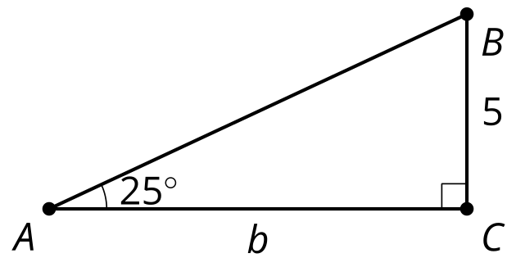
Similarly, we can estimate the measure of the missing angles in triangle $DEF$.
angle | adjacent leg $÷$ hypotenuse | opposite leg $÷$ hypotenuse | opposite leg $÷$ adjacent leg
${50}^{∘}$ | 0.643 | 0.766 | 1.192
${60}^{∘}$ | 0.500 | 0.866 | 1.732
The ratio of the leg opposite angle $D$ to the hypotenuse is 0.794. This value is between the value of opposite leg divided by hypotenuse for 50 degrees (0.766) and 60 degrees (0.866). So the measure of angle $D$ must be between 50 and 60 degrees. Similarly, the leg opposite angle $D$ divided by the leg adjacent to angle $D$ gives a ratio of 1.283, which is between the same ratio for 50 degrees (1.192) and 60 degrees (1.732). The exact value turns out to be 52 degrees.
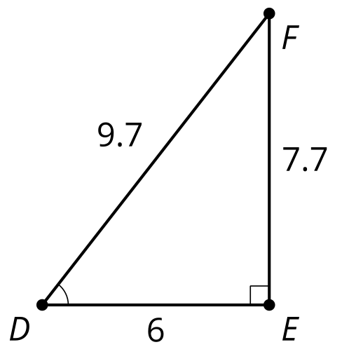
© CC BY 2019 by Illustrative Mathematics®

