Unit 4 Lesson 16: Finding and Interpreting Inverse Functions

1 Shopping for Cookbooks (Warm up)

Student Task Statement
Lin is comparing the cost of buying cookbooks at different online stores.
- Store A sells them at $9 each and offers free shipping.
- Store B sells them at $9 each and charges $5 for shipping.
- Store C sells them at $p$ dollars and charges $5 for shipping.
- Store D sells them at $p$ dollars and charges $f$ dollars for shipping.
- Write an equation to represent the total cost, $T$, in dollars as a function of $n$ cookbooks bought at each store.
- Write an equation to find the number of books, $n$, that Lin could buy if she spent $T$ dollars at each store.

2 From Celsius to Fahrenheit

Student Task Statement
If we know the temperature in degrees Celsius, $C$, we can find the temperature in degrees Fahrenheit, $F$, using the equation:
$F=\frac{9}{5}C+32$
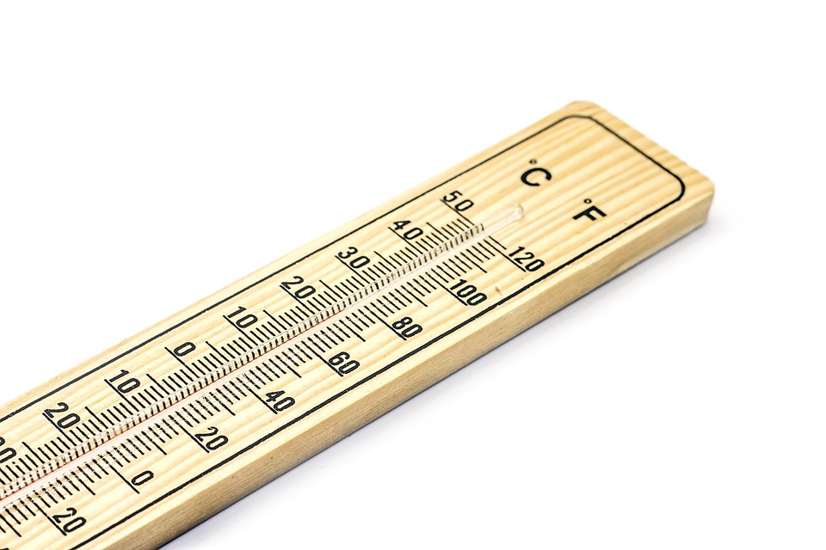
- Complete the table with temperatures in degrees Fahrenheit or degrees Celsius.
- $C$ | - 0 | - 100 | - 25
- $F$ |  |  |  | - 104 | - 50 | - 62.6
- The equation $F=\frac{9}{5}C+32$ represents a function. Write an equation to represent the inverse function. Be prepared to explain your reasoning.
- The equation $R=​\frac{9}{5}​\left(C+273.15\right)$ defines the temperature in degrees Rankine as a function of the temperature in degrees Celsius.
- Show that the equation $C=\left(R−491.67\right)⋅​\frac{5}{9}$ defines the inverse of that function.

Activity Synthesis
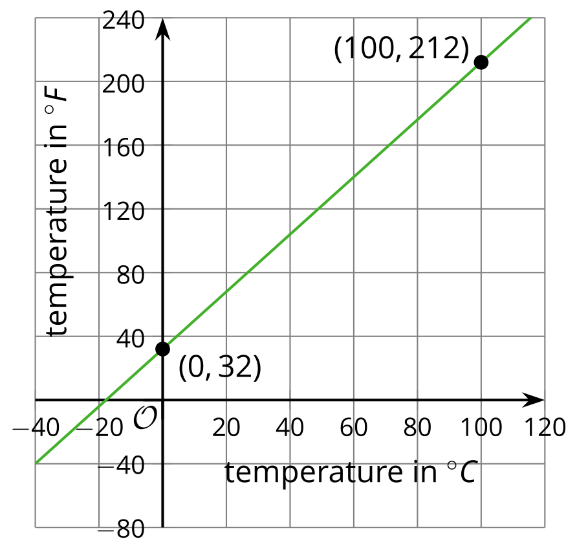
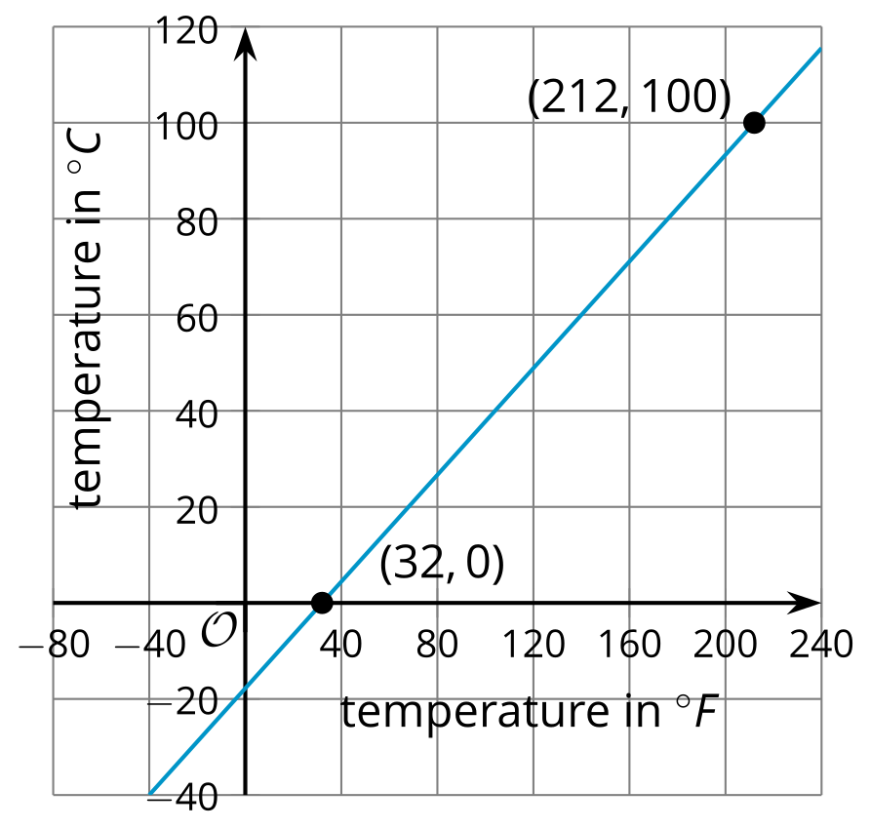

3 Info Gap: Custom Mugs

Student Task Statement
Your teacher will give you either a problem card or a data card. Do not show or read your card to your partner.
If your teacher gives you the problem card:
- Silently read your card and think about what information you need to answer the question.
- Ask your partner for the specific information that you need.
- Explain to your partner how you are using the information to solve the problem.
- Solve the problem and explain your reasoning to your partner.
If your teacher gives you the data card:
- Silently read the information on your card.
- Ask your partner “What specific information do you need?” and wait for your partner to ask for information. Only give information that is on your card. (Do not figure out anything for your partner!)
- Before telling your partner the information, ask “Why do you need that information?”
- After your partner solves the problem, ask them to explain their reasoning and listen to their explanation.
Pause here so your teacher can review your work. Ask your teacher for a new set of cards and repeat the activity, trading roles with your partner.

4 Tables and Seats (Optional)

Student Task Statement
At a party, hexagonal tables are placed side by side along one side, as shown here.
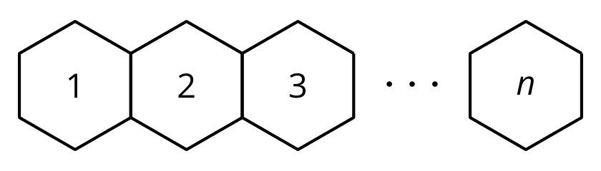
- Explain why the equation $S=4n+2$ represents the number of seats, $S$, as a function of the number of tables, $n$.
- What domain and range make sense for this function?
- Write an equation to represent the inverse of the given function. Explain what this inverse function tells us.
- How many tables are needed if the following number of people are attending the party? Be prepared to explain your reasoning.
  - 94 people
  - 95 people
- What domain makes sense for the inverse function? Is it the same set of values as the range of the original function? Explain your reasoning.
© CC BY 2019 by Illustrative Mathematics®

