Lesson 1: Exploremos estimaciones con fracciones

Standards Alignments
Addressing | 3.NF.A.1, 3.NF.A.2

Teacher-facing Learning Goals
- Estimate fractions represented in diagrams and on number lines.

Student-facing Learning Goals
- Exploremos estimaciones con fracciones.

Lesson Purpose
The purpose of this lesson is for students to practice reasoning about fraction representations through estimation.
In previous lessons, students learned how to represent fractions with area diagrams, fraction strips, and number lines. In this lesson, students revisit each of these representations in an estimation context. Students have an opportunity to think about how to partition each representation to decide what fraction is shown (MP7). Additionally, if time allows and it seems of benefit to student understanding, there is an option after each activity to find the exact value of the fraction in the task statement.
If students need additional support with the concepts in this lesson, refer back to Unit 5, Section A in the curriculum materials.

Access for:

Students with Disabilities
- Engagement (Activity 2)

English Learners
- MLR2 (Activity 1)

Instructional Routines
Which One Doesn’t Belong? (Warm-up)

Lesson Timeline
Warm-up | 10 min
Activity 1 | 15 min
Activity 2 | 10 min
Activity 3 | 10 min
Lesson Synthesis | 10 min
Cool-down | 5 min

Teacher Reflection Question
Which fraction representations did students seem most comfortable with today? Which representations do you want to be sure to work more with before the year is over?

Cool-down
(to be completed at the end of the lesson) 5min
Representaciones de fracciones

Standards Alignments
Addressing | 3.NF.A.1, 3.NF.A.2

Student-facing Task Statement
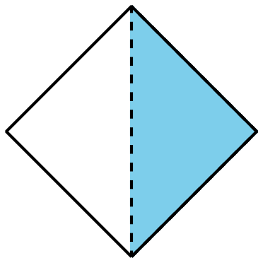
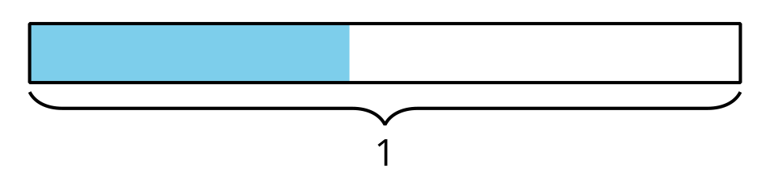
¿La parte sombreada de la figura, el punto que está en la recta numérica y la parte sombreada del diagrama pueden representar la misma fracción?
Explica tu razonamiento.

Student Responses
No. Sample response: The shaded part of the shape is $\frac{1}{2}$. The point on the number line is greater than $\frac{1}{2}$ but is less than 1. The shaded part of the diagram is less than $\frac{1}{2}$.

