Lesson 13: Encontremos el área de algunas figuras

Standards Alignments
Addressing | 3.MD.C.7.d, 3.NBT.A.2

Teacher-facing Learning Goals
- Calculate the area of ungridded figures made of rectangles using multiplication and addition.

Student-facing Learning Goals
- Encontremos el área de algunas figuras.

Lesson Purpose
The purpose of this lesson is for students to calculate the area of ungridded figures made of rectangles using multiplication and addition.
Students continue to find the area of figures composed of rectangles by decomposing them into non-overlapping rectangles. In this lesson, the square tiling is slowly removed to focus students on multiplying side lengths to find area.

Access for:

Students with Disabilities
- Engagement (Activity 1)

English Learners
- MLR7 (Activity 2)

Instructional Routines
Number Talk (Warm-up)

Lesson Timeline
Warm-up | 10 min
Activity 1 | 20 min
Activity 2 | 15 min
Lesson Synthesis | 10 min
Cool-down | 5 min

Teacher Reflection Question
This lesson is designed to help students shift toward multiplying to find areas, rather than by counting unit squares. Did you see this shift in students' strategies? What questions could you ask students about their strategies to help them make that shift if they are still counting frequently?

Cool-down
(to be completed at the end of the lesson) 5min
Encuentra el área

Standards Alignments
Addressing | 3.MD.C.7.d

Student-facing Task Statement
Encuentra el área de esta figura. Explica o muestra tu razonamiento.
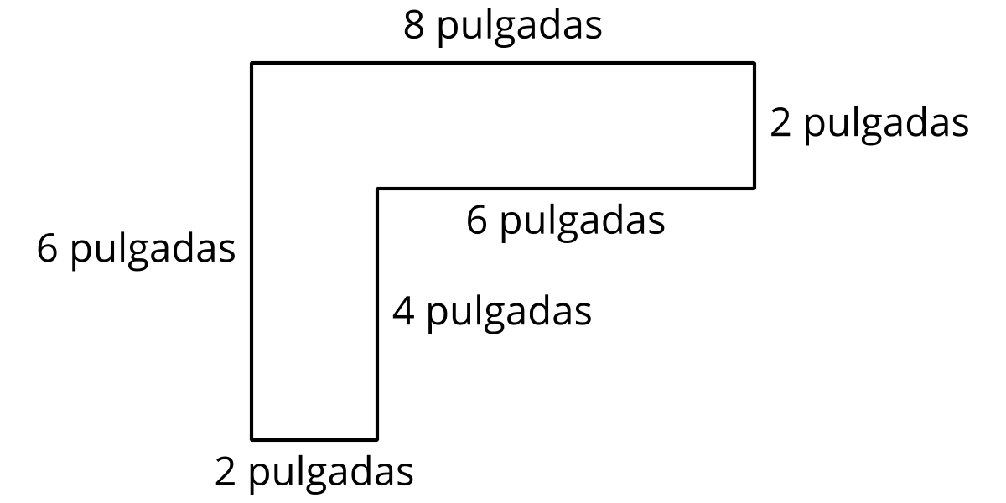

Student Responses
24 square inches. Sample response: I saw two rectangles making an L shape. I multiplied $2×8$ to find the area of the top rectangle and $2×4$ to find the area of the bottom rectangle. I added 16 and 8 to find the area of the whole figure.

