Unit 3 Lesson 2: Meanings of Division

1 A Division Expression (Warm up)

Student Task Statement
Here is an expression: $20÷4$.
What are some ways to think about this expression? Describe at least two meanings you think it could have.

2 Bags of Almonds

Student Task Statement
A baker has 12 pounds of almonds. She puts them in bags, so that each bag has the same weight.
Clare and Tyler drew diagrams and wrote equations to show how they were thinking about $12÷6$.
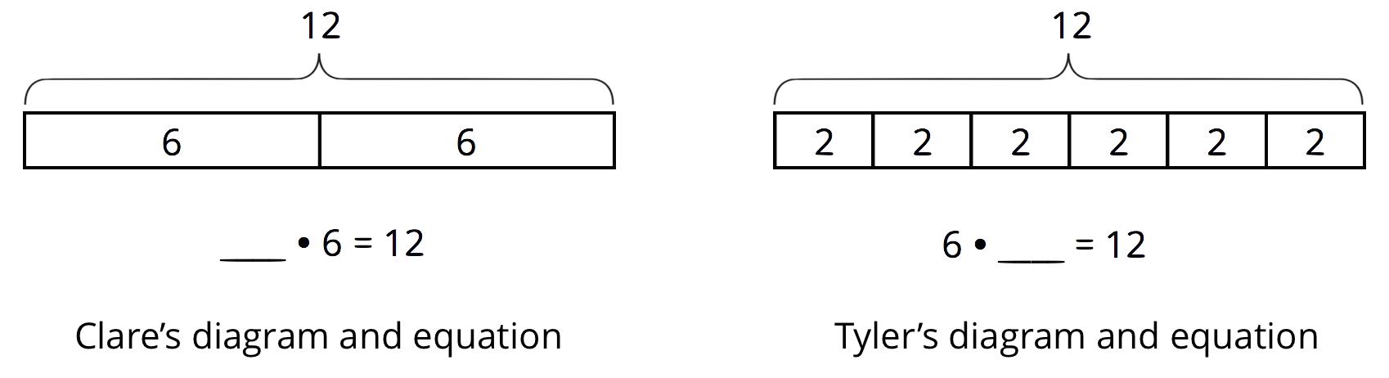
- How do you think Clare and Tyler thought about $12÷6$? Explain what each diagram and the parts of each equation could mean about the situation with the bags of almonds. Make sure to include the meaning of the missing number.
- Pause here for a class discussion.
- Explain what each division expression could mean about the situation with the bags of almonds. Then draw a diagram and write a multiplication equation to show how you are thinking about the expression.
  - $12÷4$
  - $12÷2$
  - $12÷\frac{1}{2}$

3 Homemade Jams

Images for Launch
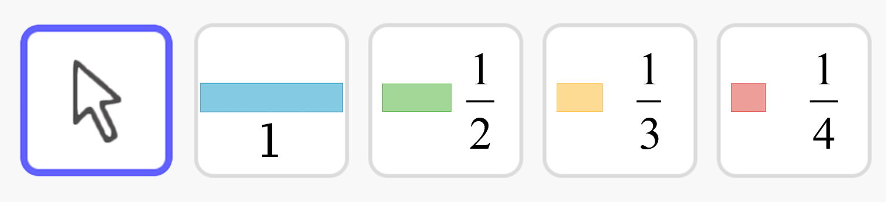

Student Task Statement
Draw a diagram, and write a multiplication equation to represent each situation. Then answer the question.
- Mai had 4 jars. In each jar, she put $2\frac{1}{4}$ cups of homemade blueberry jam. Altogether, how many cups of jam are in the jars?
- Priya filled 5 jars, using a total of $7\frac{1}{2}$ cups of strawberry jam. How many cups of jam are in each jar?
- Han had some jars. He put $\frac{3}{4}$ cup of grape jam in each jar, using a total of $6\frac{3}{4}$ cups. How many jars did he fill?

Activity Synthesis
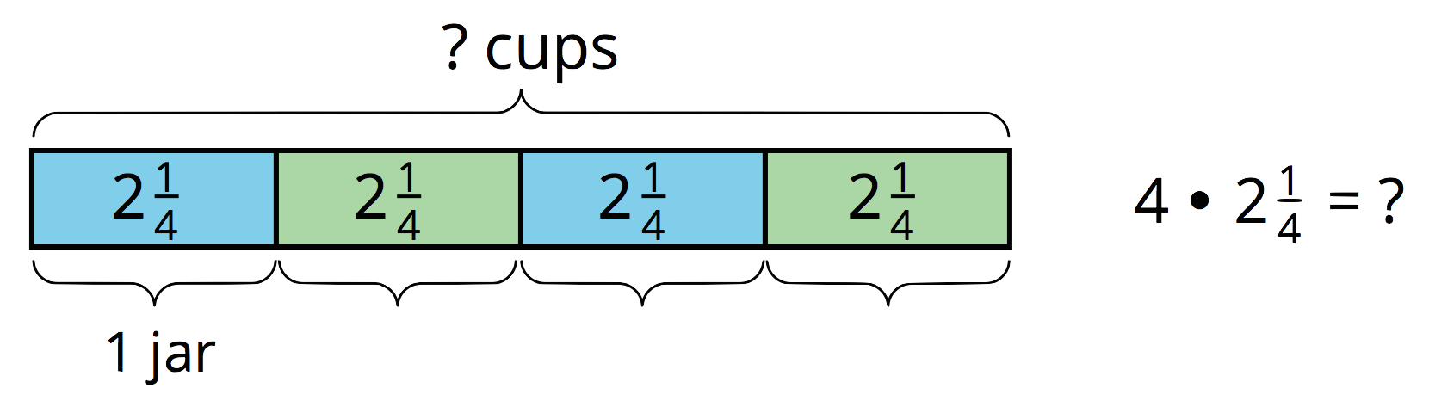
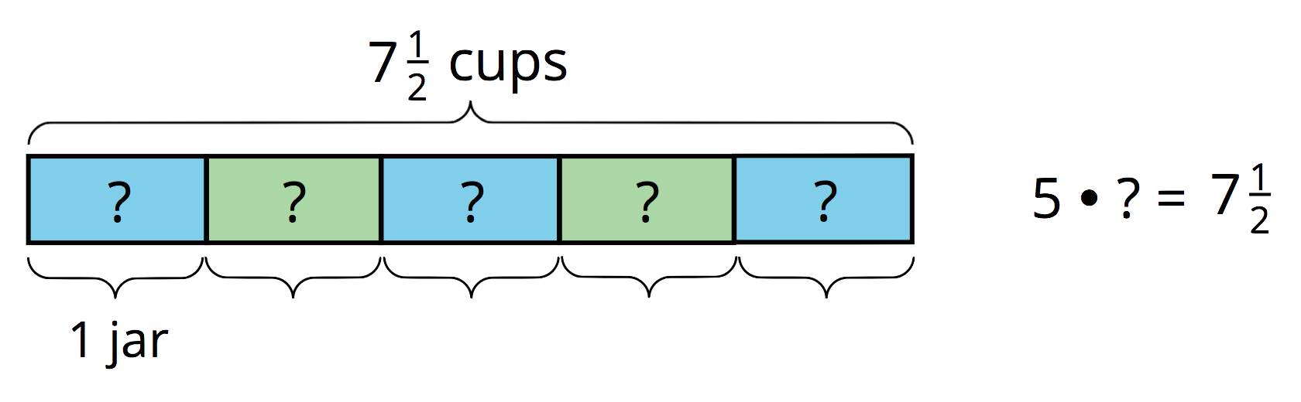
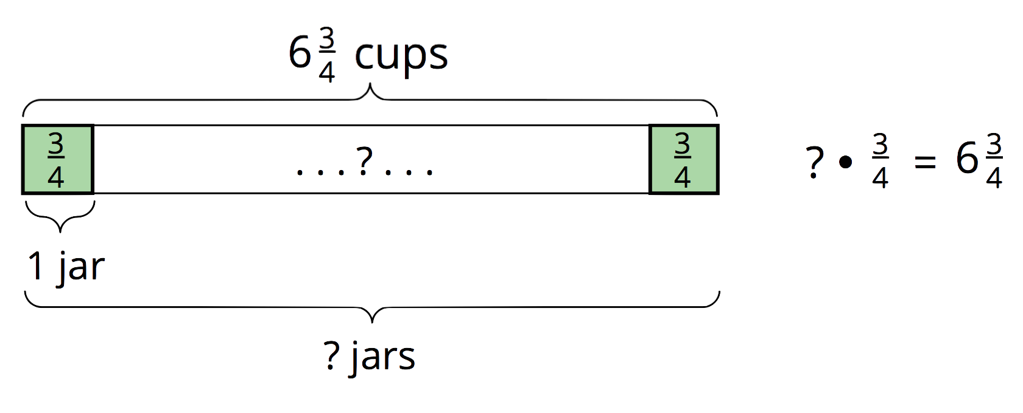
© CC BY Open Up Resources. Adaptations CC BY IM.

