Lesson 7: Why Is That Okay?
- Let’s rewrite equations without changing their value.

7.1: Estimation: Equal Weights
How many pencils are the same weight as a standard stapler?
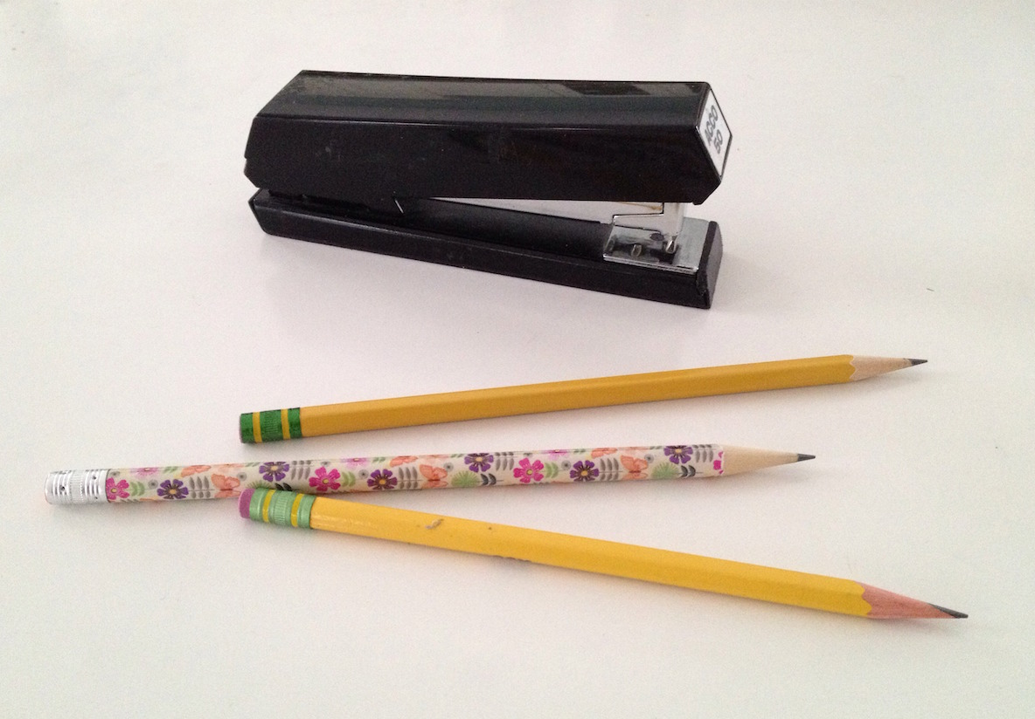
- Record an estimate that is:
- too low | - about right | - too high
- Explain your reasoning

7.2: What’s the Same? What’s Different?
For each pair of equations, decide whether the given value of $x$ is a solution to one or both equations:
- Is $x=2$ a solution to:
  - $x\left(2+3\right)=10$
  - $2x+3x=10$
- Is $x=3$ a solution to:
  - $x−4=1$
  - $4−x=1$
- Is $x=\text{-}2$ a solution to:
  - $7x=\text{-}14$
  - $x⋅14=\text{-}28$
- Is $x=\text{-}1$ a solution to:
  - $x+3=2$
  - $3+x=2$
- Is $x=\text{-5}$ a solution to:
  - $3−x=8$
  - $5−x=10$
- Is $x=\left(8+1\right)+3$ a solution to:
  - $\frac{12}{2}=\frac{1}{2}\left(x\right)$
  - $18=2x$
- Is $x=2$ a solution to:
  - $\frac{12}{x}=6$
  - $6x=12$
- Is $x=\frac{10}{3}$ a solution to:
  - $\text{-}1+3x=9$
  - $9=3x−1$
- Is $x=\frac{1}{2}$ a solution to:
  - $5\left(x+1\right)=\frac{15}{2}$
  - $5x+1=\frac{15}{2}$

7.3: Generating Equivalent Equations
- Your teacher will display an equation. Take turns with your partner to generate an equivalent equation—an equation with the same solution. Generate as many different equations with the same solution as you can. Keep track of each one you find.
- For each change that you make, explain to your partner how you know your new equation is equivalent. Ask your partner if they agree with your thinking.
- For each change that your partner makes, listen carefully to their explanation about why their new equation is equivalent. If you disagree, discuss your thinking and work to reach an agreement.
© CC BY 2019 by Illustrative Mathematics®

