Lesson 2: Comparemos la longitud de objetos de manera indirecta

Standards Alignments
Addressing | 1.MD.A.1, 1.NBT.C.4

Teacher-facing Learning Goals
- Compare the length of two objects indirectly by using a third object.

Student-facing Learning Goals
- Comparemos 2 objetos usando un tercer objeto.

Lesson Purpose
The purpose of this lesson is for students to compare the length of two objects indirectly by comparing each with the length of a third object.
In the previous lesson, students ordered three objects by length by lining them up at their endpoints. Students used complete sentences to describe the relative length of objects.
The purpose of this lesson is for students to compare the length of two objects indirectly by comparing them with the length of a third object. Indirect comparison allows students to compare the length of objects that are difficult to compare by lining them up. The ideas in this lesson lead to the understanding that iterated length units can be used to measure and compare the length of objects. Students may intuitively understand the concept of indirect comparison and this lesson provides an opportunity for them to develop language to communicate that understanding (MP6).

Access for:

Students with Disabilities
- Action and Expression (Activity 2)

English Learners
- MLR8 (Activity 1)

Instructional Routines
Number Talk (Warm-up)

Materials to Gather
- Materials from a previous lesson: Activity 1
- Pencils: Activity 1
- Scissors: Activity 2
- String: Activity 2

Lesson Timeline
Warm-up | 10 min
Activity 1 | 15 min
Activity 2 | 20 min
Lesson Synthesis | 10 min
Cool-down | 5 min

Teacher Reflection Question
How did students explain how they used a tool (like the pencil or the string) to compare lengths indirectly? What did their explanations show they understand about comparing attributes like length?

Cool-down
(to be completed at the end of the lesson) 5min
Compara el lápiz con el marcador

Standards Alignments
Addressing | 1.MD.A.1

Student-facing Task Statement
El lápiz es más largo que el bolígrafo.
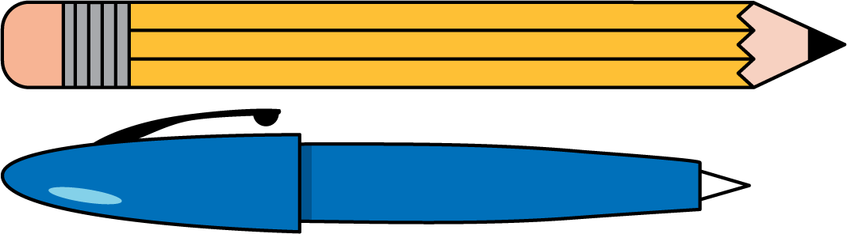
El marcador es más corto que el bolígrafo.
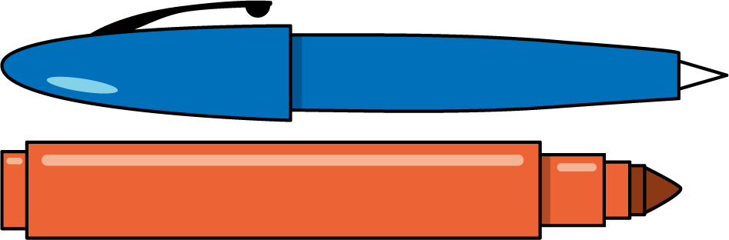
Usa las palabras lápiz y marcador para completar esta oración:
El ___________________ es más corto que el ___________________.

Student Responses
The marker is shorter than the pencil.

