Unit 6 Lesson 10: Beyond $2π$

1 All the Way Around (Warm up)

Student Task Statement
Here is a unit circle with a point $A$ marked at $\left(1,0\right)$. For each angle of rotation listed here, mark the new location of $A$ on the unit circle. Be prepared to explain your reasoning.
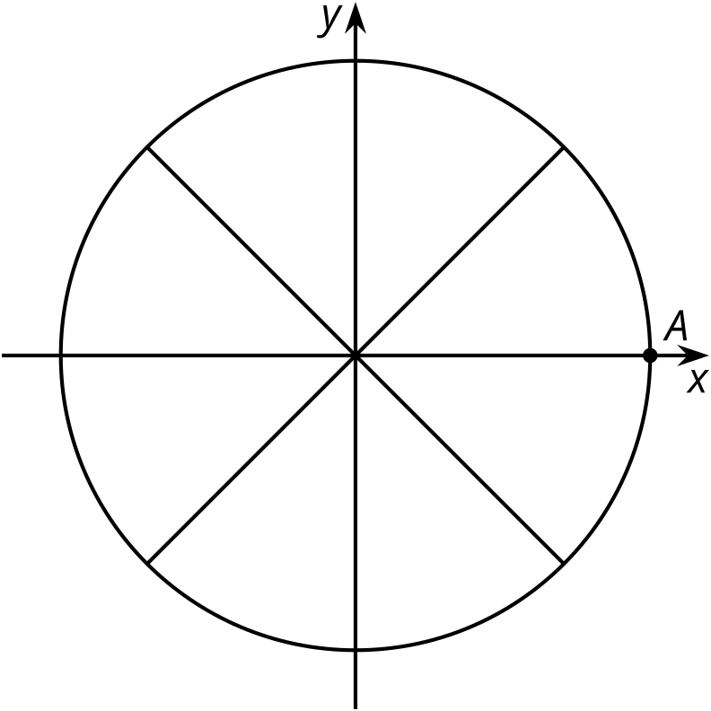
- $B$, $\frac{π}{3}$
- $C$, $\frac{4π}{3}$
- $D$, $\frac{7π}{4}$
- $E$, $\frac{5π}{2}$
- $F$, $\frac{6π}{2}$

2 Going Around and Around and Around

Images for Launch
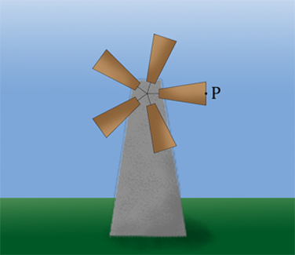

Student Task Statement
The center of a windmill is $\left(0,0\right)$ and it has 5 blades, each 1 meter in length. A point $P$ is at the end of the blade that is pointing directly to the right of the center. Here are graphs showing the horizontal and vertical distances of point $P$ relative to the center of the windmill as the blades rotate counterclockwise.
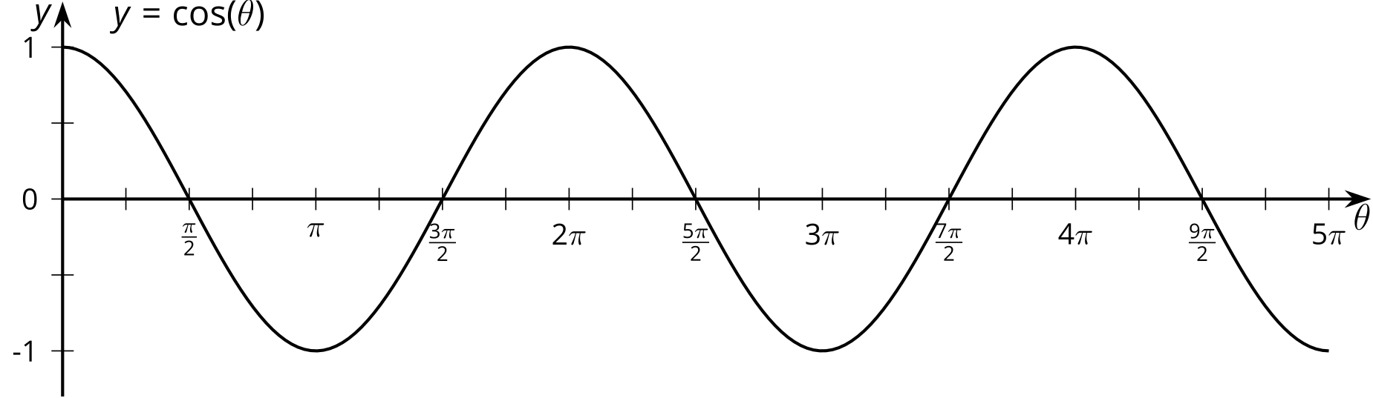
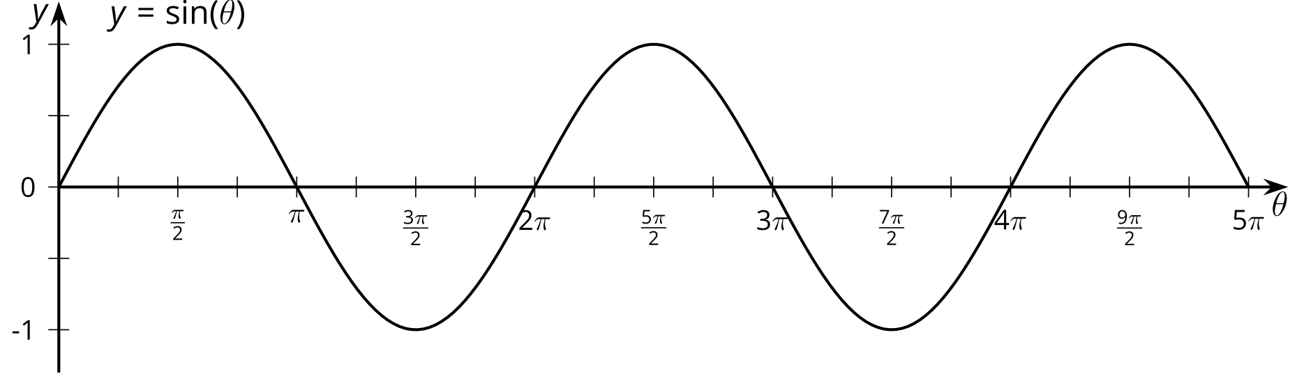
- How many full rotations are shown by the graphs? Explain how you know.
- What do the values of the graphs at $θ=3π$ mean in this context?
- List some different angles of rotation that bring $P$ to the highest point in its circle of rotation. What do you notice about these angles?
- How many angles show point $P$ at a height of 0.71 meters? Explain or show your reasoning.

3 Back to Where We Started

Student Task Statement
- The point $P$ on the unit circle has coordinates $\left(1,0\right)$. For each angle of rotation, state the number of rotations defined by the angle and then identify the coordinates of $P$ after the given rotation.
- 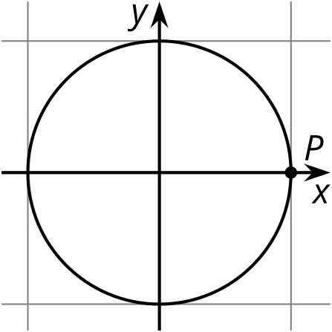
- rotation in radians | - number of rotations | - horizontal coordinate | - vertical coordinate
- $\frac{3π}{2}$ | - 0.75 | - 0 | - -1
- $\frac{25π}{12}$
- $\frac{5π}{2}$
- $\frac{7π}{3}$
- $\frac{49π}{12}$
- $5π$
- In general, if $θ$ is greater than $2π$ radians, explain how you can use the unit circle to make sense of $cos\left(θ\right)$ and $sin\left(θ\right)$.

Images for Activity Synthesis
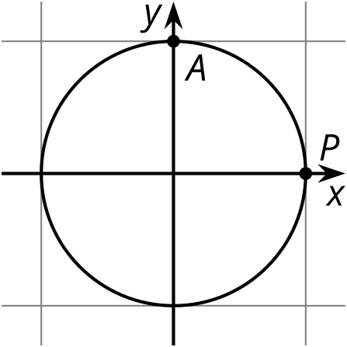
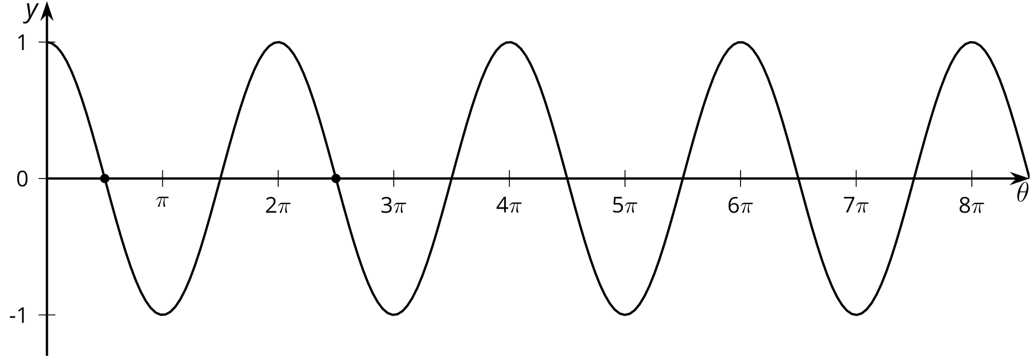
© CC BY 2019 by Illustrative Mathematics®

