Lesson 11: Área y la tabla de multiplicar (Optional)

Standards Alignments
Building On | 3.OA.B.5
Addressing | 3.MD.C.7.b, 3.OA.B.5, 3.OA.D.9
Building Towards | 3.MD.C.7.d

Teacher-facing Learning Goals
- Explore connections between area and the multiplication table.

Student-facing Learning Goals
- Exploremos el área y la tabla de multiplicar.

Lesson Purpose
The purpose of this lesson is for students to explore connections between area and the multiplication table.
This lesson introduces students to the multiplication table as a way to organize and find products of two whole-number factors (up to 10). Students begin by marking rectangles on blank multiplication tables, always starting from the upper left corner, and finding their areas. They see that the area of each rectangle is the product of the numbers at the right and bottom boundaries of the rectangle.
Through repeated reasoning, students see that finding the value of each cell in the table is like finding the area of a rectangle whose side lengths are a number from the top of the table and one from the left. Along the way, students notice patterns in the table and make use of them to complete the rest of the table (MP8).
This lesson is optional because it gives students more time to take a deeper look at the relationship between multiplication and area, and make addition connections.

Access for:

Students with Disabilities
- Representation (Activity 1)

English Learners
- MLR8 (Activity 2)

Instructional Routines
How Many Do You See? (Warm-up)

Lesson Timeline
Warm-up | 10 min
Activity 1 | 15 min
Activity 2 | 20 min
Lesson Synthesis | 10 min
Cool-down | 5 min

Teacher Reflection Question
Which multiplication facts did students seem most confident in as they found products in the multiplication table? For ones they did not know right away, what strategy did they go to?

Cool-down
(to be completed at the end of the lesson) 5min
¿Cuál es el producto?

Standards Alignments
Addressing | 3.MD.C.7.b

Student-facing Task Statement
¿Cuál es el producto desconocido? Explica tu razonamiento.
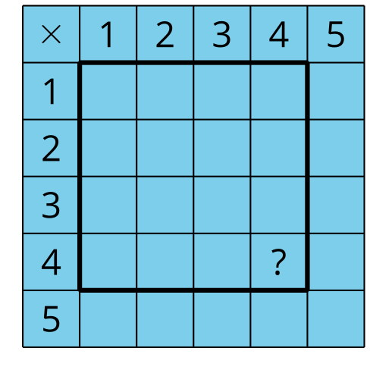

Student Responses
16. Sample response: I saw there are 4 squares in each row so I counted 4, 8, 12, 16.

