Lesson 2: Congruent Parts, Part 2
- Let’s name figures in ways that help us see the corresponding parts.

2.1: Math Talk: Which Are Congruent?
Each pair of figures is congruent. Decide whether each congruence statement is true or false.

$△ABC≅△FED$
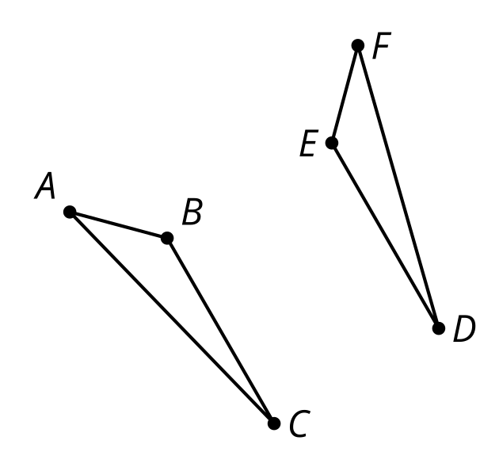

$PZJM≅LYXB$
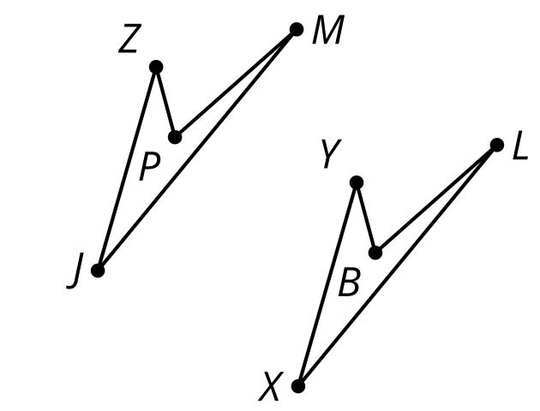
Triangle $ABC$ is congruent to triangle $FED$.
Quadrilateral $PZJM$ is congruent to quadrilateral $LYXB$.

$△JKL≅△QRS$
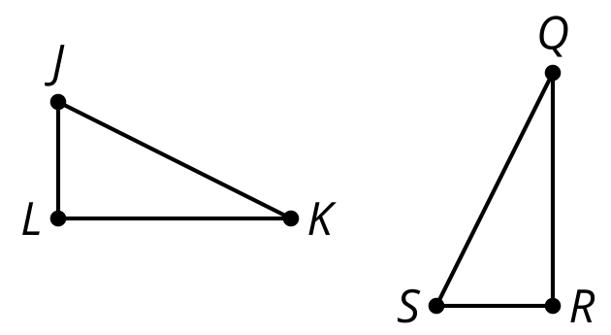

$ABCDE≅PQRST$
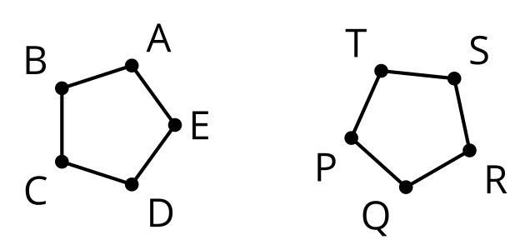
Triangle $JKL$ is congruent to triangle $QRS$.
Pentagon $ABCDE$ is congruent to pentagon $PQRST$.

2.2: Which Triangles Are Congruent?
Here are 3 triangles.
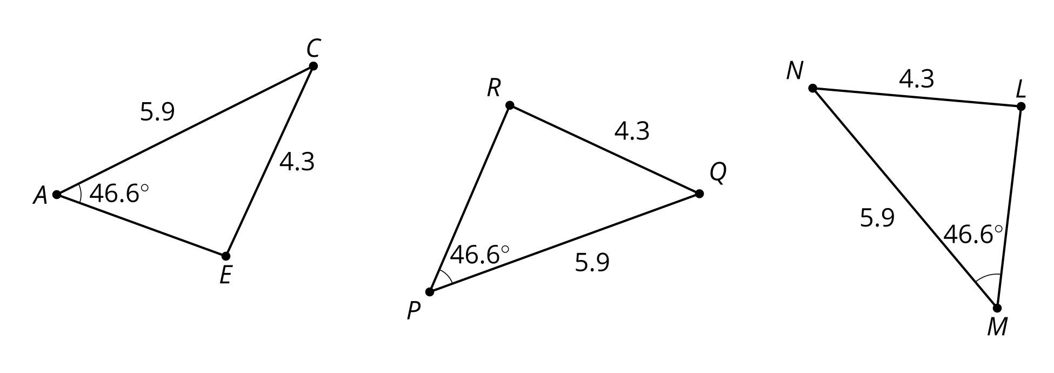
- Triangle $PQR$ is congruent to which triangle? Explain your reasoning.
- Show a sequence of rigid motions that takes triangle $PQR$ to that triangle. Draw each step of the transformation.
- Explain why there can’t be a rigid motion from triangle $PQR$ to the other triangle.

2.3: Are These Parts Congruent?
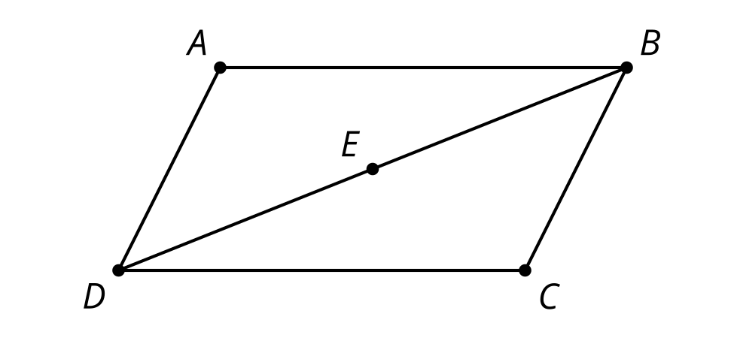
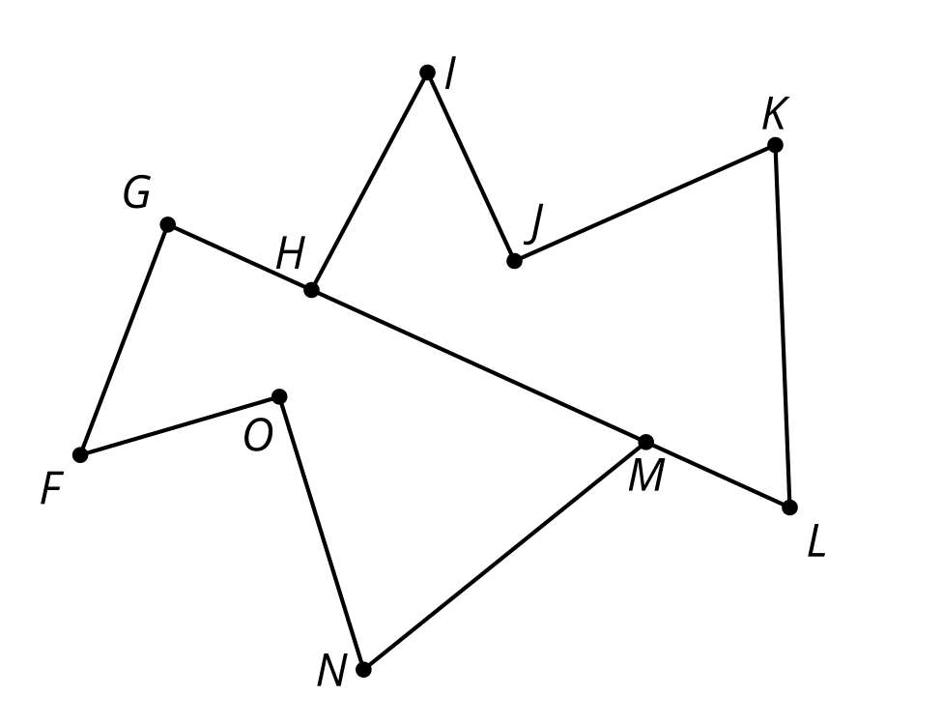
- Triangle $ABD$ is a rotation of triangle $CDB$ around point $E$ by ${180}^{∘}$. Is angle $ADB$ congruent to angle $CDB$? If so, explain your reasoning. If not, which angle is $ADB$ congruent to?
- Polygon $HIJKL$ is a reflection and translation of polygon $GFONM$. Is segment $KJ$ congruent to segment $NM$? If so, explain your reasoning. If not, which segment is $NM$ congruent to?
- Quadrilateral $PQRS$ is a rotation of polygon $VZYW$. Is angle $QRS$ congruent to angle $ZYW$? If so, explain your reasoning. If not, which angle is $QRS$ congruent to?

Are you ready for more?
Suppose quadrilateral $PQRS$ was both a rotation of quadrilateral $VZYW$ and also a reflection of quadrilateral $YZVW$. What can we conclude about the shape of our quadrilaterals? Explain why.

Lesson 2 Summary
Naming congruent figures so it’s clear from the name which parts correspond makes it easier to check whether 2 figures are congruent and to use corresponding parts. In this image, segment $AB$ appears to be congruent to segment $DE$. Also, segment $EF$ appears to be congruent to segment $BC$. So, it makes more sense to conjecture that triangle $ABC$ is congruent to triangle $DEF$ than to conjecture triangle $ABC$ is congruent to triangle $FDE$.
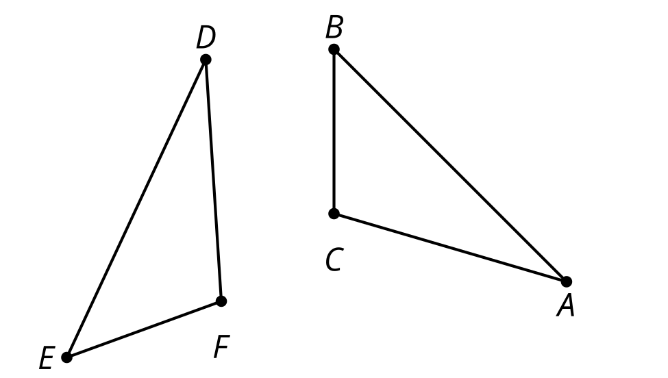
If we are told quadrilateral $MATH$ is congruent to quadrilateral $LOVE$, without even looking at the figures we know:
- Angle $M$ is congruent to angle $L$.
- Angle $A$ is congruent to angle $O$.
- Angle $T$ is congruent to angle $V$.
- Angle $H$ is congruent to angle $E$.
- Segments $MA$ and $LO$ are congruent.
- Segments $AT$ and $OV$ are congruent.
- Segments $TH$ and $VE$ are congruent.
- Segments $HM$ and $EL$ are congruent.
Quadrilaterals $MATH$ and $LOVE$ can be named in many different ways so that they still correspond—such as $ATHM$ is congruent to $OVEL$ or $THMA$ is congruent to $VELO$. But $ATMH$ is congruent to $LOVE$ means there are different corresponding parts. Note that quadrilateral $MATH$ refers to a different way of connecting the points than quadrilateral $ATMH$.
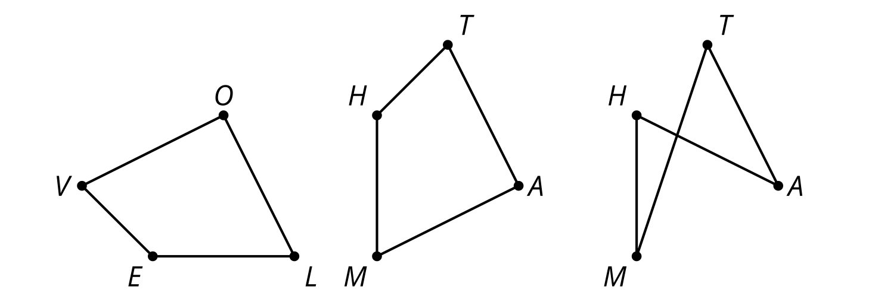
© CC BY 2019 by Illustrative Mathematics®

