Lesson 3 Practice Problems
- For each diagram, decide if $y$ is an increase or a decrease relative to $x$. Then determine the percent increase or decrease.
- 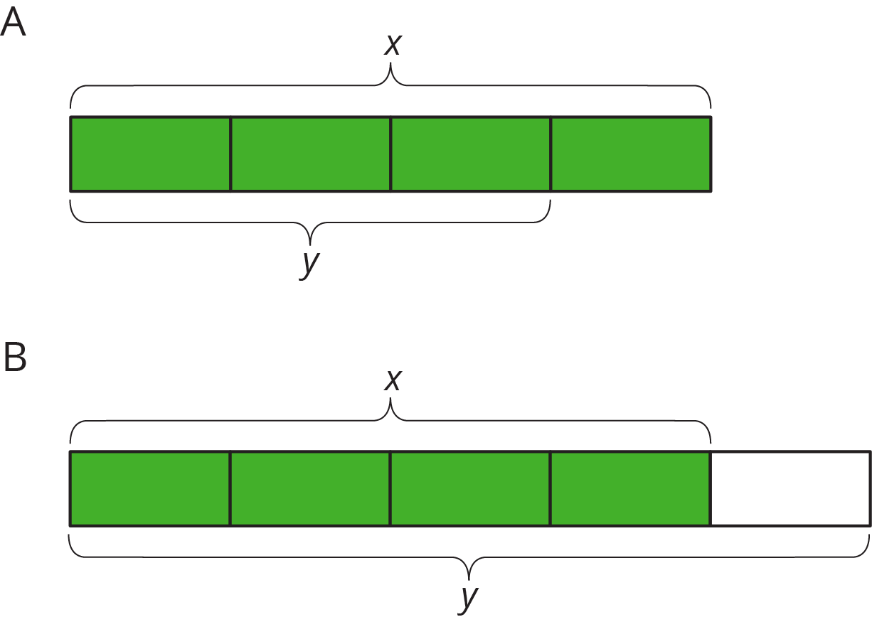
- Draw diagrams to represent the following situations.
  - The amount of flour that the bakery used this month was a 50% increase relative to last month.
  - The amount of milk that the bakery used this month was a 75% decrease relative to last month.
- Write each percent increase or decrease as a percentage of the initial amount. The first one is done for you.
  - This year, there was 40% more snow than last year.
  - The amount of snow this year is 140% of the amount of snow last year.
  - This year, there were 25% fewer sunny days than last year.
  - Compared to last month, there was a 50% increase in the number of houses sold this month.
  - The runner’s time to complete the marathon was a 10% less than the time to complete the last marathon.
- The graph shows the relationship between the diameter and the circumference of a circle with the point $\left(1,π\right)$ shown. Find 3 more points that are on the line.
- 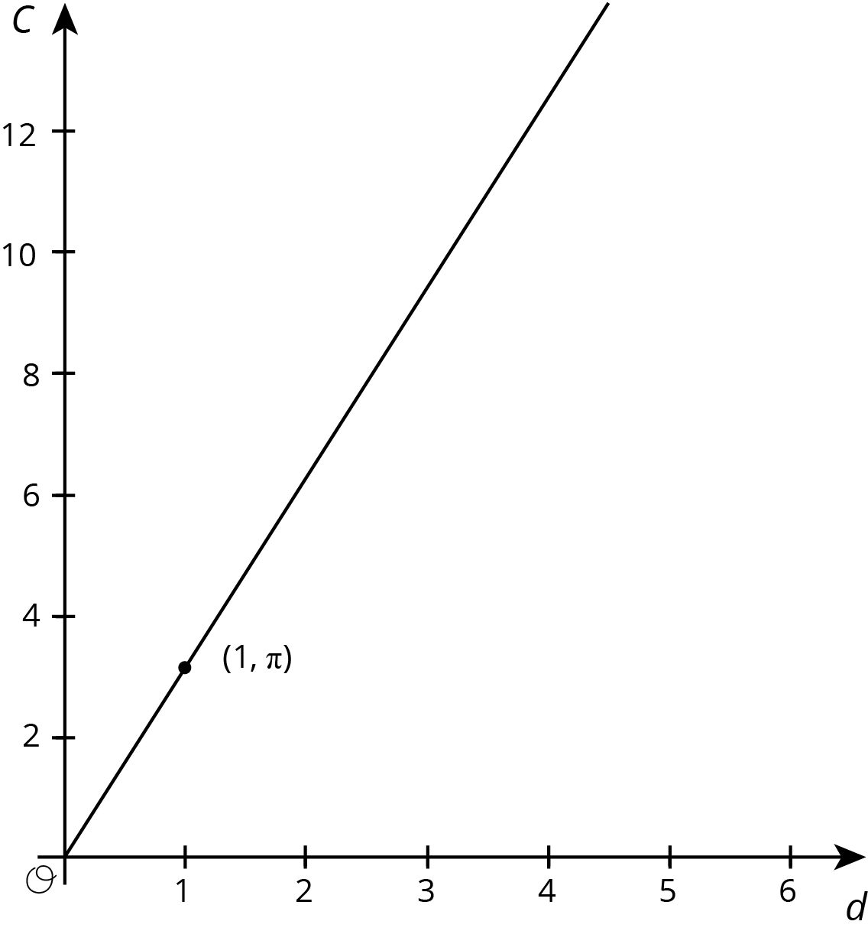
- (From Unit 5, Lesson 12.)
- Priya bought $x$ grams of flour. Clare bought $\frac{3}{8}$ more than that. Select all equations that represent the relationship between the amount of flour that Priya bought, $x$, and the amount of flour that Clare bought, $y$.
  - $y=\frac{3}{8}x$
  - $y=\frac{5}{8}x$
  - $y=x+\frac{3}{8}x$
  - $y=x−\frac{3}{8}x$
  - $y=\frac{11}{8}x$
- (From Unit 6, Lesson 1.)
© CC BY Open Up Resources. Adaptations CC BY IM.

