Lesson 1 Practice Problems
- Which one of these shapes is not like the others? Explain what makes it different by representing each width and height pair with a ratio.
- 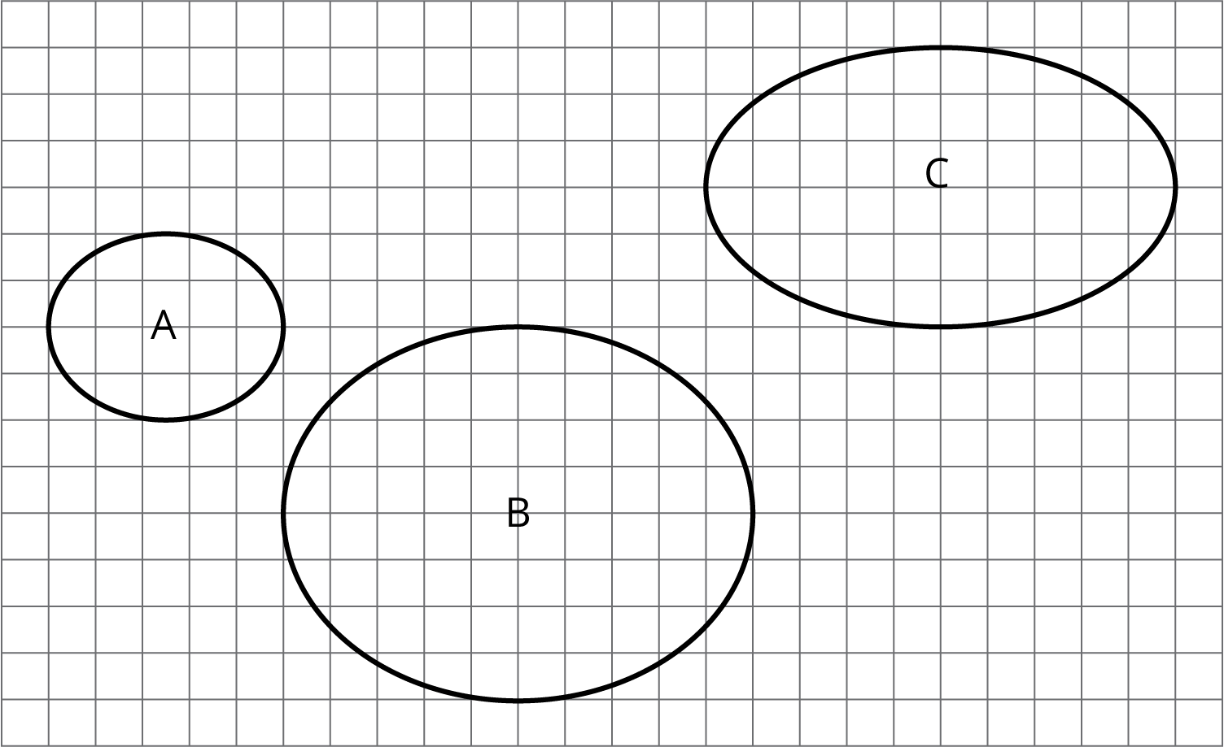

- In one version of a trail mix, there are 3 cups of peanuts mixed with 2 cups of raisins. In another version of trail mix, there are 4.5 cups of peanuts mixed with 3 cups of raisins. Are the ratios equivalent for the two mixes? Explain your reasoning.
- For each object, choose an appropriate scale for a drawing that fits on a regular sheet of paper. Not all of the scales on the list will be used.
- Objects
  - A person
  - A football field (120 yards by 53$\frac{1}{3}$ yards)
  - The state of Washington (about 240 miles by 360 miles)
  - The floor plan of a house
  - A rectangular farm (6 miles by 2 mile)
- Scales
  - 1 in : 1 ft
  - 1 cm : 1 m
  - 1: 1000
  - 1 ft: 1 mile
  - 1: 100,000
  - 1 mm: 1 km
  - 1: 10,000,000
- (From Unit 1, Lesson 12.)
- Which scale is equivalent to 1 cm to 1 km?
  - 1 to 1000
  - 10,000 to 1
  - 1 to 100,000
  - 100,000 to 1
  - 1 to 1,000,000
- (From Unit 1, Lesson 11.)

  - Find 3 different ratios that are equivalent to $7:3$.
  - Explain why these ratios are equivalent.
© CC BY Open Up Resources. Adaptations CC BY IM.

