Unit 6 Lesson 9: Looking for Associations

1 Notice and Wonder: Bar Association (Warm up)

Student Task Statement
What do you notice? What do you wonder?
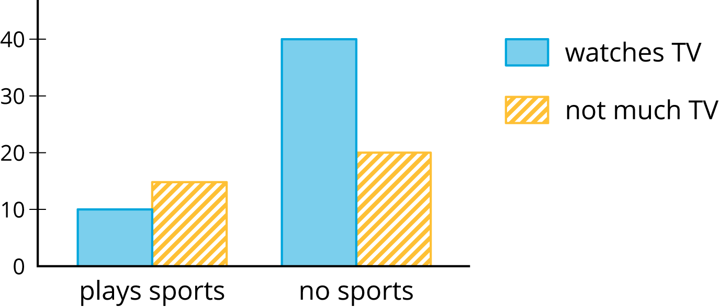

2 Card Sort: Matching Representations

Images for Launch
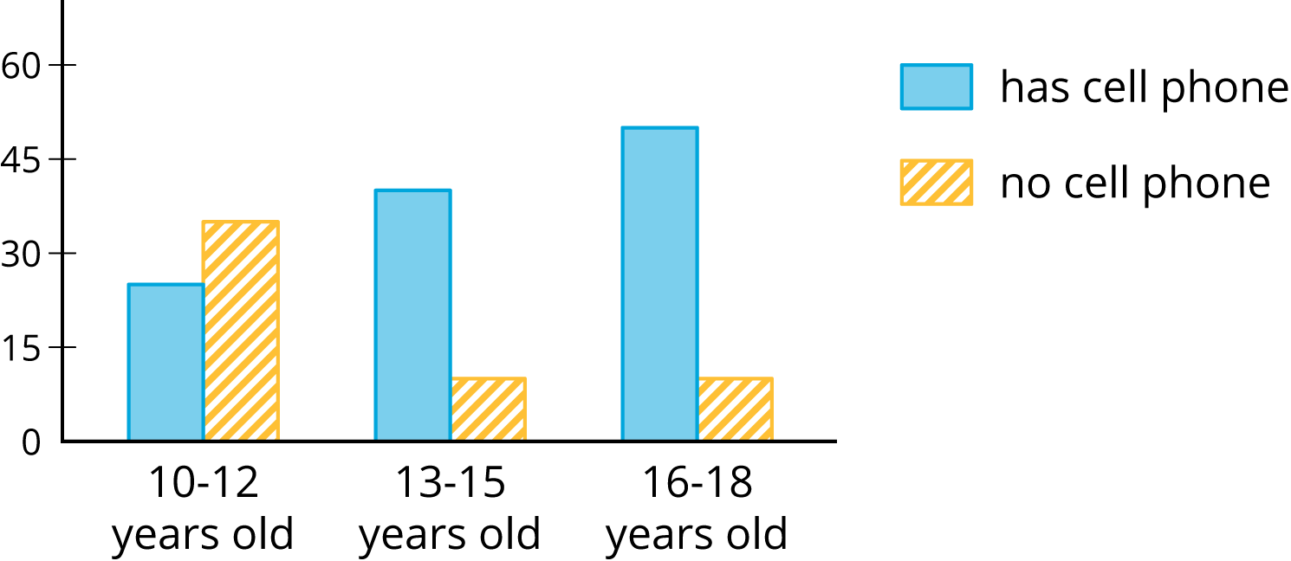
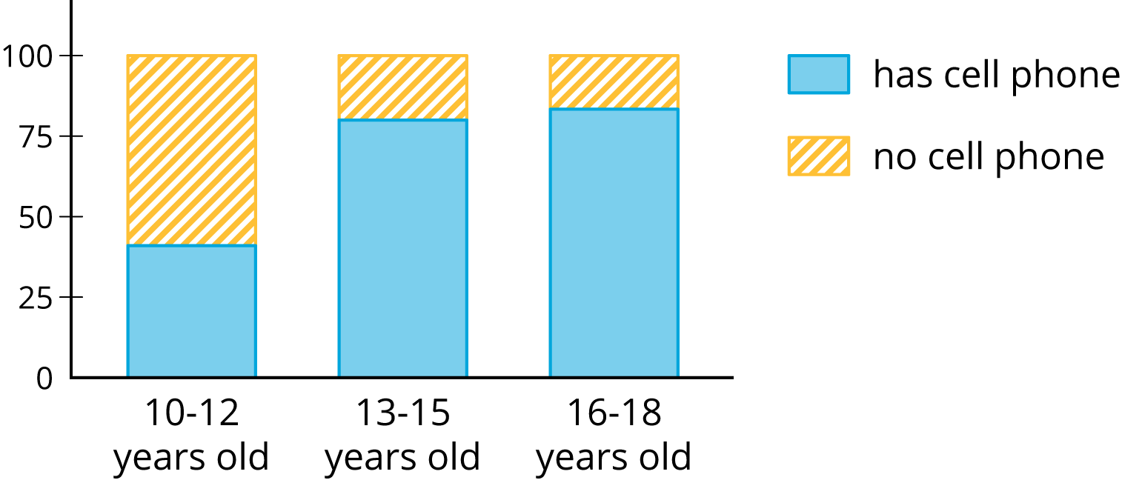

Student Task Statement
Your teacher will hand out some cards.
Some cards show two-way tables like this:
 | has cell phone | does not have cell phone | total
10 to 12 years old | 25 | 35 | 60
13 to 15 years old | 40 | 10 | 50
16 to 18 years old | 50 | 10 | 60
total | 115 | 55 | 170

Some cards show bar graphs like this:
Some cards show segmented bar graphs like this:
The bar graphs and segmented bar graphs have their labels removed.
- Put all the cards that describe the same situation in the same group.
- One of the groups does not have a two-way table. Make a two-way table for the situation described by the graphs in the group.
- Label the bar graphs and segmented bar graphs so that the categories represented by each bar are indicated.
- Describe in your own words the kind of information shown by a segmented bar graph.

3 Building Another Type of Two-Way Table

Student Task Statement
Here is a two-way table that shows data about cell phone usage among children aged 10 to 18.
 | has cell phone | does not have cell phone | total
10 to 12 years old | 25 | 35 | 60
13 to 15 years old | 40 | 10 | 50
16 to 18 years old | 50 | 10 | 60
total | 115 | 55 | 170
- Complete the table. In each row, the entries for “has cell phone” and “does not have cell phone” should have the total 100%. Round entries to the nearest percentage point.
 | - has cell phone | - does not have cell phone | - total
- 10 to 12 years old | - 42%
- 13 to 15 years old |  |  | - 100%
- 16 to 18 years old |  | - 17%
- This is still a two-way table. Instead of showing frequency, this table shows relative frequency.
- Two-way tables that show relative frequencies often don’t include a “total” row at the bottom. Why?
- Is there an association between age and cell phone use? How does the two-way table of relative frequencies help to illustrate this?

Images for Activity Synthesis
© CC BY Open Up Resources. Adaptations CC BY IM.

