Unit 7 Lesson 15: Distinguishing Volume and Surface Area

1 The Science Fair (Warm up)

Student Task Statement
Mai’s science teacher told her that when there is more ice touching the water in a glass, the ice melts faster. She wants to test this statement so she designs her science fair project to determine if crushed ice or ice cubes will melt faster in a drink.
She begins with two cups of warm water. In one cup, she puts a cube of ice. In a second cup, she puts crushed ice with the same volume as the cube. What is your hypothesis? Will the ice cube or crushed ice melt faster, or will they melt at the same rate? Explain your reasoning.

2 Revisiting the Box of Chocolates

Images for Launch
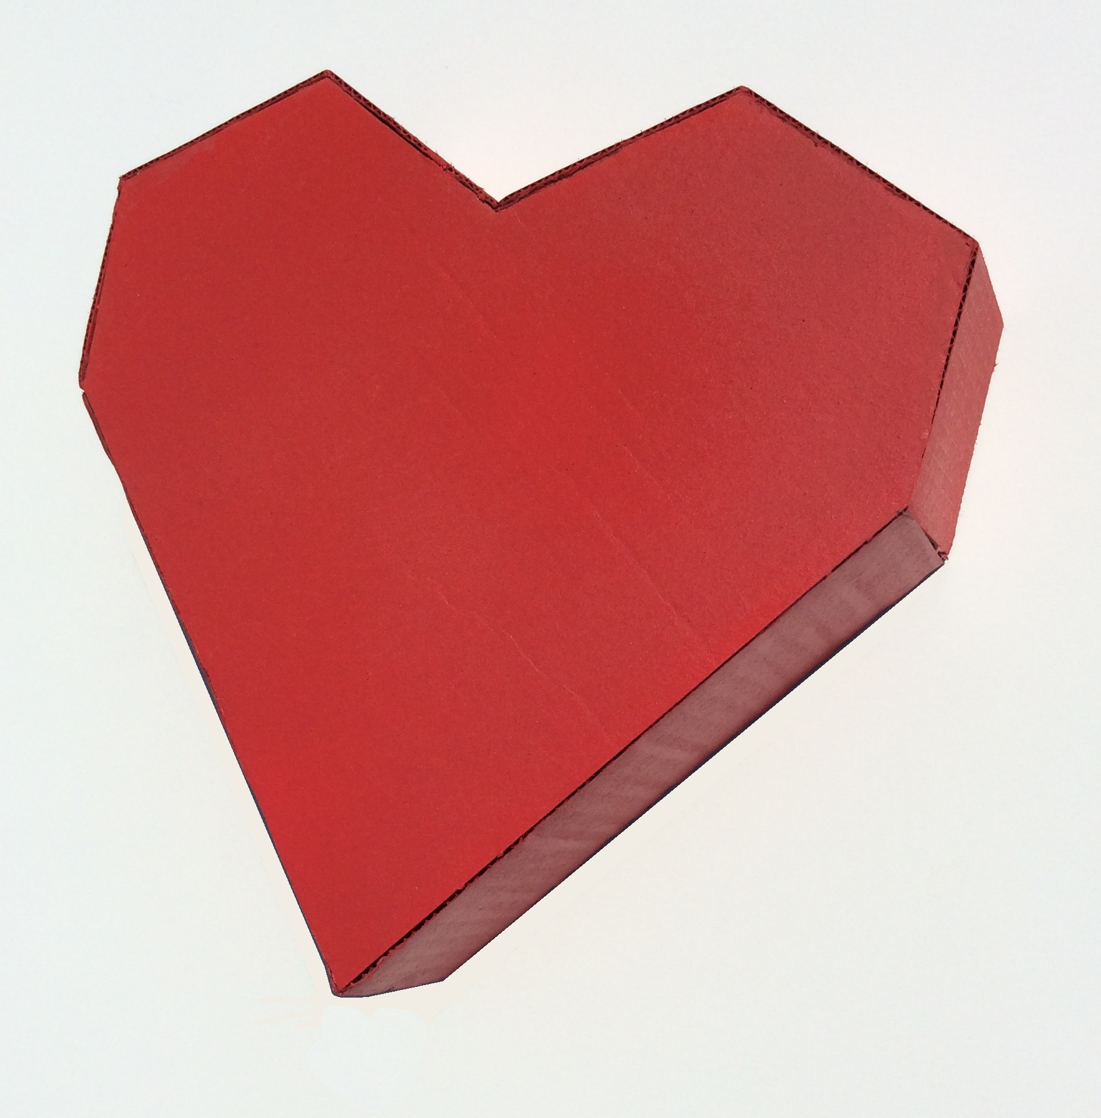

Student Task Statement
The other day, you calculated the volume of this heart-shaped box of chocolates.
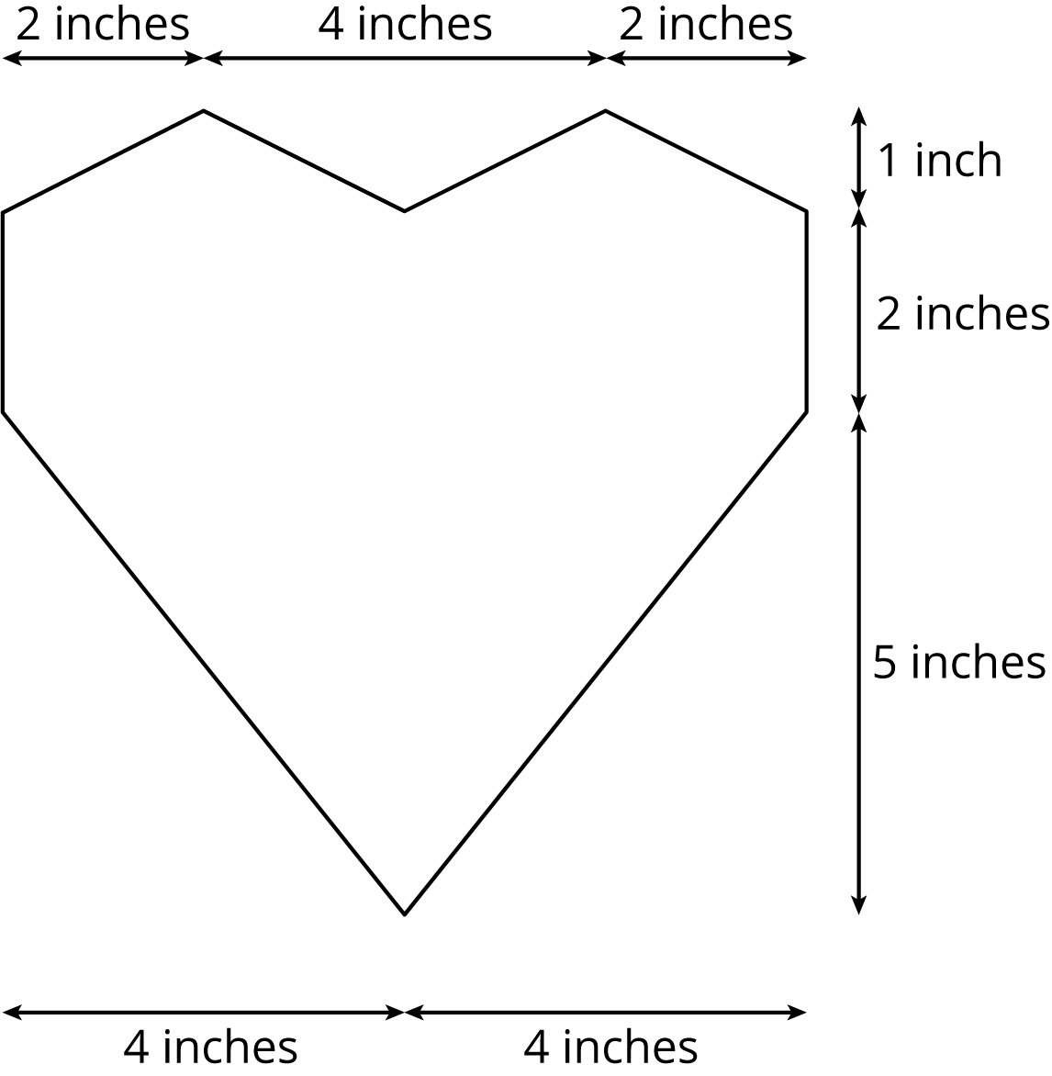
The depth of the box is 2 inches. How much cardboard is needed to create the box?

3 Card Sort: Surface Area or Volume

Student Task Statement
Your teacher will give you cards with different figures and questions on them.
- Sort the cards into two groups based on whether it would make more sense to think about the surface area or the volume of the figure when answering the question. Pause here so your teacher can review your work.
- Your teacher will assign you a card to examine more closely. What additional information would you need to be able to answer the question on your card?
- Estimate reasonable measurements for the figure on your card.
- Use your estimated measurements to calculate the answer to the question.

4 A Wheelbarrow of Concrete (Optional)

Images for Launch
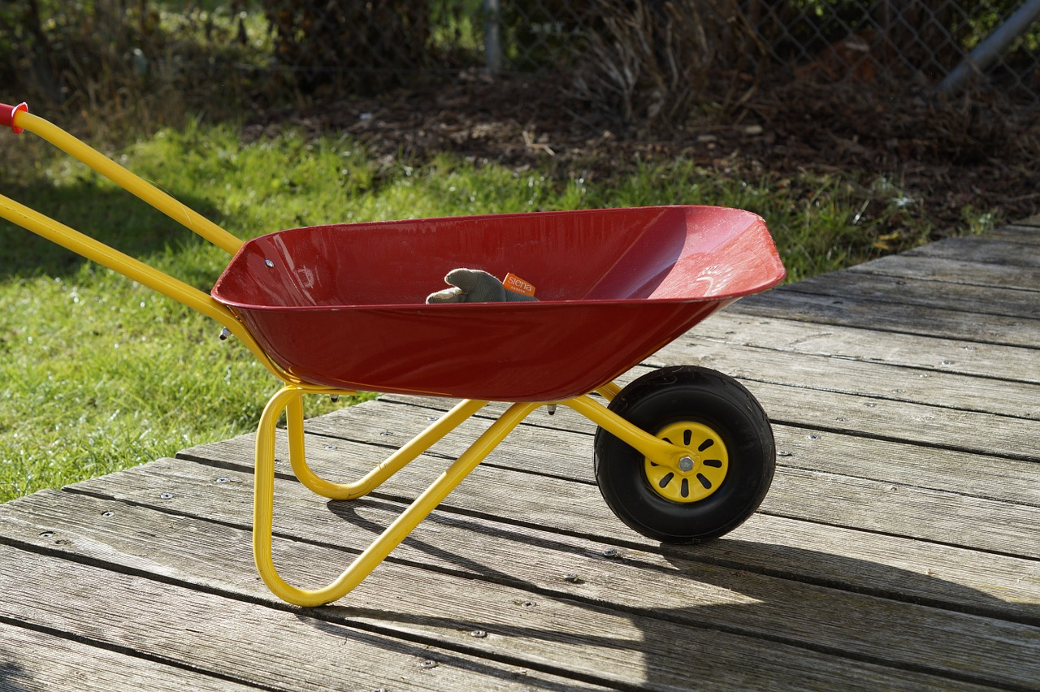

Student Task Statement
A wheelbarrow is being used to carry wet concrete. Here are its dimensions.
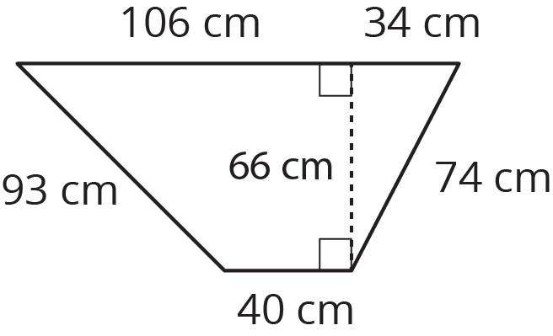
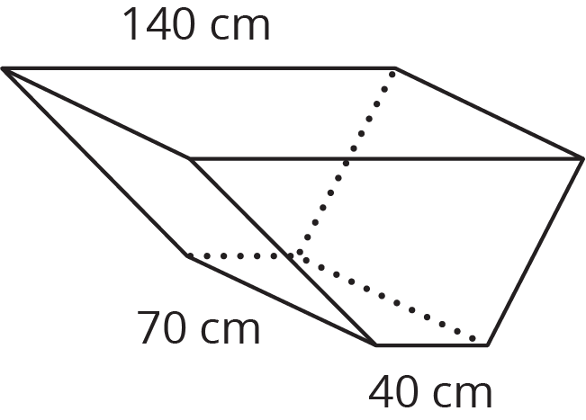
- What volume of concrete would it take to fill the tray?
- After dumping the wet concrete, you notice that a thin film is left on the inside of the tray. What is the area of the concrete coating the tray? (Remember, there is no top.)
© CC BY Open Up Resources. Adaptations CC BY IM.

