Unit 6 Lesson 7: Observing More Patterns in Scatter Plots

1 Notice and Wonder: Nonlinear Scatter Plot (Warm up)

Student Task Statement
What do you notice? What do you wonder?
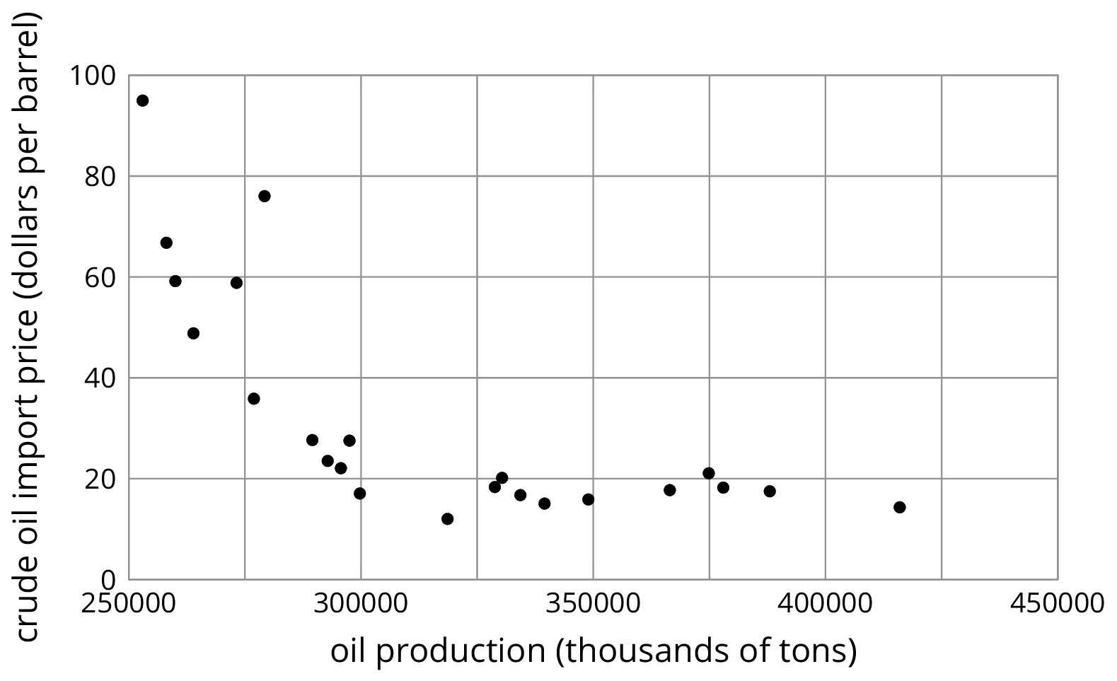

2 Scatter Plot City

Student Task Statement
Your teacher will give you a set of cards. Each card shows a scatter plot.
- Sort the cards into categories and describe each category.
- Explain the reasoning behind your categories to your partner. Listen to your partner’s reasoning for their categories.
- Sort the cards into two categories: positive associations and negative associations. Compare your sorting with your partner’s and discuss any disagreements.
- Sort the cards into two categories: linear associations and non-linear associations. Compare your sorting with your partner’s and discuss any disagreements.

3 Clustering

Student Task Statement
How are these scatter plots alike? How are they different?
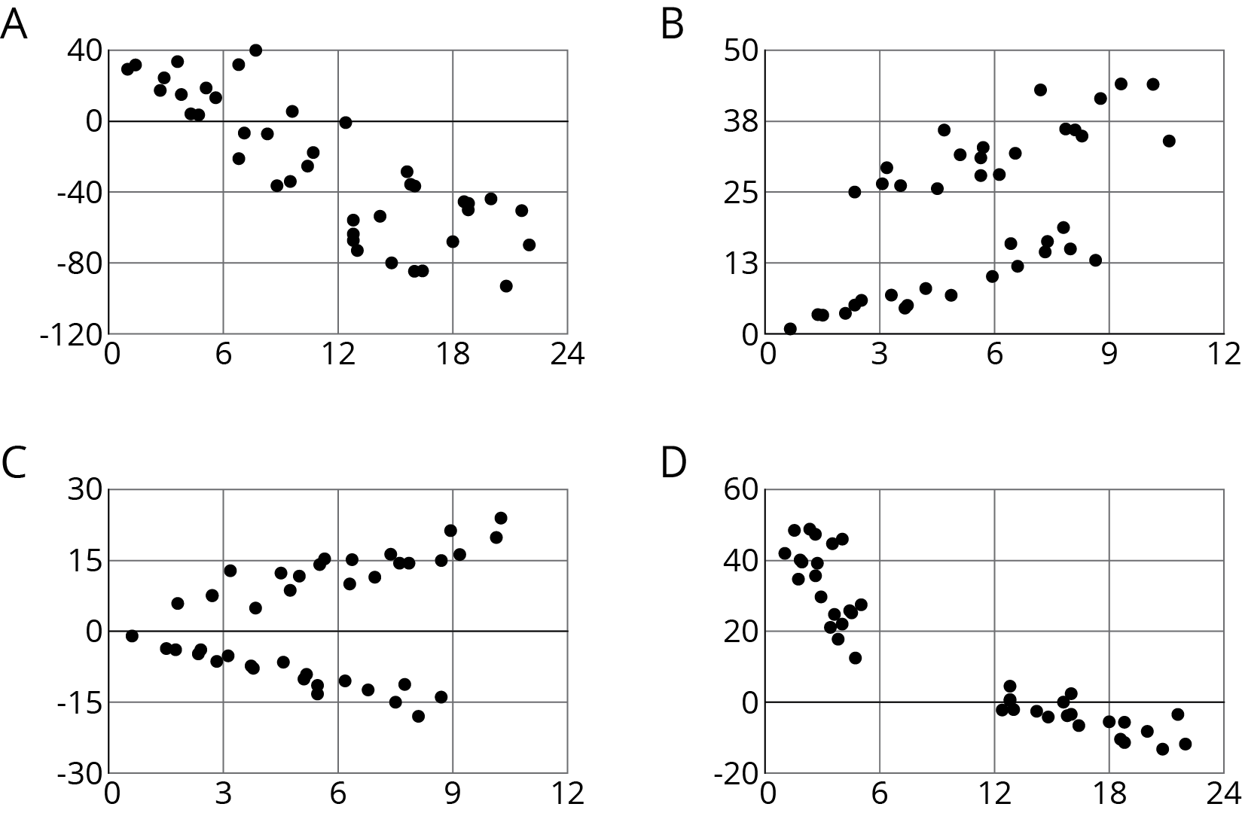

© CC BY Open Up Resources. Adaptations CC BY IM.

