Lesson 2 Practice Problems
- The likelihood that Han makes a free throw in basketball is 60%. The likelihood that he makes a 3-point shot is 0.345. Which event is more likely, Han making a free throw or making a 3-point shot? Explain your reasoning.
- Different events have the following likelihoods. Sort them from least to greatest:
- 60%
- 8 out of 10
- 0.37
- 20%
- $\frac{5}{6}$

- There are 25 prime numbers between 1 and 100. There are 46 prime numbers between 1 and 200. Which situation is more likely? Explain your reasoning.
  - A computer produces a random number between 1 and 100 that is prime.
  - A computer produces a random number between 1 and 200 that is prime.
- It takes $4\frac{3}{8}$ cups of cheese, $\frac{7}{8}$ cups of olives, and $2\frac{5}{8}$ cups of sausage to make a signature pizza. How much of each ingredient is needed to make 10 pizzas? Explain or show your reasoning.
- (From Unit 4, Lesson 2.)
- Here is a diagram of a birdhouse Elena is planning to build. (It is a simplified diagram, since in reality, the sides will have a thickness.) About how many square inches of wood does she need to build this birdhouse?
- 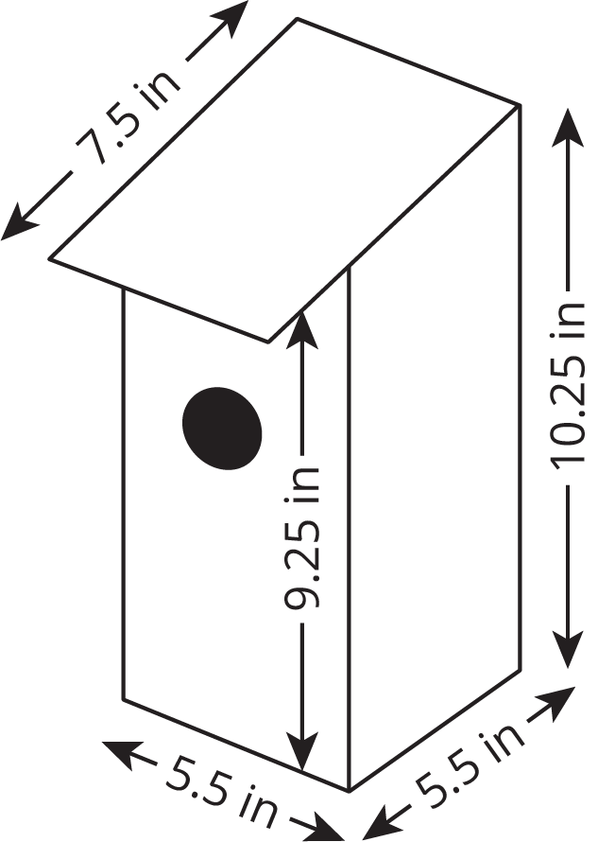

- (From Unit 7, Lesson 16.)
- Select all the situations where knowing the surface area of an object would be more useful than knowing its volume.
  - Placing an order for tiles to replace the roof of a house.
  - Estimating how long it will take to clean the windows of a greenhouse.
  - Deciding whether leftover soup will fit in a container.
  - Estimating how long it will take to fill a swimming pool with a garden hose.
  - Calculating how much paper is needed to manufacture candy bar wrappers.
  - Buying fabric to sew a couch cover.
  - Deciding whether one muffin pan is enough to bake a muffin recipe.
- (From Unit 7, Lesson 15.)
© CC BY Open Up Resources. Adaptations CC BY IM.

