Unit 6 Lesson 17: Lines in Triangles

1 Folding Altitudes (Warm up)

Student Task Statement
Draw a triangle on tracing paper. Fold the altitude from each vertex.

2 Altitude Attributes

Student Task Statement
Triangle $ABC$ is graphed.
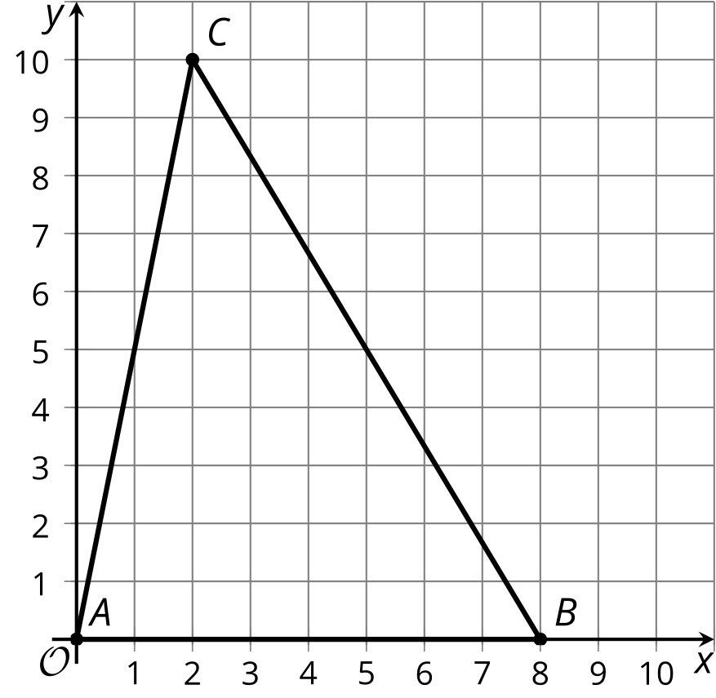
- Find the slope of each side of the triangle.
- Find the slope of each altitude of the triangle.
- Sketch the altitudes. Label the point of intersection $H$.
- Write equations for all 3 altitudes.
- Use the equations to find the coordinates of $H$ and verify algebraically that the altitudes all intersect at $H$.

3 Percolating on Perpendicular Bisectors (Optional)

Student Task Statement
Triangle $ABC$ is graphed.
- Find the midpoint of each side of the triangle.
- Sketch the perpendicular bisectors, using an index card to help draw 90 degree angles. Label the intersection point $P$.
- Write equations for all 3 perpendicular bisectors.
- Use the equations to find the coordinates of $P$ and verify algebraically that the perpendicular bisectors all intersect at $P$.

4 Perks of Perpendicular Bisectors (Optional)

Student Task Statement
Consider triangle $ABC$ from an earlier activity.
- What is the distance from $A$ to $P$, the intersection point of the perpendicular bisectors of the triangle’s sides? Round to the nearest tenth.
- Write the equation of a circle with center $P$ and radius $AP$.
- Construct the circle. What do you notice?
- Verify your hypothesis algebraically.

5 Amazing Points (Optional)

Student Task Statement
Consider triangle $ABC$ from earlier activities.
- Plot point $H$, the intersection point of the altitudes.
- Plot point $P$, the intersection point of the perpendicular bisectors.
- Find the point where the 3 medians of the triangle intersect. Plot this point and label it $J$.
- What seems to be true about points $H,P,$ and $J$? Prove that your observation is true.

6 Tiling the (Coordinate) Plane (Optional)

Student Task Statement
A tessellation covers the entire plane with shapes that do not overlap or leave gaps.
- Tile the plane with congruent rectangles:
  - Draw the rectangles on your grid.
  - Write the equations for lines that outline 1 rectangle.
- Tile the plane with congruent right triangles:
  - Draw the right triangles on your grid.
  - Write the equations for lines that outline 1 right triangle.
- Tile the plane with any other shapes:
  - Draw the shapes on your grid.
  - Write the equations for lines that outline 1 of the shapes.
© CC BY 2019 by Illustrative Mathematics®

