Lesson 5 Practice Problems
- What is the same about these two experiments? What is different?
  - Selecting a letter at random from the word “ALABAMA”
  - Selecting a letter at random from the word “LAMB”

- Andre picks a block out of a bag 60 times and notes that 43 of them were green.
  - What should Andre estimate for the probability of picking out a green block from this bag?
  - Mai looks in the bag and sees that there are 6 blocks in the bag. Should Andre change his estimate based on this information? If so, what should the new estimate be? If not, explain your reasoning.
- Han has a number cube that he suspects is not so standard.
  - Han rolls the cube 100 times, and it lands on a six 40 times.
  - Kiran rolls the cube 50 times, and it lands on a six 21 times.
  - Lin rolls the cube 30 times, and it lands on a six 11 times.
- Based on these results, is there evidence to help prove that this cube is not a standard number cube? Explain your reasoning.
- A textbook has 428 pages numbered in order starting with 1. You flip to a random page in the book in a way that it is equally likely to stop at any of the pages.
  - What is the sample space for this experiment?
  - What is the probability that you turn to page 45?
  - What is the probability that you turn to an even numbered page?
  - If you repeat this experiment 50 times, about how many times do you expect you will turn to an even numbered page?
- (From Unit 8, Lesson 3.)
- A rectangular prism is cut along a diagonal on each face to create two triangular prisms. The distance between $A$ and $B$ is 5 inches.
- 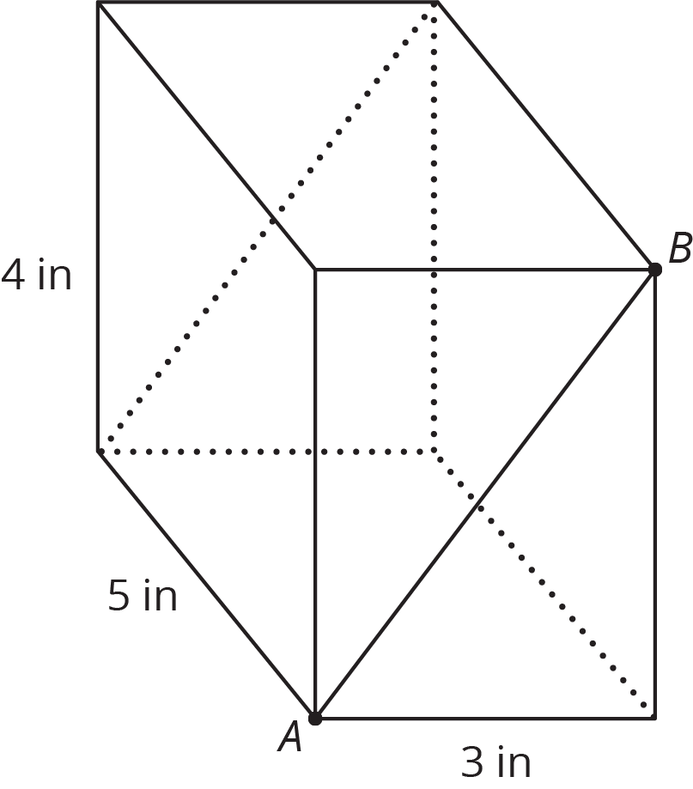
- What is the surface area of the original rectangular prism? What is the total surface area of the two triangular prisms together?
- (From Unit 7, Lesson 15.)
© CC BY Open Up Resources. Adaptations CC BY IM.

