Unit 6 Lesson 16: Weighted Averages in a Triangle

1 Triangle Midpoints (Warm up)

Student Task Statement
Triangle $ABC$ is graphed.
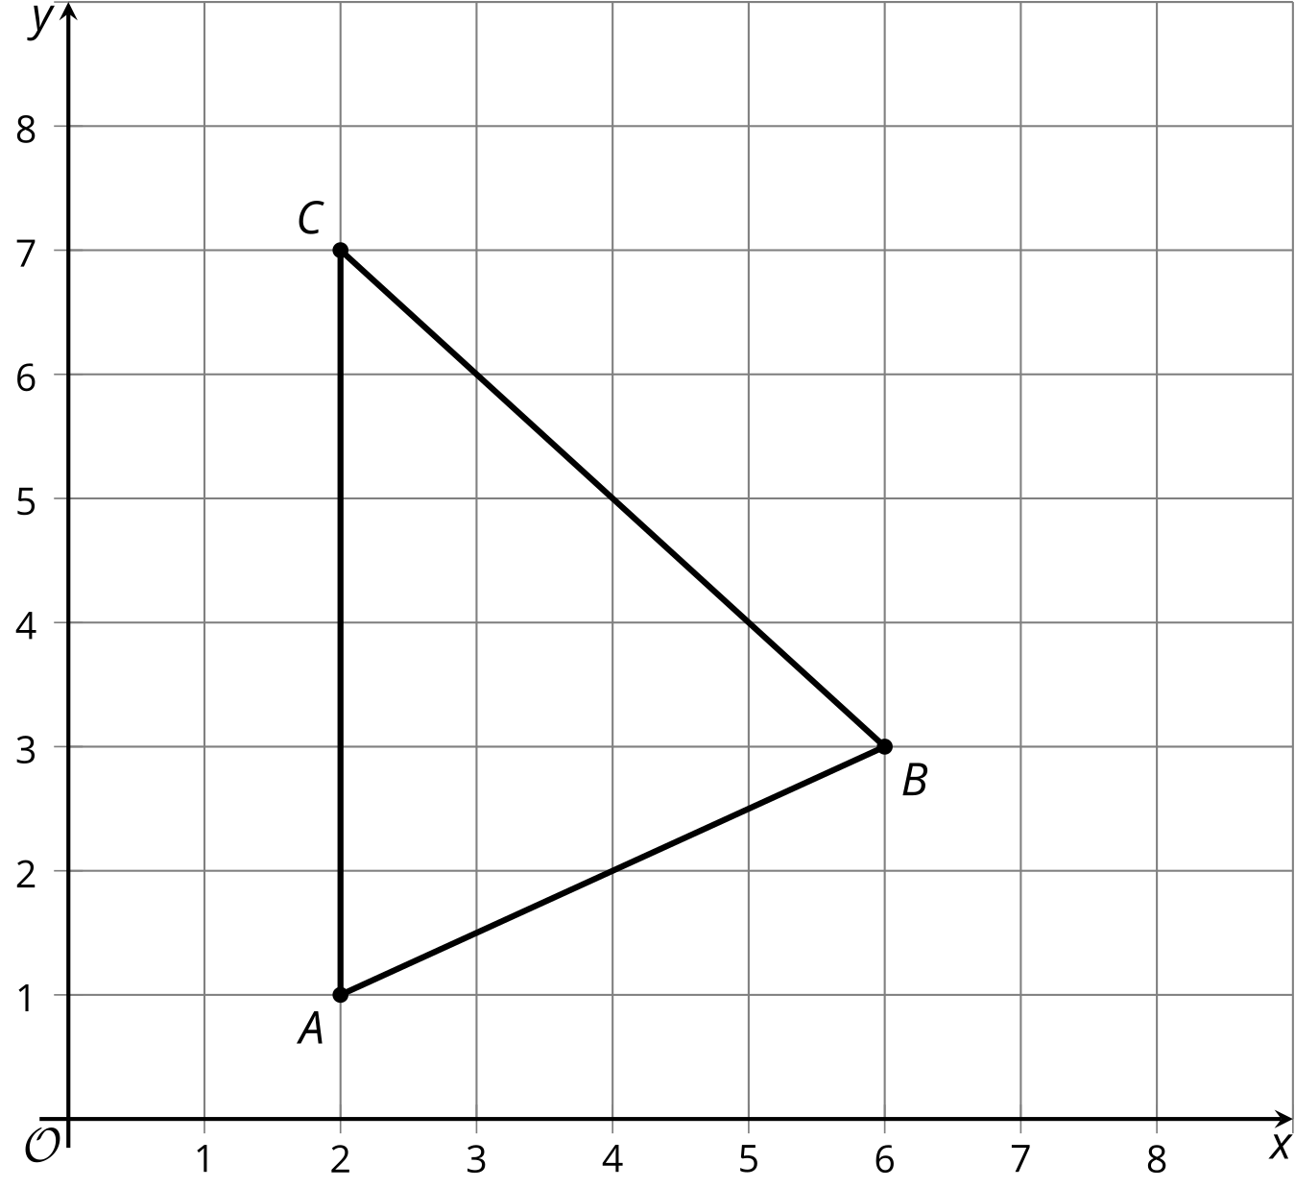
Find the midpoint of each side of this triangle.

2 Triangle Medians

Images for Launch
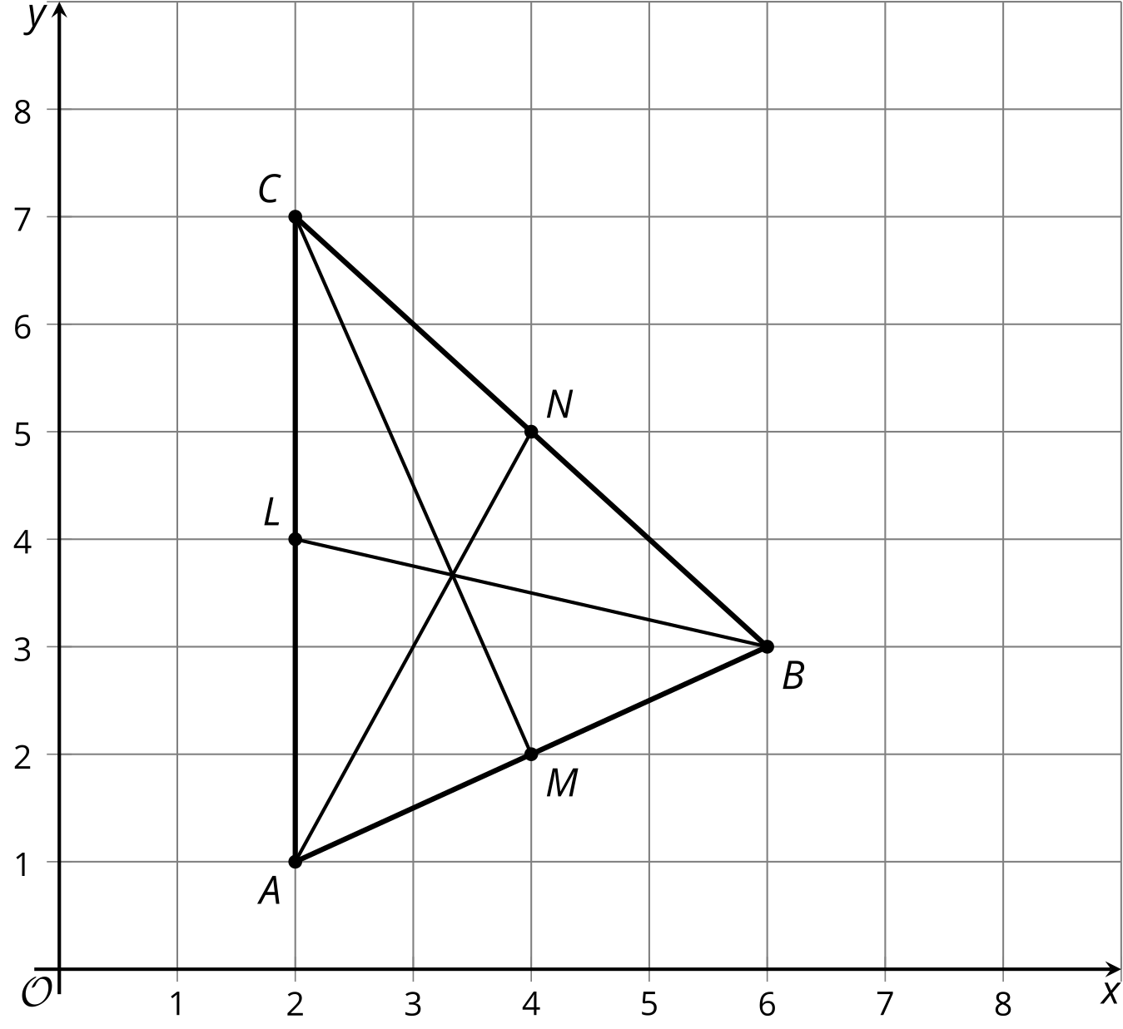

Student Task Statement
Your teacher will tell you how to draw and label the medians of the triangle in the warm-up.
- After the medians are drawn and labeled, measure all 6 segments inside the triangle using centimeters. What is the ratio of the 2 parts of each median?
- Find the coordinates of the point that partitions segment $AN$ in a $2:1$ ratio.
- Find the coordinates of the point that partitions segment $BL$ in a $2:1$ ratio.
- Find the coordinates of the point that partitions segment $CM$ in a $2:1$ ratio.

3 Any Triangle’s Medians

Student Task Statement
The goal is to prove that the medians of any triangle intersect at a point. Suppose the vertices of a triangle are $\left(0,0\right),\left(w,0\right),$ and $\left(a,b\right)$.
- Each student in the group should choose 1 side of the triangle. If your group has 4 people, 2 can work together. Write an expression for the midpoint of the side you chose.
- Each student in the group should choose a median. Write an expression for the point that partitions each median in a $2:1$ ratio from the vertex to the midpoint of the opposite side.
- Compare the coordinates of the point you found to those of your groupmates. What do you notice?
- Explain how these steps prove that the 3 medians of any triangle intersect at a single point.
© CC BY 2019 by Illustrative Mathematics®

