Lesson 6: Rewriting Quadratic Expressions in Factored Form (Part 1)
- Let’s write expressions in factored form.

6.1: Puzzles of Rectangles
Here are two puzzles that involve side lengths and areas of rectangles. Can you find the missing area in Figure A and the missing length in Figure B? Be prepared to explain your reasoning.

Figure A
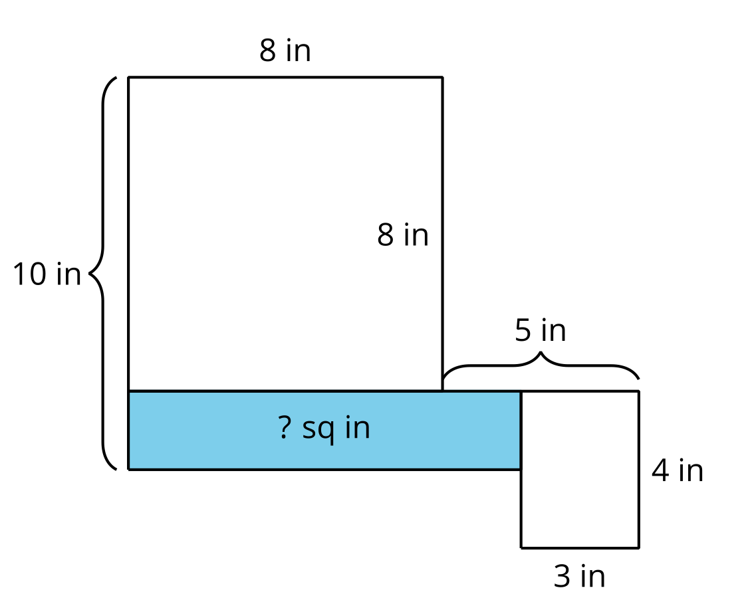
​​​​​​

Figure B
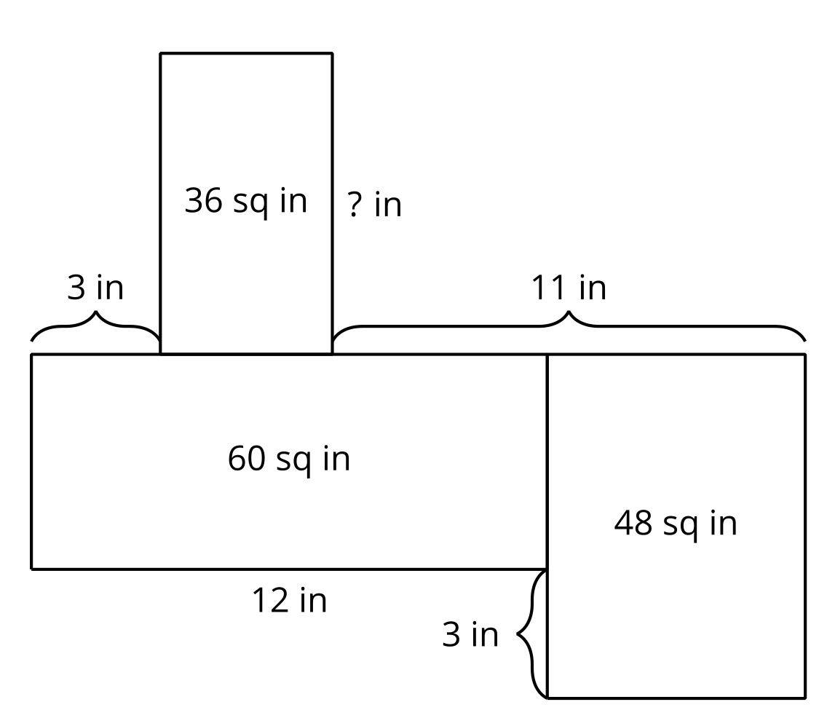

6.2: Using Diagrams to Understand Equivalent Expressions
- Use a diagram to show that each pair of expressions is equivalent.
- $x\left(x+3\right)$ and $x^{2}+3x$
- $x\left(x+\text{-}6\right)$ and $x^{2}−6x$
- $\left(x+2\right)\left(x+4\right)$ and $x^{2}+6x+8$
- $\left(x+4\right)\left(x+10\right)$ and $x^{2}+14x+40$
- $\left(x+\text{-}5\right)\left(x+\text{-}1\right)$ and $x^{2}−6x+5$
- $\left(x−1\right)\left(x−7\right)$ and $x^{2}−8x+7$
- Observe the pairs of expressions that involve the product of two sums or two differences. How is each expression in factored form related to the equivalent expression in standard form?

6.3: Let’s Rewrite Some Expressions!
Each row in the table contains a pair of equivalent expressions.
Complete the table with the missing expressions. If you get stuck, consider drawing a diagram.
factored form | standard form
$x\left(x+7\right)$
 | $x^{2}+9x$
 | $x^{2}−8x$
$\left(x+6\right)\left(x+2\right)$
 | $x^{2}+13x+12$
$\left(x−6\right)\left(x−2\right)$
 | $x^{2}−7x+12$
 | $x^{2}+6x+9$
 | $x^{2}+10x+9$
 | $x^{2}−10x+9$
 | $x^{2}−6x+9$
 | $x^{2}+\left(m+n\right)x+mn$

Are you ready for more?
A mathematician threw a party. She told her guests, “I have a riddle for you. I have three daughters. The product of their ages is 72. The sum of their ages is the same as my house number. How old are my daughters?”
The guests went outside to look at the house number. They thought for a few minutes, and then said, “This riddle can’t be solved!”
The mathematician said, “Oh yes, I forgot to tell you the last clue. My youngest daughter prefers strawberry ice cream.”
With this last clue, the guests could solve the riddle. How old are the mathematician’s daughters?

Lesson 6 Summary
Previously, you learned how to expand a quadratic expression in factored form and write it in standard form by applying the distributive property.
For example, to expand $\left(x+4\right)\left(x+5\right)$, we apply the distributive property to multiply $x$ by $\left(x+5\right)$ and 4 by $\left(x+5\right)$. Then, we apply the property again to multiply $x$ by $x$ and $x$ by 5, and multiply 4 by $x$ and 4 by 5.
To keep track of all the products, we could make a diagram like this:
 | $x$ | $4$
$x$
$5$
Next, we could write the products of each pair inside the spaces:
 | $x$ | $4$
$x$ | $x^{2}$ | $4x$
$5$ | $5x$ | $4⋅5$
The diagram helps us see that $\left(x+4\right)\left(x+5\right)$ is equivalent to $x^{2}+5x+4x+4⋅5$, or in standard form, $x^{2}+9x+20$.
- The linear term, $9x$, has a coefficient of 9, which is the sum of 5 and 4.
- The constant term, 20, is the product of 5 and 4.
We can use these observations to reason in the other direction: to start with an expression in standard form and write it in factored form.
For example, suppose we wish to write $x^{2}−11x+24$ in factored form.
Let’s start by creating a diagram and writing in the terms $x^{2}$ and 24.
We need to think of two numbers that multiply to make 24 and add up to -11.
 | $x$
$x$ | $x^{2}$
 |  | $24$
After some thinking, we see that -8 and -3 meet these conditions.
The product of -8 and -3 is 24. The sum of -8 and -3 is -11.
 | $x$ | $\text{-}8$
$x$ | $x^{2}$ | $\text{-}8x$
$\text{-}3$ | $\text{-}3x$ | $24$
So, $x^{2}−11x+24$ written in factored form is $\left(x−8\right)\left(x−3\right)$.
© CC BY 2019 by Illustrative Mathematics®

