Unit 6 Lesson 5: Describing Trends in Scatter Plots

1 Which One Doesn’t Belong: Scatter Plots (Warm up)

Student Task Statement
Which one doesn’t belong?
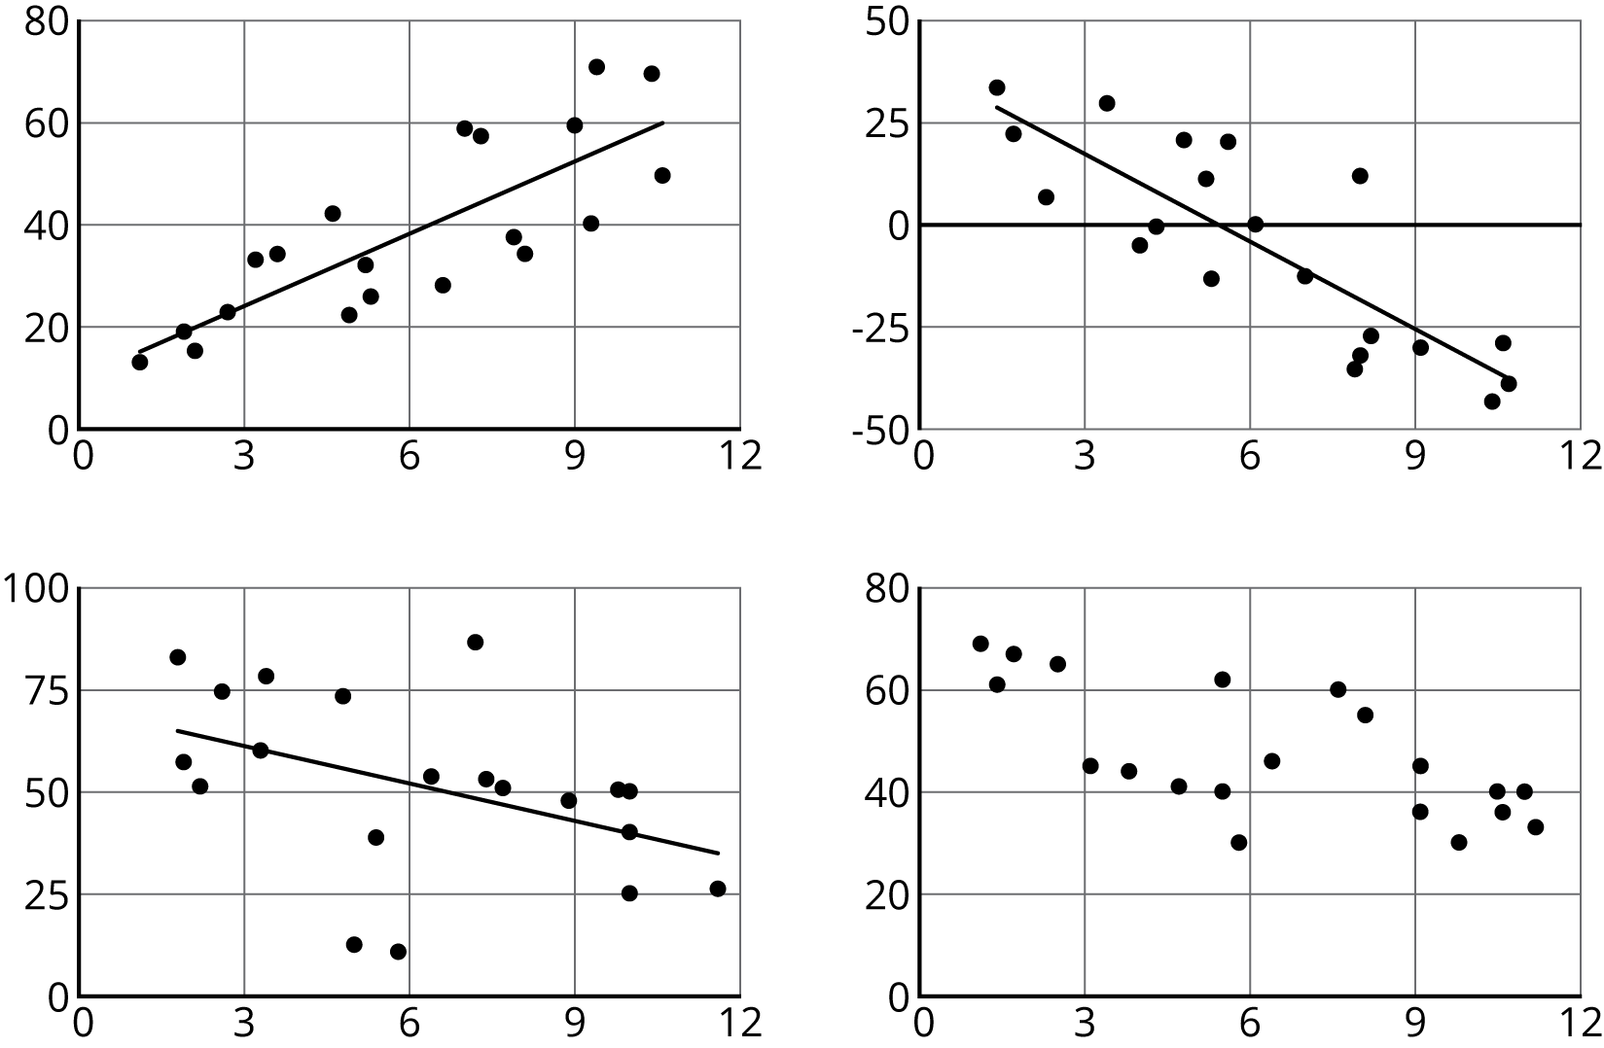

2 Fitting Lines

Student Task Statement
Your teacher will give you a piece of pasta and a straightedge.
- Here are two copies of the same scatter plot. Experiment with drawing lines to fit the data. Pick the line that you think best fits the data. Compare it with a partner’s.
- 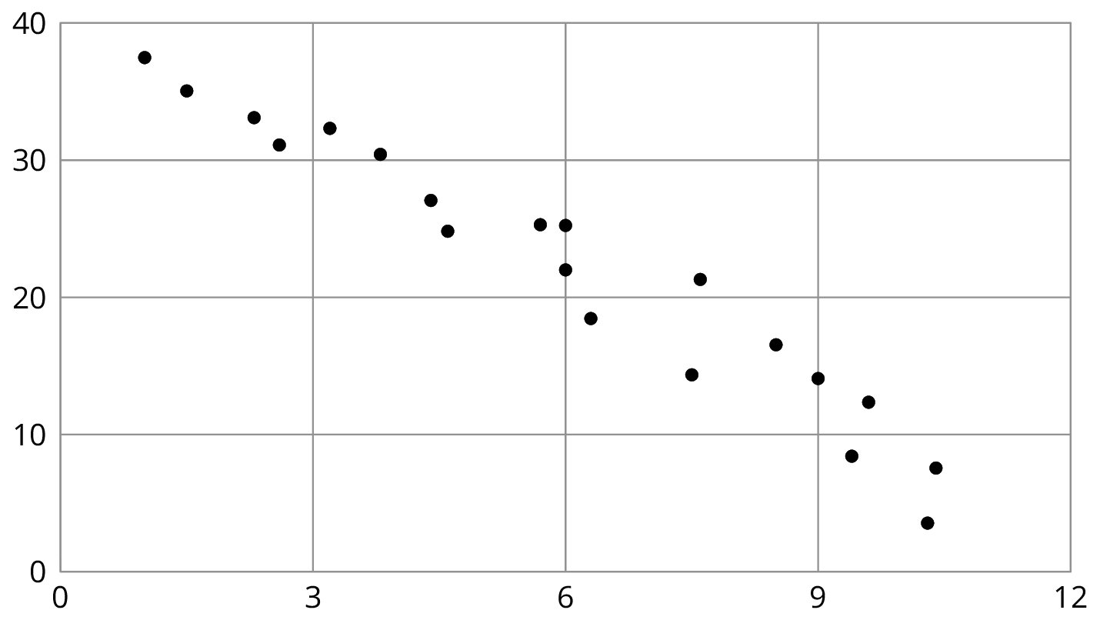
- Here are two copies of another scatter plot. Experiment with drawing lines to fit the data. Pick the line that you think best fits the data. Compare it with a partner’s.
- 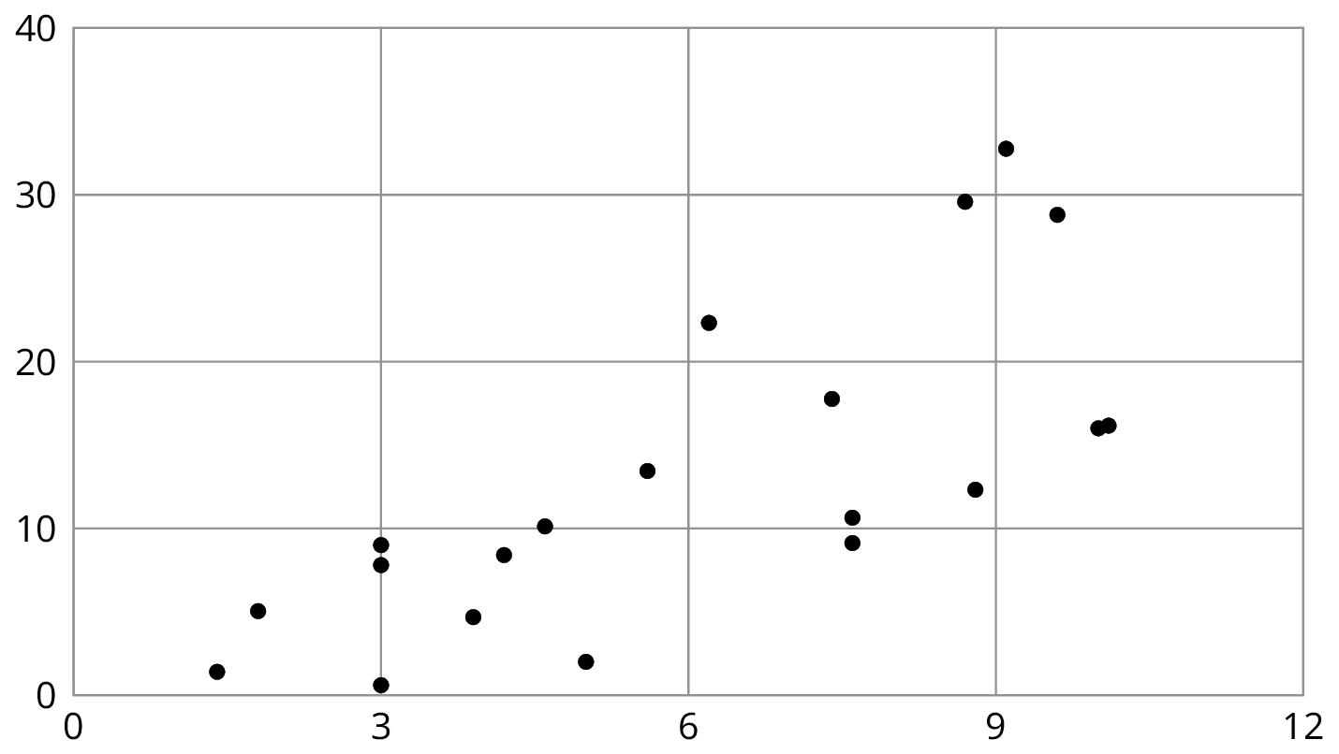
- In your own words, describe what makes a line fit a data set well.

Activity Synthesis
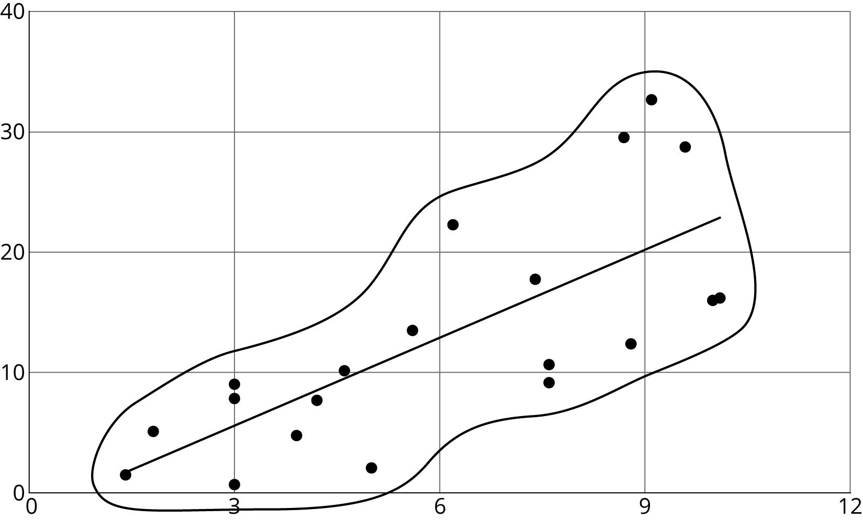

3 Good Fit Bad Fit (Optional)

Images for Launch
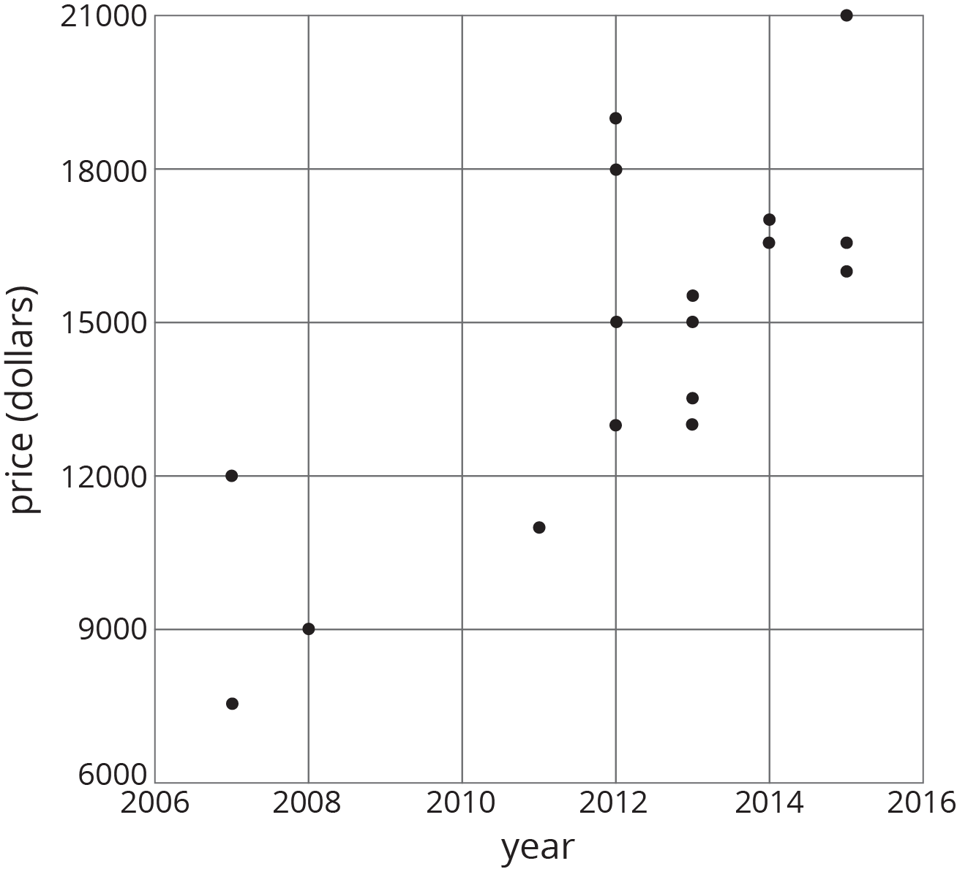

Student Task Statement
The scatter plots both show the year and price for the same 17 used cars. However, each scatter plot shows a different model for the relationship between year and price.
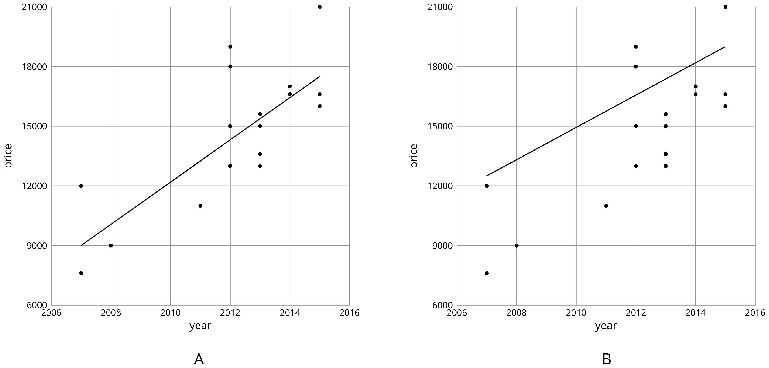
- Look at Diagram A.
  - For how many cars does the model in Diagram A make a good prediction of its price?
  - For how many cars does the model underestimate the price?
  - For how many cars does it overestimate the price?
- Look at Diagram B.
  - For how many cars does the model in Diagram B make a good prediction of its price?
  - For how many cars does the model underestimate the price?
  - For how many cars does it overestimate the price?
- For how many cars does the prediction made by the model in Diagram A differ by more than $3,000? What about the model in Diagram B?
- Which model does a better job of predicting the price of a used car from its year?

4 Practice Fitting Lines

Student Task Statement
- Is this line a good fit for the data? Explain your reasoning.
- 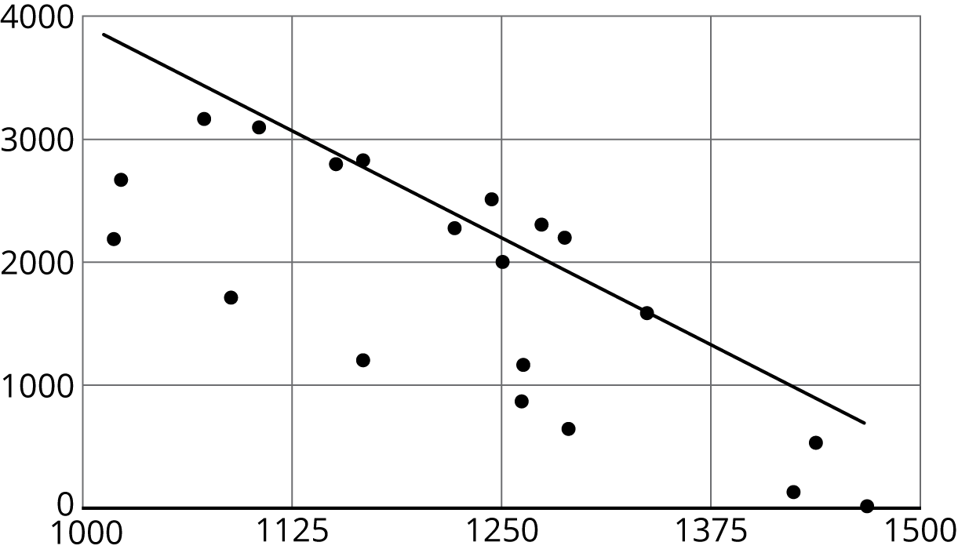
- Draw a line that fits the data better.
- 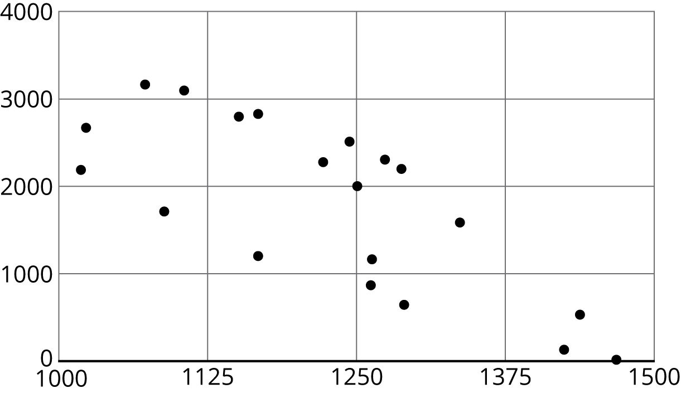
- Is this line a good fit for the data? Explain your reasoning.
- 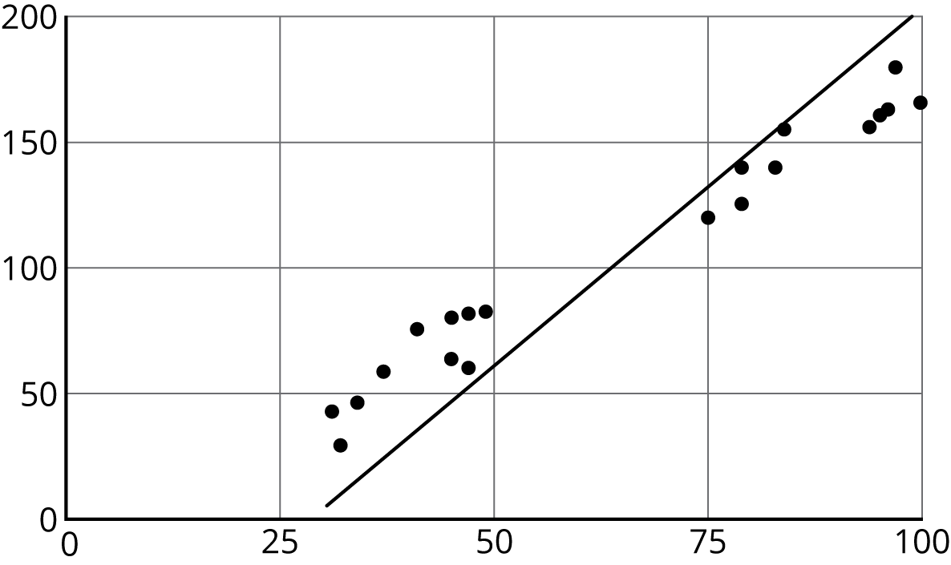
- Draw a line that fits the data better.
- 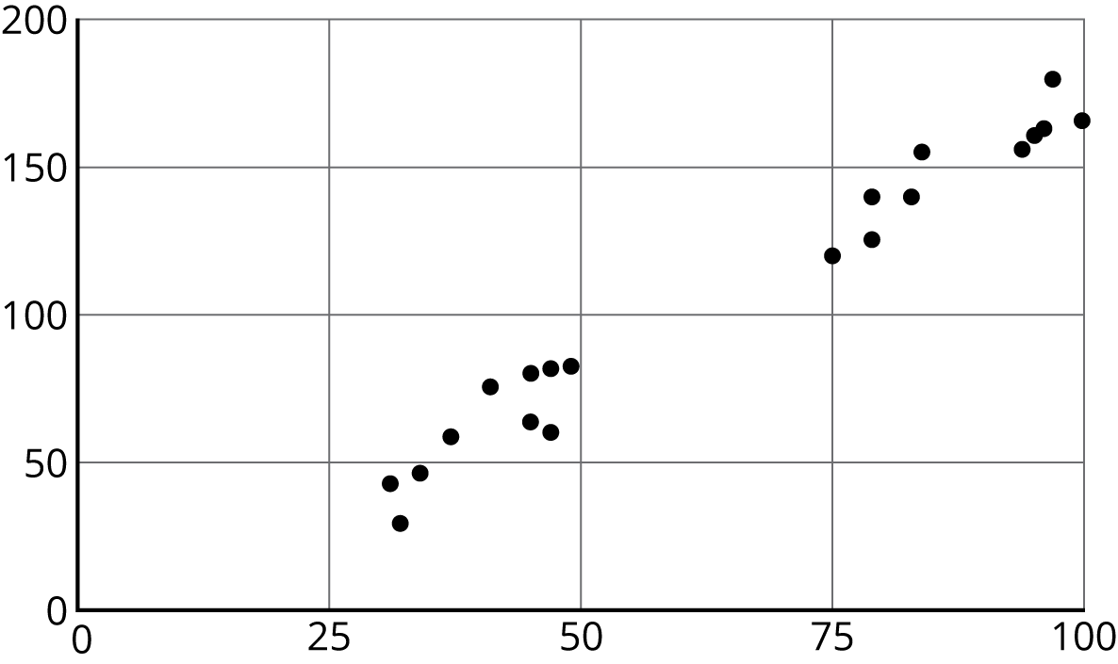

Images for Activity Synthesis
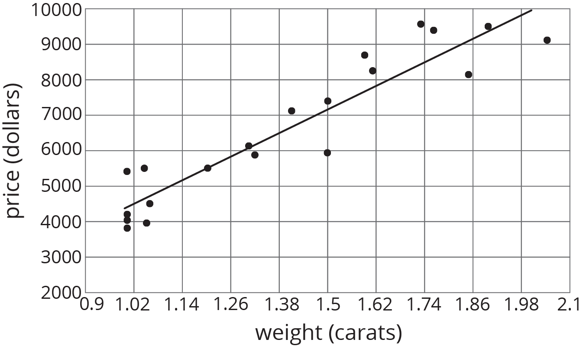
© CC BY Open Up Resources. Adaptations CC BY IM.

