Lesson 5: How Many Solutions?
- Let’s use graphs to investigate quadratic equations that have two solutions, one solution, or no solutions.

5.1: Math Talk: Four Equations
Decide whether each statement is true or false.
3 is the only solution to $x^{2}−9=0$.
A solution to $x^{2}+25=0$ is -5.
$x\left(x−7\right)=0$ has two solutions.
5 and -7 are the solutions to $\left(x−5\right)\left(x+7\right)=12$.

5.2: Solving by Graphing
Han is solving three equations by graphing.
$\left(x−5\right)\left(x−3\right)=0$
$\left(x−5\right)\left(x−3\right)=\text{-}1$
$\left(x−5\right)\left(x−3\right)=\text{-}4$
- To solve the first equation, $\left(x−5\right)\left(x−3\right)=0$, he graphed $y=\left(x−5\right)\left(x−3\right)$ and then looked for the $x$-intercepts of the graph.
  - Explain why the $x$-intercepts can be used to solve $\left(x−5\right)\left(x−3\right)=0$.
  - What are the solutions?
- To solve the second equation, Han rewrote it as $\left(x−5\right)\left(x−3\right)+1=0$. He then graphed $y=\left(x−5\right)\left(x−3\right)+1$.
- Use graphing technology to graph $y=\left(x−5\right)\left(x−3\right)+1$. Then, use the graph to solve the equation. Be prepared to explain how you use the graph for solving.
- Solve the third equation using Han’s strategy.
- Think about the strategy you used and the solutions you found.
  - Why might it be helpful to rearrange each equation to equal 0 on one side and then graph the expression on the non-zero side?
  - How many solutions does each of the three equations have?

Are you ready for more?
The equations $\left(x−3\right)\left(x−5\right)=\text{-}1$, $\left(x−3\right)\left(x−5\right)=0$, and $\left(x−3\right)\left(x−5\right)=3$ all have whole-number solutions.
- Use graphing technology to graph each of the following pairs of equations on the same coordinate plane. Analyze the graphs and explain how each pair helps to solve the related equation.
  - $y=\left(x−3\right)\left(x−5\right)$ and $y=\text{-}1$
  - $y=\left(x−3\right)\left(x−5\right)$ and $y=0$
  - $y=\left(x−3\right)\left(x−5\right)$ and $y=3$
- Use the graphs to help you find a few other equations of the form $\left(x−3\right)\left(x−5\right)=z$ that have whole-number solutions.
- Find a pattern in the values of $z$ that give whole-number solutions.
- Without solving, determine if $\left(x−5\right)\left(x−3\right)=120$ and $\left(x−5\right)\left(x−3\right)=399$ have whole-number solutions. Explain your reasoning.

5.3: Finding All the Solutions
Solve each equation. Be prepared to explain or show your reasoning.
- $x^{2}=121$
- $x^{2}−31=5$
- $\left(x−4\right)\left(x−4\right)=0$
- $\left(x+3\right)\left(x−1\right)=5$
- ${\left(x+1\right)}^{2}=\text{-}4$
- $\left(x−4\right)\left(x−1\right)=990$

5.4: Analyzing Errors in Equation Solving
- Consider $\left(x−5\right)\left(x+1\right)=7$. Priya reasons that if this is true, then either $x−5=7$ or $x+1=7$. So, the solutions to the original equation are 12 and 6.
- Do you agree? If not, where was the mistake in Priya’s reasoning?
- Consider $x^{2}−10x=0$. Diego says to solve we can just divide each side by $x$ to get $x−10=0$, so the solution is 10. Mai says, “I wrote the expression on the left in factored form, which gives $x\left(x−10\right)=0$, and ended up with two solutions: 0 and 10.”
- Do you agree with either strategy? Explain your reasoning.

Lesson 5 Summary
Quadratic equations can have two, one, or no solutions.
We can find out how many solutions a quadratic equation has and what the solutions are by rearranging the equation into the form of $\text{expression}=0$, graphing the function that the expression defines, and determining its zeros. Here are some examples.
- $x^{2}=5x$
- Let's first subtract $5x$ from each side and rewrite the equation as $x^{2}−5x=0$. We can think of solving this equation as finding the zeros of a function defined by $x^{2}−5x$.
- If the output of this function is $y$, we can graph $y=x^{2}−5x$ and identify where the graph intersects the $x$-axis, where the $y$-coordinate is 0.
- 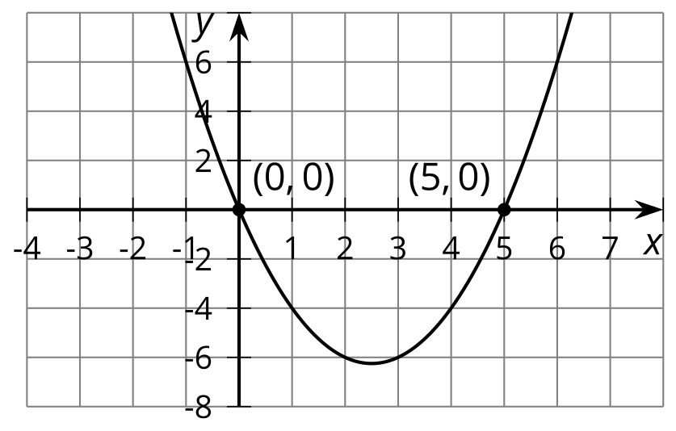
- From the graph, we can see that the $x$-intercepts are $\left(0,0\right)$ and $\left(5,0\right)$, so $x^{2}−5x$ equals 0 when $x$ is 0 and when $x$ is 5.
- The graph readily shows that there are two solutions to the equation.
Note that the equation $x^{2}=5x$ can be solved without graphing, but we need to be careful not to divide both sides by $x$. Doing so will give us $x=5$ but will show no trace of the other solution, $x=0$!
Even though dividing both sides by the same value is usually acceptable for solving equations, we avoid dividing by the same variable because it may eliminate a solution.
- $\left(x−6\right)\left(x−4\right)=\text{-}1$
- Let’s rewrite the equation as $\left(x−6\right)\left(x−4\right)+1=0$, and consider it to represent a function defined by $\left(x−6\right)\left(x−4\right)+1$ and whose output, $y$, is 0.
- Let's graph $y=\left(x−6\right)\left(x−4\right)+1$ and identify the $x$-intercepts.
- 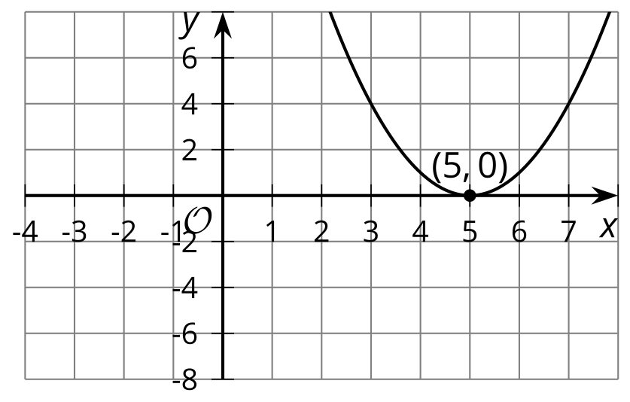
- The graph shows one $x$-intercept at $\left(5,0\right)$. This tells us that the function defined by$\left(x−6\right)\left(x−4\right)+1$ has only one zero.
- It also means that the equation $\left(x−6\right)\left(x−4\right)+1=0$ is true only when $x=5$. The value 5 is the only solution to the equation.
- $\left(x−3\right)\left(x−3\right)=\text{-}4$
- Rearranging the equation gives $\left(x−3\right)\left(x−3\right)+4=0$.
- Let’s graph $y=\left(x−3\right)\left(x−3\right)+4$ and find the $x$-intercepts.
- 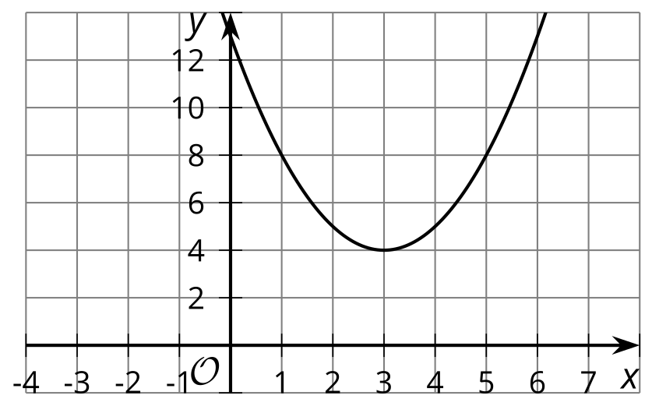
- ​​​
- The graph does not intersect the $x$-axis, so there are no $x$-intercepts.
- This means there are no $x$-values that can make the expression $\left(x−3\right)\left(x−3\right)+4$ equal 0, so the function defined by $y=\left(x−3\right)\left(x−3\right)+4$ has no zeros.
- The equation $\left(x−3\right)\left(x−3\right)=\text{-}4$ has no solutions.
- We can see that this is the case even without graphing. $\left(x−3\right)\left(x−3\right)=\text{-}4$ is ${\left(x−3\right)}^{2}=\text{-}4$. Because no number can be squared to get a negative value, the equation has no solutions.
Earlier you learned that graphing is not always reliable for showing precise solutions. This is still true here. The $x$-intercepts of a graph are not always whole-number values. While they can give us an idea of how many solutions there are and what the values may be (at least approximately), for exact solutions we still need to rely on algebraic ways of solving.
© CC BY 2019 by Illustrative Mathematics®

