Unit 6 Lesson 13: Intersection Points

1 Which One Doesn’t Belong: Lines and Curves (Warm up)

Student Task Statement
Which one doesn’t belong?

A
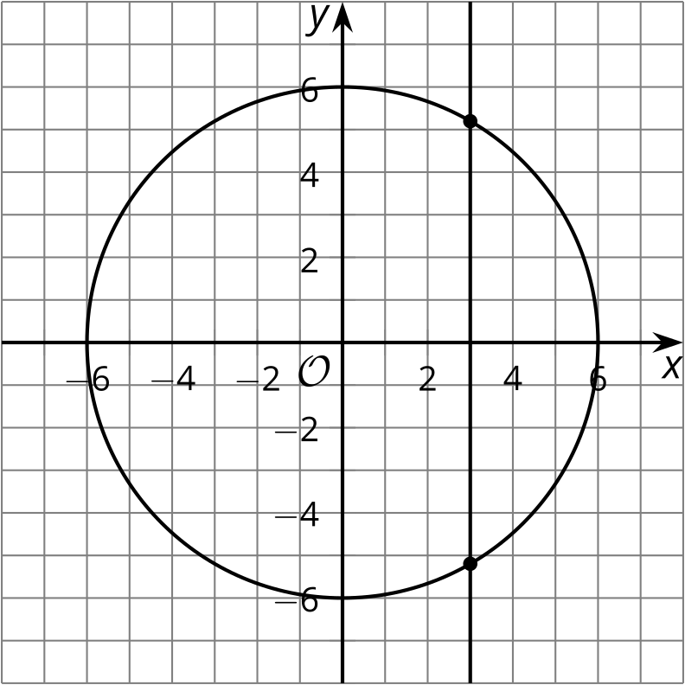

B
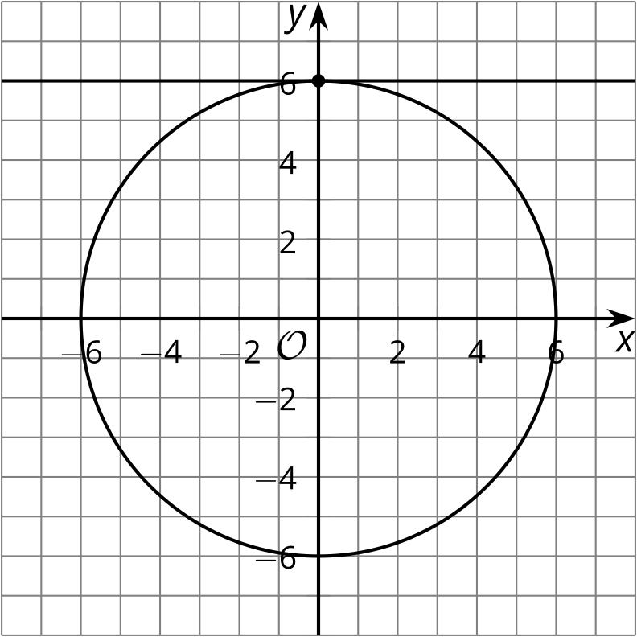

C
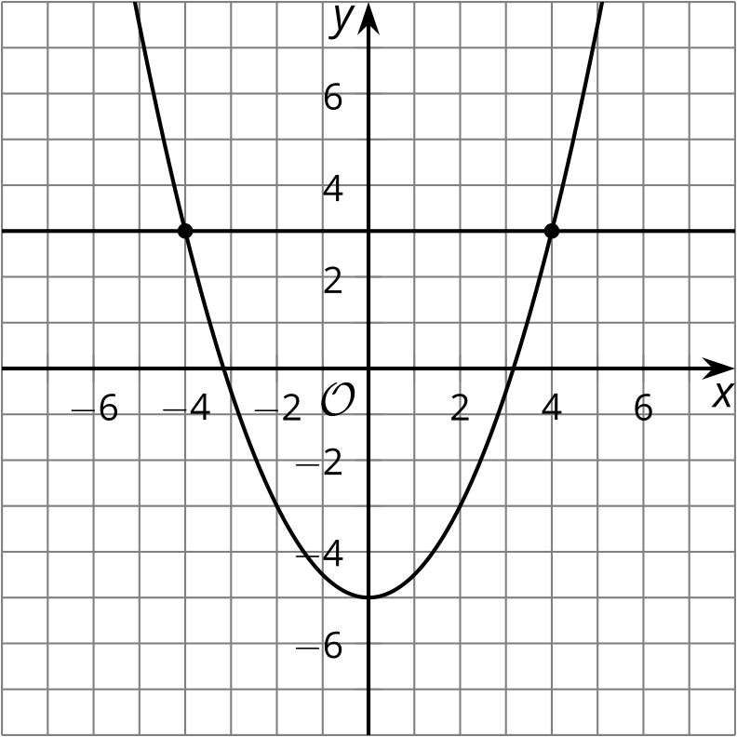

D
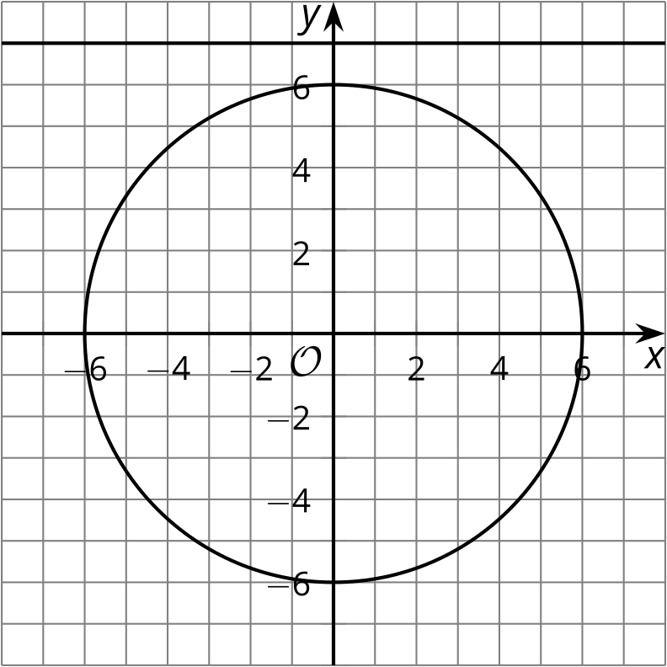

2 Circles and Lines

Student Task Statement
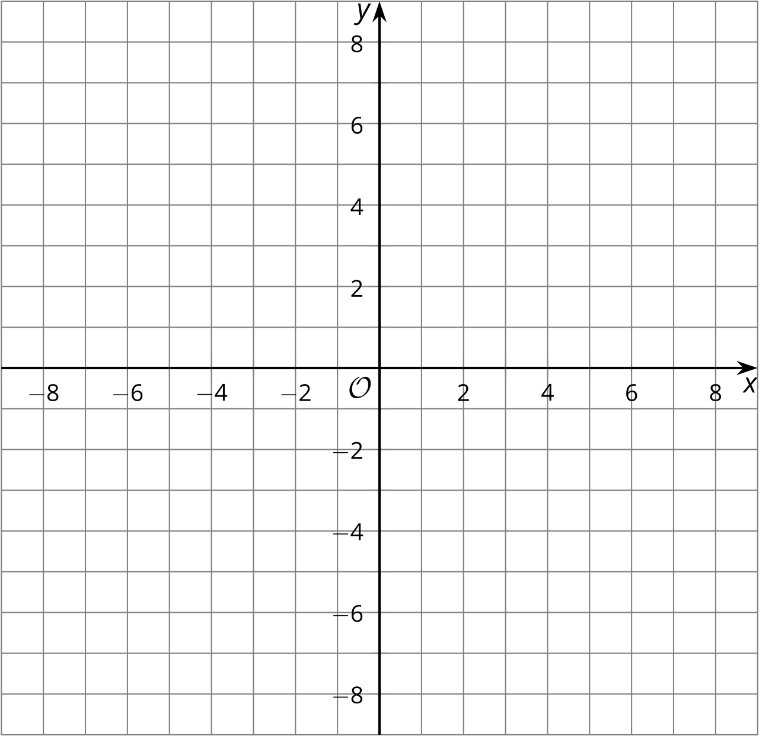
- The equation ${\left(x−3\right)}^{2}+{\left(y−2\right)}^{2}=25$ represents a circle. Graph this circle on the coordinate grid.
- Graph the line $y=6$. At what points does this line appear to intersect the circle?
- How can you verify that the 2 figures really intersect at these points? Carry out whatever procedure you decide.
- Graph the line $y=x−2$. At what points does this line appear to intersect the circle? Verify that the 2 figures really do intersect at these points.

3 Creating Lines

Student Task Statement
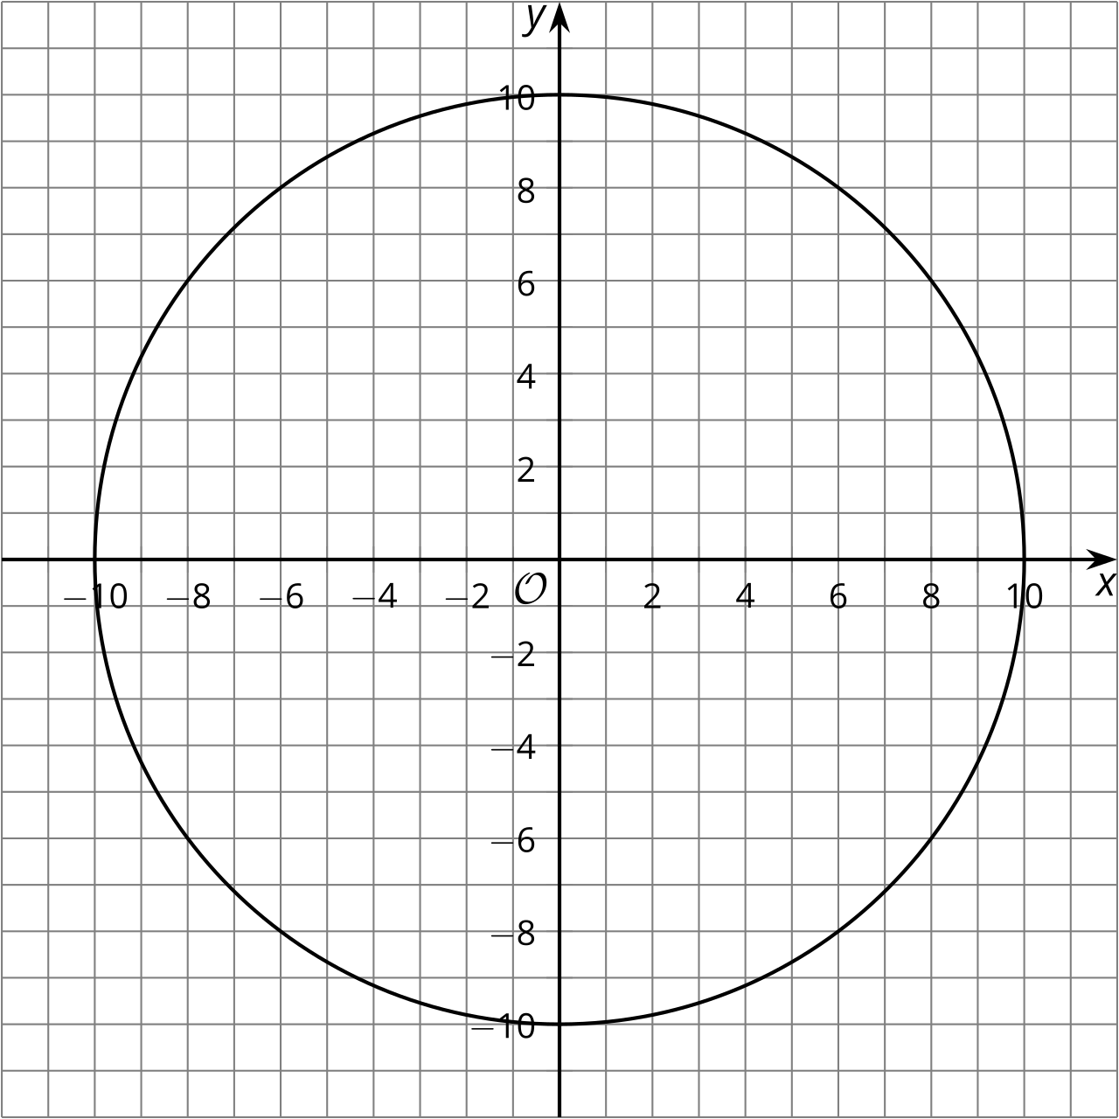
- Write an equation representing the circle in the graph.
- Graph and write equations for each line described:
  - any line parallel to the $x$-axis that intersects the circle at 2 points
  - any line perpendicular to the $x$-axis that doesn’t intersect the circle
  - the line perpendicular to $y=\text{-}\frac{1}{3}x+5$ that intersects the circle at $\left(6,8\right)$
- For the last line you graphed, find the second point where the line intersects the circle. Explain or show your reasoning.

Images for Activity Synthesis
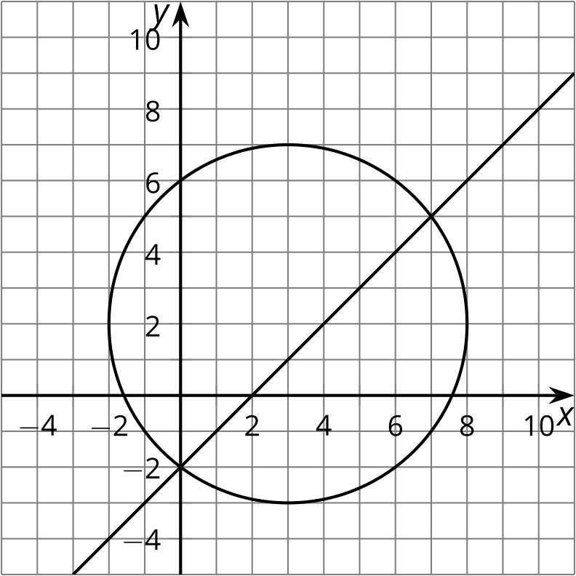
© CC BY 2019 by Illustrative Mathematics®

