Unit 6 Lesson 12: It’s All on the Line

1 Parallel and Perpendicular (Warm up)

Student Task Statement
The image shows line $n$.
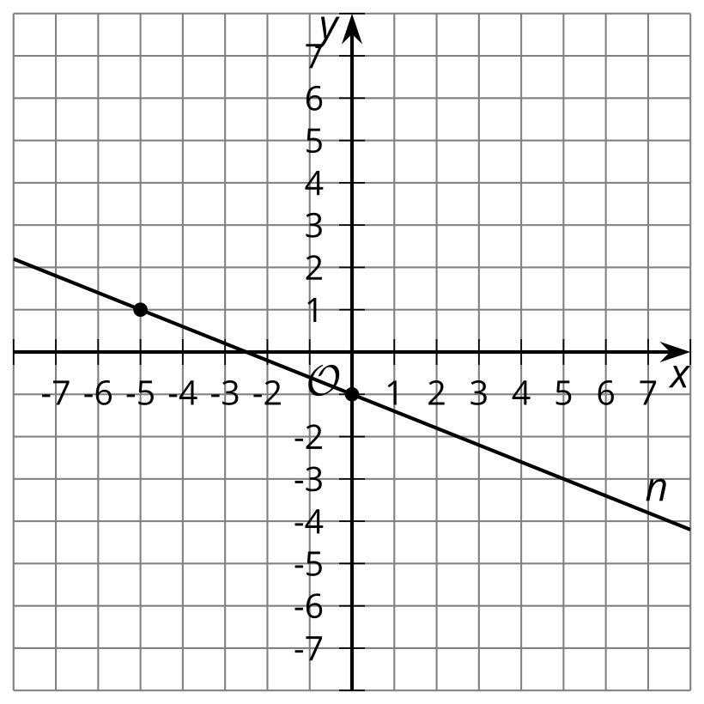
- Write an equation for the line that is perpendicular to $n$ and whose $y$-intercept is $\left(0,5\right)$. Graph this line.
- Write an equation for the line that is parallel to $n$ and that passes through the point $\left(3,1\right)$. Graph this line.

2 Info Gap: Lines

Student Task Statement
Your teacher will give you either a problem card or a data card. Do not show or read your card to your partner.
If your teacher gives you the data card:
- Silently read the information on your card.
- Ask your partner, “What specific information do you need?” and wait for your partner to ask for information. Only give information that is on your card. (Do not figure out anything for your partner!)
- Before telling your partner the information, ask, “Why do you need to know (that piece of information)?”
- Read the problem card, and solve the problem independently.
- Share the data card, and discuss your reasoning.
If your teacher gives you the problem card:
- Silently read your card and think about what information you need to answer the question.
- Ask your partner for the specific information that you need.
- Explain to your partner how you are using the information to solve the problem.
- When you have enough information, share the problem card with your partner, and solve the problem independently.
- Read the data card, and discuss your reasoning.
Pause here so your teacher can review your work. Ask your teacher for a new set of cards and repeat the activity, trading roles with your partner.
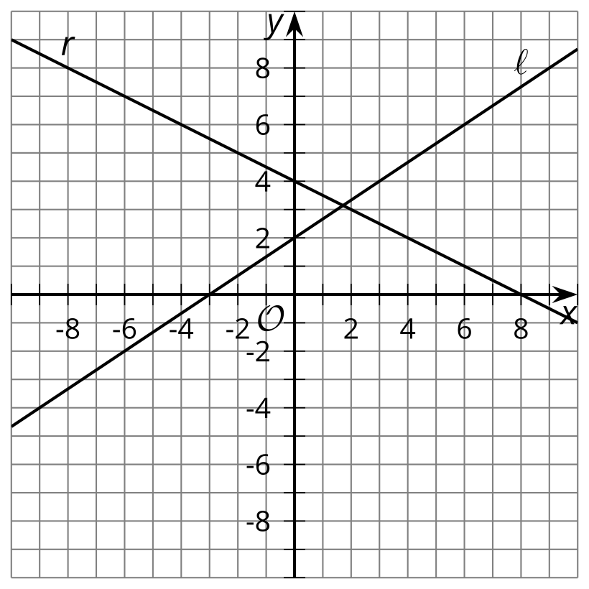

3 Three Lines

Student Task Statement
- Line $ℓ$ is represented by the equation $y=\frac{2}{3}x+3$. Write an equation of the line perpendicular to $ℓ$, passing through $\left(\text{-}6,4\right)$. Call this line $p$.
- Write an equation of the line perpendicular to $p$, passing through $\left(3,\text{-}2\right)$. Call this line $n$.
- What do you notice about lines $ℓ$ and $n$? Does this always happen? Show or explain your answer.

Activity Synthesis
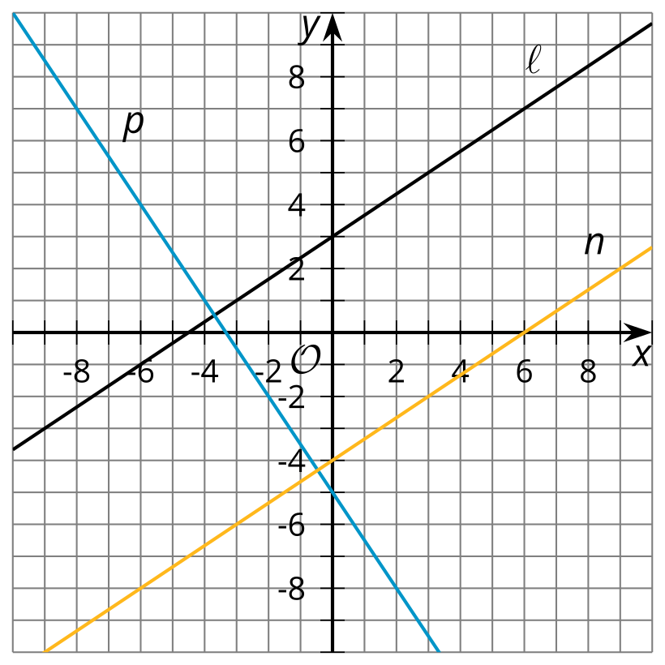

Images for Activity Synthesis
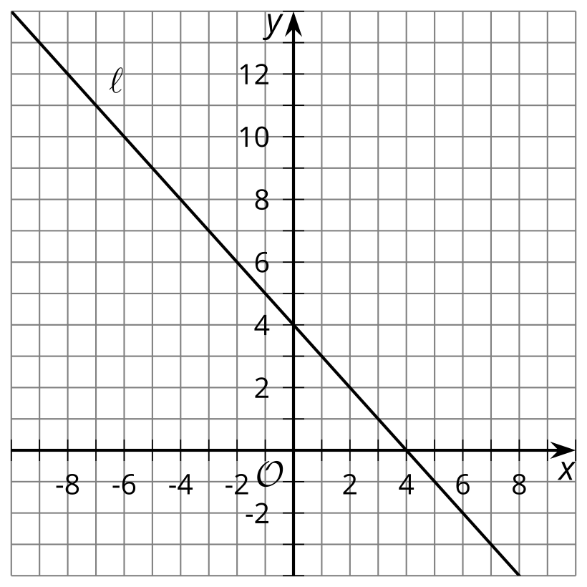
© CC BY 2019 by Illustrative Mathematics®

