Unit 4 Lesson 12: Balanced Moves

1 Matching Hangers (Warm up)

Student Task Statement
Figures A, B, C, and D show the result of simplifying the hanger in Figure A by removing equal weights from each side.
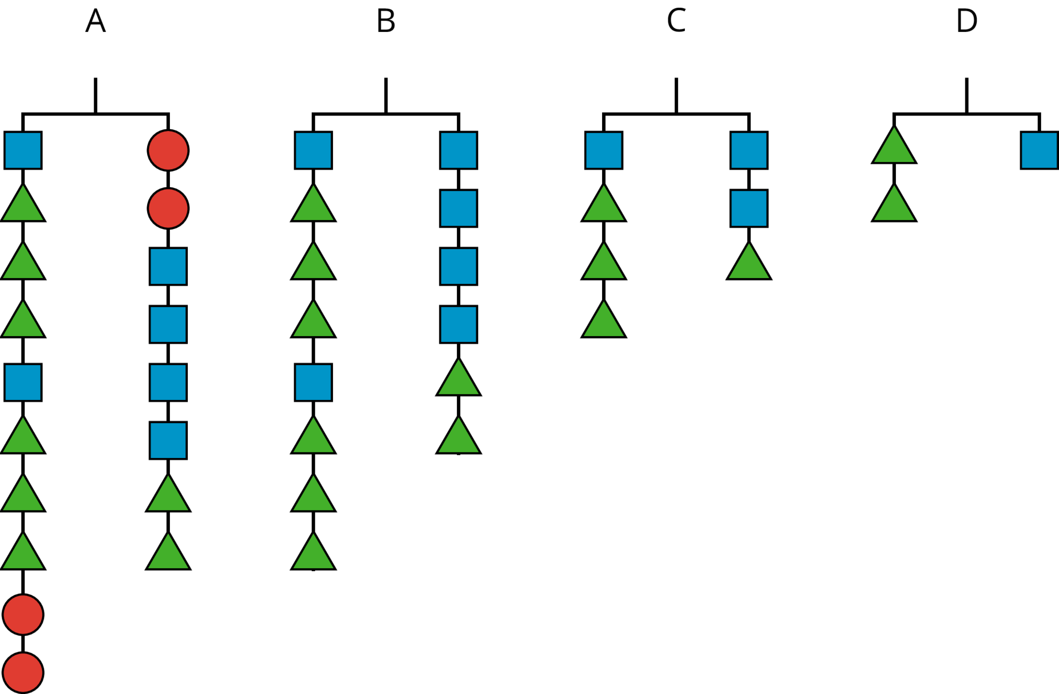
Here are some equations. Each equation represents one of the hanger diagrams.
$2\left(x+3y\right)=4x+2y$
$2y=x$
$2\left(x+3y\right)+2z=2z+4x+2y$
$x+3y=2x+y$
- Write the equation that goes with each figure:
- A:
- B:
- C:
- D:
- Each variable ($x$, $y$, and $z$) represents the weight of one shape. Which goes with which?
- Explain what was done to each equation to create the next equation. If you get stuck, think about how the hangers changed.

2 Matching Equation Moves

Student Task Statement
Your teacher will give you some cards. Each of the cards 1 through 6 show two equations. Each of the cards A through E describe a move that turns one equation into another.
- Match each number card with a letter card.
- One of the letter cards will not have a match. For this card, write two equations showing the described move.

3 Keeping Equality

Student Task Statement
- Noah and Lin both solved the equation $14a=2\left(a−3\right)$.
- Do you agree with either of them? Why?
- Noah's solution:
- $\begin{matrix}14a & =2\left(a−3\right) \\ 14a & =2a−6 \\ 12a & =\text{-}6 \\ a & =\text{-}\frac{1}{2}\end{matrix}$
- Lin's solution:
- $\begin{matrix}14a & =2\left(a−3\right) \\ 7a & =a−3 \\ 6a & =\text{-}3 \\ a & =\text{-}\frac{1}{2}\end{matrix}$
- Elena is asked to solve $15−10x=5\left(x+9\right)$. What do you recommend she does to each side first?
- Diego is asked to solve $3x−8=4\left(x+5\right)$. What do you recommend he does to each side first?
© CC BY Open Up Resources. Adaptations CC BY IM.

