Lesson 5 Practice Problems
- Select all segments that could represent a corresponding height if the side $m$ is the base.
- 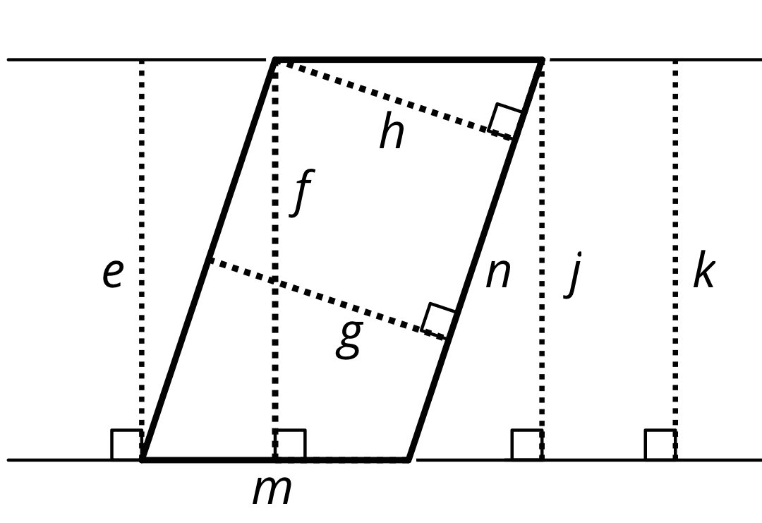
  - e
  - f
  - g
  - h
  - j
  - k
  - n
- Find the area of each parallelogram.
- 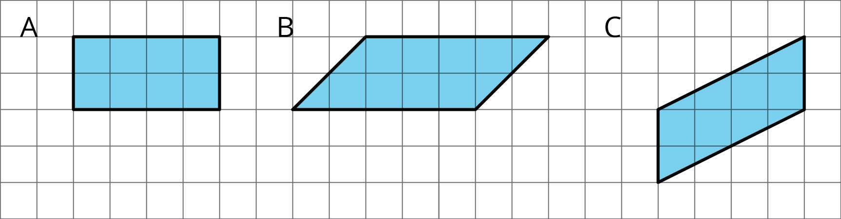
- Find the area of each parallelogram.
- 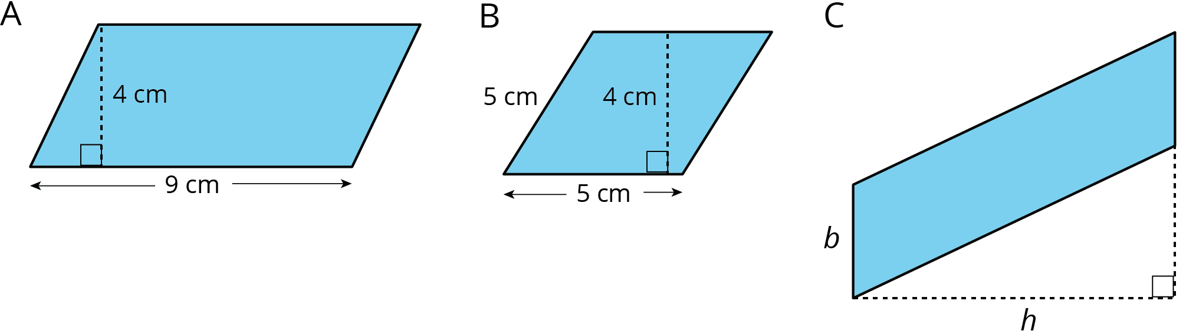

- The Dockland Building in Hamburg, Germany is shaped like a parallelogram.
- 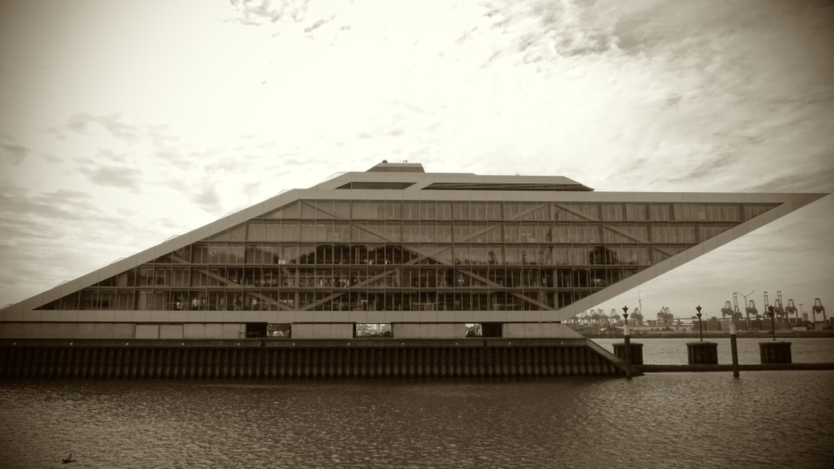
- If the length of the building is 86 meters and its height is 55 meters, what is the area of this face of the building?

- Do you agree with each of these statements? Explain your reasoning.
  - A parallelogram has six sides.
  - Opposite sides of a parallelogram are parallel.
  - A parallelogram can have one pair or two pairs of parallel sides.
  - All sides of a parallelogram have the same length.
  - All angles of a parallelogram have the same measure.
- (From Unit 1, Lesson 4.)
- A square with an area of 1 square meter is decomposed into 9 identical small squares. Each small square is decomposed into two identical triangles.
  - What is the area, in square meters, of 6 triangles? If you get stuck, consider drawing a diagram.
  - How many triangles are needed to compose a region that is $1\frac{1}{2}$ square meters?
- (From Unit 1, Lesson 2.)
- Find the area of the shaded region. All measurements are in centimeters. Show your reasoning.
- 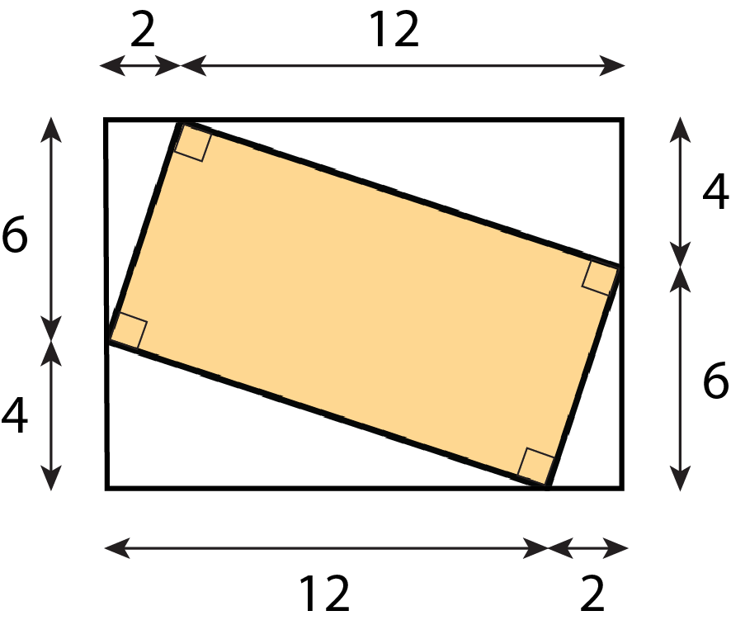
- (From Unit 1, Lesson 3.)
© CC BY Open Up Resources. Adaptations CC BY IM.

