Lesson 12: Infinite Decimal Expansions
Let’s think about infinite decimals.

12.1: Searching for Digits
The first 3 digits after the decimal for the decimal expansion of $\frac{3}{7}$ have been calculated. Find the next 4 digits.
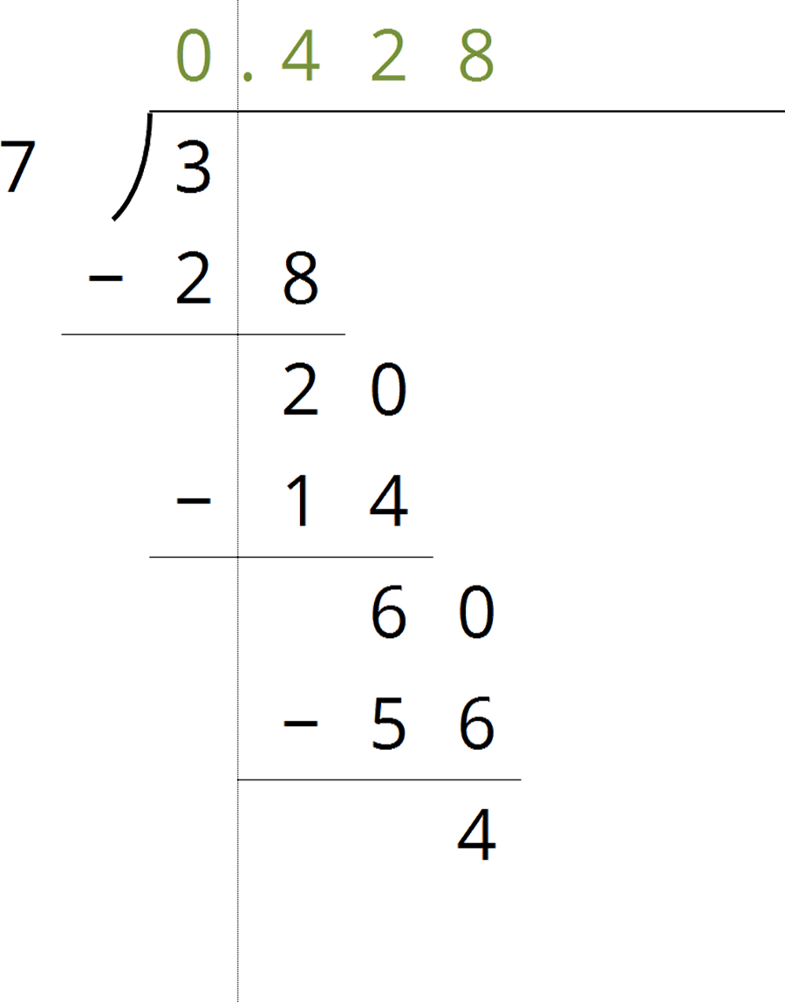

12.2: Some Numbers Are Rational
Your teacher will give your group a set of cards. Each card will have a calculations side and an explanation side.
- The cards show Noah’s work calculating the fraction representation of $0.4\overset{¯}{85}$. Arrange these in order to see how he figured out that $0.4\overset{¯}{85}=\frac{481}{990}$ without needing a calculator.
- Use Noah’s method to calculate the fraction representation of:
  - $0.1\overset{¯}{86}$
  - $0.7\overset{¯}{88}$

Are you ready for more?
Use this technique to find fractional representations for $0.\overset{¯}{3}$ and $0.\overset{¯}{9}$.

12.3: Some Numbers Are Not Rational

  - Why is $\sqrt{2}$ between 1 and 2 on the number line?
  - Why is $\sqrt{2}$ between 1.4 and 1.5 on the number line?
  - How can you figure out an approximation for $\sqrt{2}$ accurate to 3 decimal places?
  - Label all of the tick marks. Plot $\sqrt{2}$ on all three number lines. Make sure to add arrows from the second to the third number lines.
  - 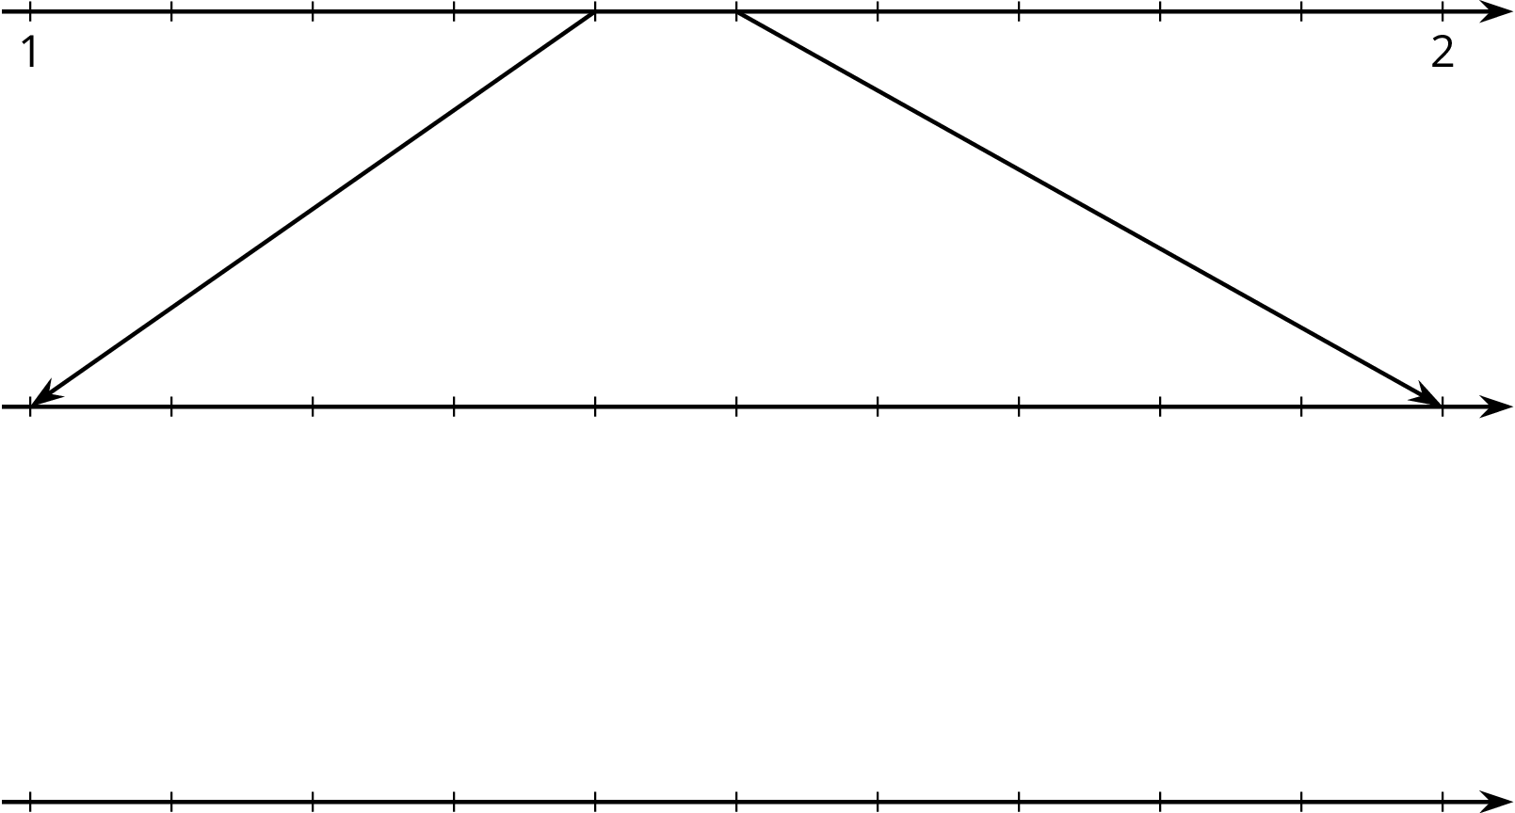

  - Elena notices a beaker in science class says it has a diameter of 9 cm and measures its circumference to be 28.3 cm. What value do you get for $π$ using these values and the equation for circumference, $C=2πr$?
  - Diego learned that one of the space shuttle fuel tanks had a diameter of 840 cm and a circumference of 2,639 cm. What value do you get for $π$ using these values and the equation for circumference, $C=2πr$?
  - Label all of the tick marks on the number lines. Use a calculator to get a very accurate approximation of $π$ and plot that number on all three number lines.
  - 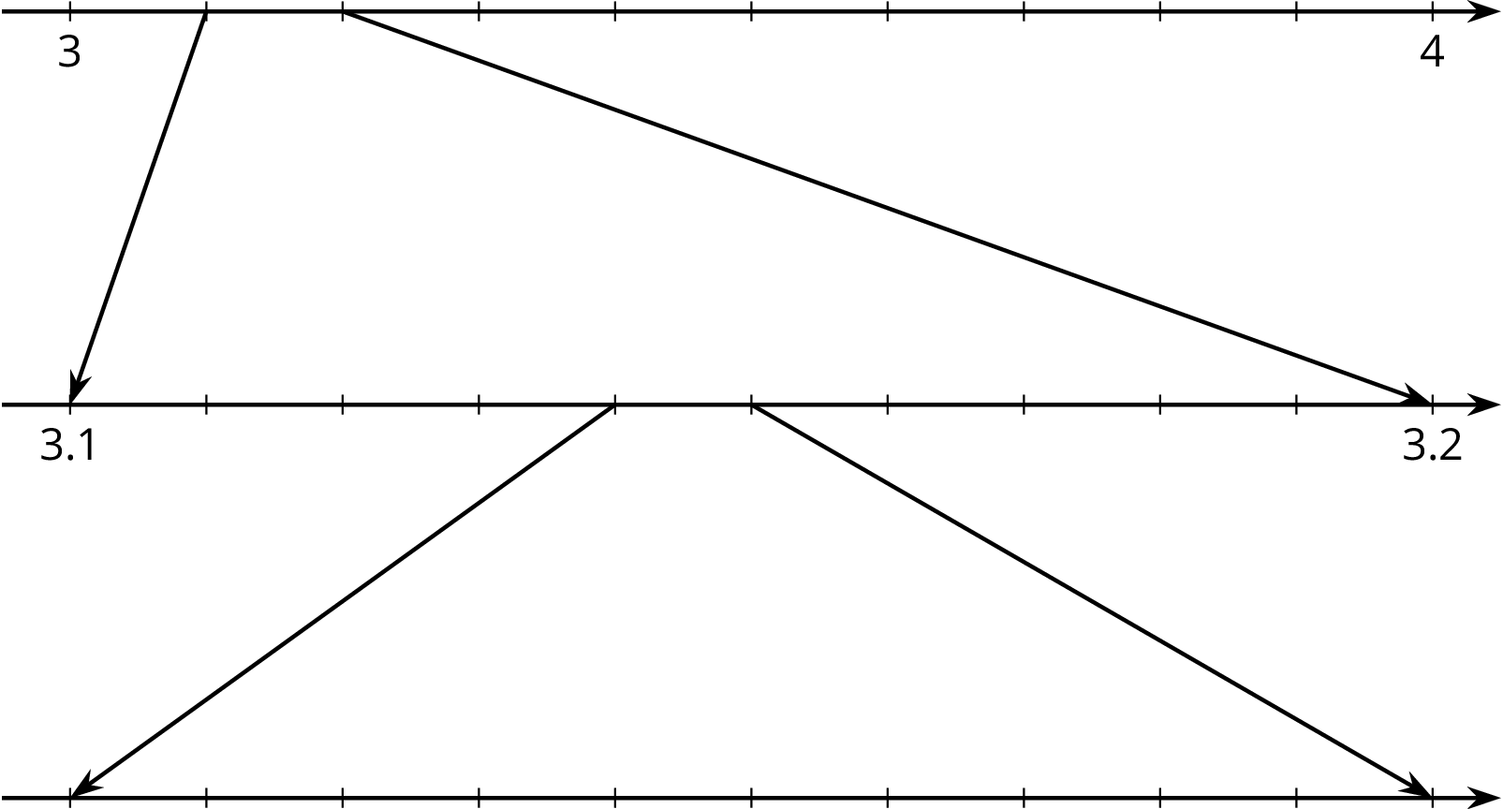

  - How can you explain the differences between these calculations of $π$?

Lesson 12 Summary
Not every number is rational. Earlier we tried to find a fraction whose square is equal to 2. That turns out to be impossible, although we can get pretty close (try squaring $\frac{7}{5}$). Since there is no fraction equal to $\sqrt{2}$ it is not a rational number, which is why we call it an irrational number. Another well-known irrational number is $π$.
Any number, rational or irrational, has a decimal expansion. Sometimes it goes on forever. For example, the rational number $\frac{2}{11}$ has the decimal expansion $0.181818...$ with the 18s repeating forever. Every rational number has a decimal expansion that either stops at some point or ends up in a repeating pattern like $\frac{2}{11}$. Irrational numbers also have infinite decimal expansions, but they don't end up in a repeating pattern. From the decimal point of view we can see that rational numbers are pretty special. Most numbers are irrational, even though the numbers we use on a daily basis are more frequently rational.
© CC BY Open Up Resources. Adaptations CC BY IM.

