Unit 6 Lesson 14: Coordinate Proof

1 Which One Doesn’t Belong: Coordinate Quadrilaterals (Warm up)

Student Task Statement
Which one doesn’t belong?

A
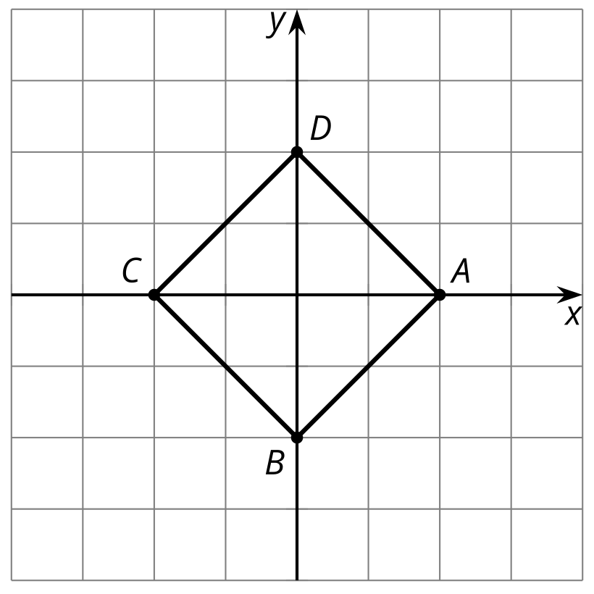

B
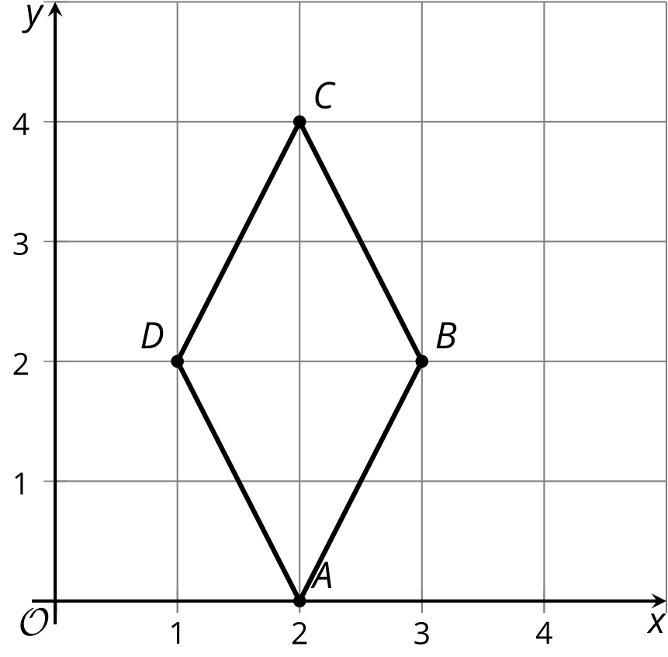

C
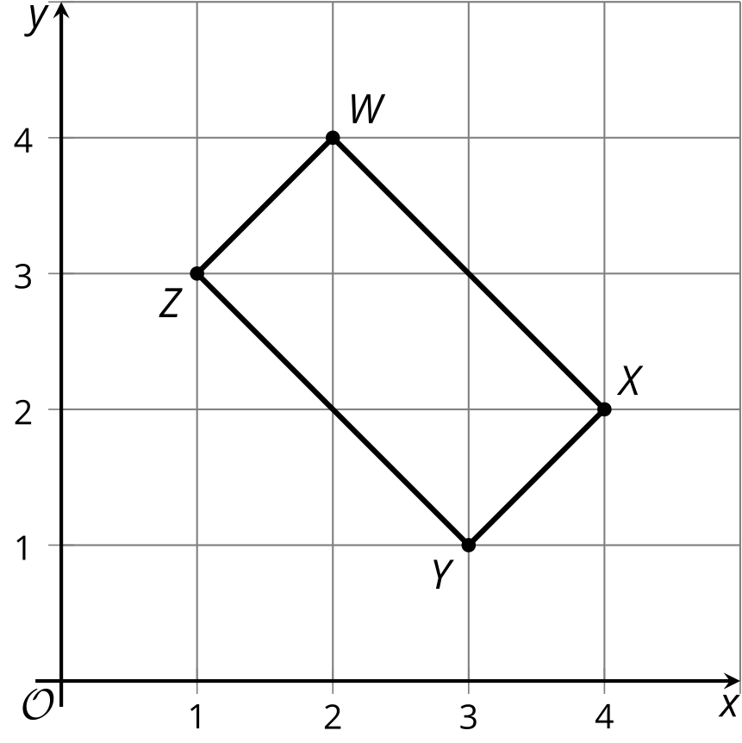

D
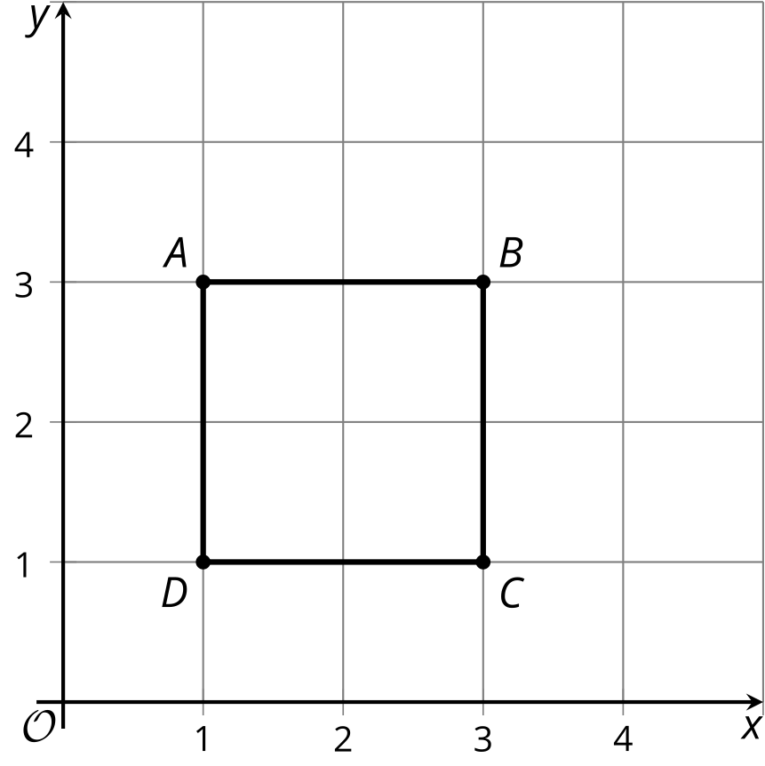

2 Name This Quadrilateral

Student Task Statement
A quadrilateral has vertices $\left(0,0\right),\left(4,3\right),\left(13,\text{-}9\right),$ and $\left(9,\text{-}12\right)$.
- What type of quadrilateral is it? Explain or show your reasoning.
- Find the perimeter of this quadrilateral.
- Find the area of this quadrilateral.

3 Circular Logic

Student Task Statement
The image shows a circle with several points plotted on the circle.
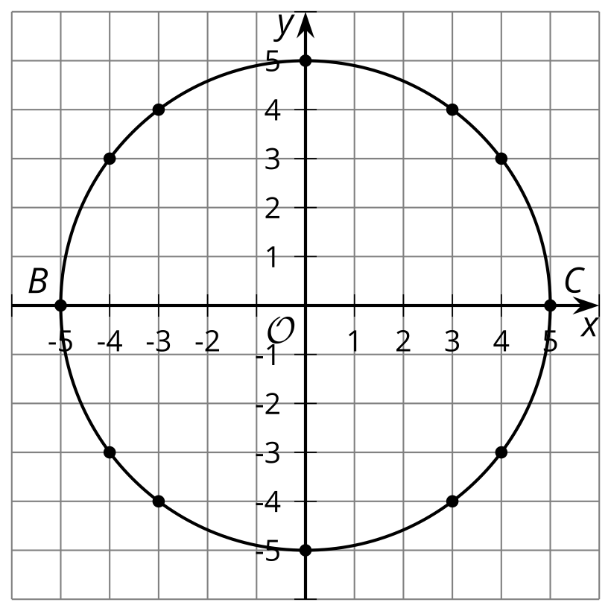
- What kind of segment is $BC$ in reference to the circle?
- Choose one of the plotted points on the circle and call it $D$. Each student in the group should choose a different point. Draw segments $BD$ and $DC$. What does the measure of angle $BDC$ appear to be?
- Calculate the slopes of segments $BD$ and $DC$. What do your results tell you?
- Compare your results to those of others in your group. What did they find?
- Based on your group’s results, write a conjecture that captures what you are seeing.

Images for Activity Synthesis

A

B

C

D
© CC BY 2019 by Illustrative Mathematics®

