Lesson 1: Identifiquemos y clasifiquemos figuras

Standards Alignments
Building On | 1.G.A.1
Addressing | 2.G.A.1
Building Towards | 2.G.A.1

Teacher-facing Learning Goals
- Recognize triangles, quadrilaterals, pentagons, and hexagons based on the number of sides and vertices (corners).

Student-facing Learning Goals
- Clasifiquemos y nombremos figuras según sus lados y esquinas.

Lesson Purpose
The purpose of this lesson is for students to recognize and name shapes based on the number of sides and vertices (corners). Students name triangles, quadrilaterals, pentagons, and hexagons.
In previous grades, students identified, described, and compared two-dimensional and three-dimensional shapes. Students learned that shapes have defining attributes and drew shapes that possessed these attributes.
In this lesson, students learn that they can identify a shape by the number of sides and corners it has. Students sort shapes into examples and non-examples of triangles, quadrilaterals, pentagons, and hexagons. They define triangle, quadrilateral, pentagon, and hexagon based on the number of sides and corners and use these terms to name shapes. Throughout the lesson, students have opportunities to think about how to clearly describe the attributes of shapes to others and consider the precision of their language (MP6). It is not necessary for students to use the term vertices, so they are referred to as “corners” in this unit.

Access for:

Students with Disabilities
- Representation (Activity 2)

Instructional Routines
Card Sort (Activity 1), MLR2 Collect and Display (Activity 1), Notice and Wonder (Warm-up)

Materials to Gather
- Materials from a previous activity: Activity 2, Activity 3

Materials to Copy
- Shape Cards Grade 2, Spanish (groups of 2): Activity 1

Lesson Timeline
Warm-up | 10 min
Activity 1 | 15 min
Activity 2 | 10 min
Activity 3 | 10 min
Lesson Synthesis | 10 min
Cool-down | 5 min

Teacher Reflection Question
In grade 1, students learned to distinguish between attributes that define a shape and those that do not. How does this understanding help students classify shapes as quadrilaterals, pentagons, and hexagons?

Cool-down
(to be completed at the end of the lesson) 5min
Encuentra las figuras

Standards Alignments
Addressing | 2.G.A.1

Student-facing Task Statement
- Escribe una x dentro de cada pentágono.
- Escribe una o dentro de cada hexágono.
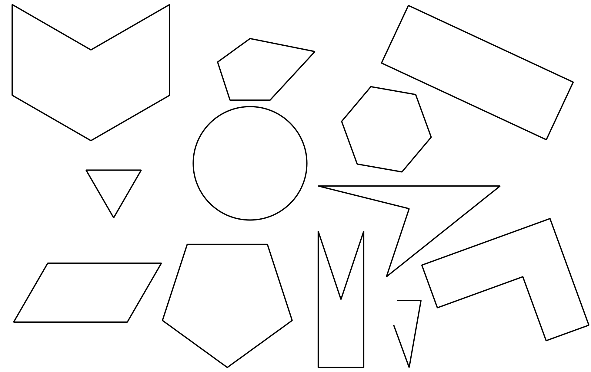

Student Responses
