Lesson 4: Half as Much Again
Let’s use fractions to describe increases and decreases.

4.1: Notice and Wonder: Tape Diagrams
What do you notice? What do you wonder?
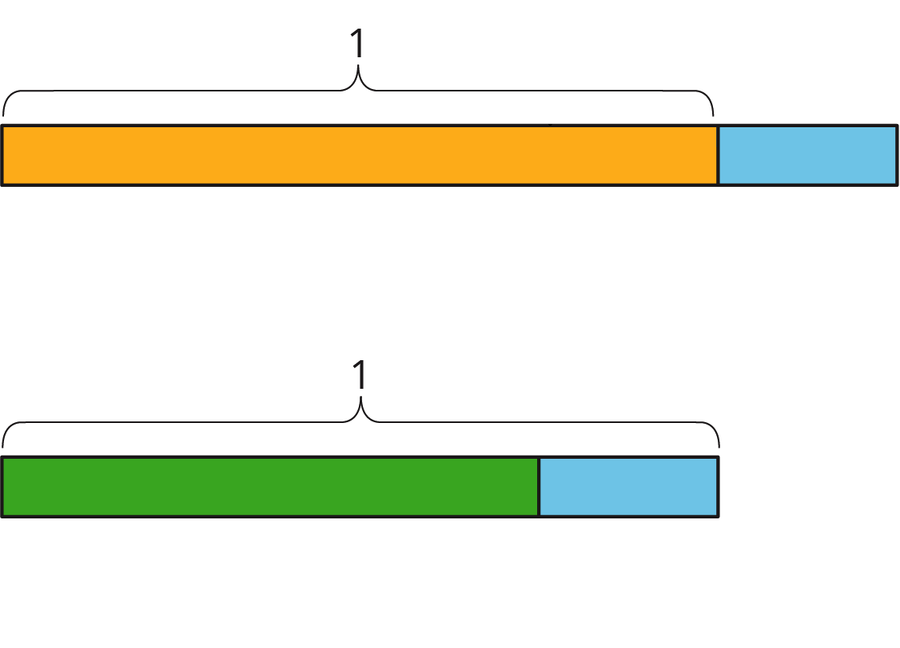

4.2: Walking Half as Much Again
- Complete the table to show the total distance walked in each case.
  - Jada’s pet turtle walked 10 feet, and then half that length again.
  - Jada’s baby brother walked 3 feet, and then half that length again.
  - Jada’s hamster walked 4.5 feet, and then half that length again.
  - Jada’s robot walked 1 foot, and then half that length again.
  - A person walked $x$ feet and then half that length again.
- initial distance | - total distance
- 10
- 3
- 4.5
- 1
- $x$
- Explain how you computed the total distance in each case.
- Two students each wrote an equation to represent the relationship between the initial distance walked ($x$) and the total distance walked ($y$).
  - Mai wrote $y=x+\frac{1}{2}x$.
  - Kiran wrote $y=\frac{3}{2}x$.
- Do you agree with either of them? Explain your reasoning.

Are you ready for more?
Zeno jumped 8 meters. Then he jumped half as far again (4 meters). Then he jumped half as far again (2 meters). So after 3 jumps, he was $8+4+2=14$ meters from his starting place.
- Zeno kept jumping half as far again. How far would he be after 4 jumps? 5 jumps? 6 jumps?
- Before he started jumping, Zeno put a mark on the floor that was exactly 16 meters from his starting place. How close can Zeno get to the mark if he keeps jumping half as far again?
- If you enjoyed thinking about this problem, consider researching Zeno's Paradox.

4.3: More and Less
- Match each situation with a diagram. A diagram may not have a match.
- 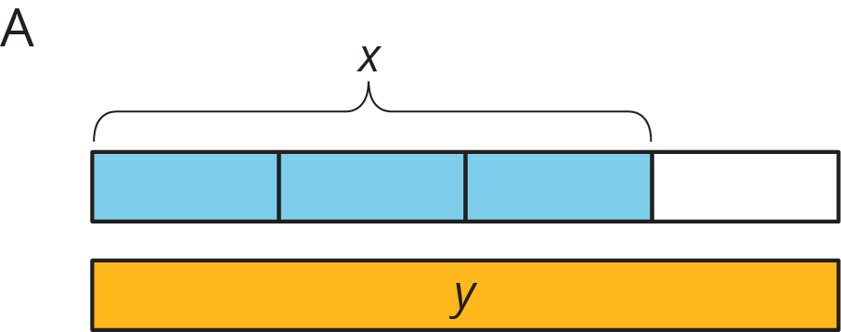
- 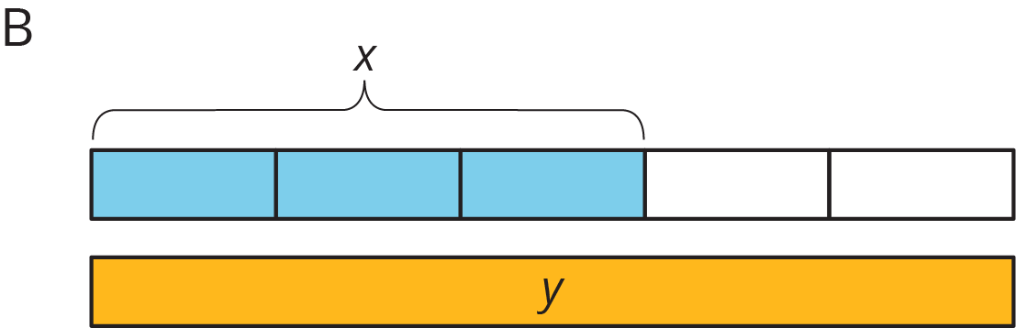
- 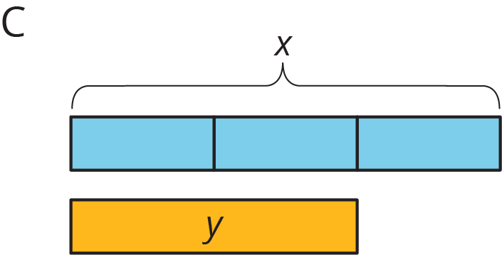
- 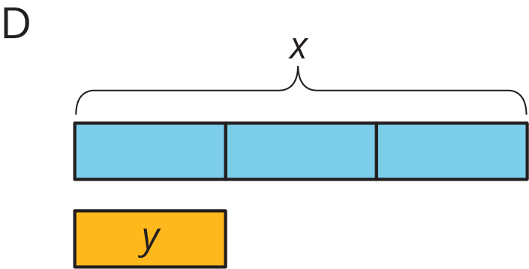
  - Han ate $x$ ounces of blueberries. Mai ate $\frac{1}{3}$ less than that.
  - Mai biked $x$ miles. Han biked $\frac{2}{3}$ more than that.
  - Han bought $x$ pounds of apples. Mai bought $\frac{2}{3}$ of that.
- For each diagram, write an equation that represents the relationship between $x$ and $y$.
  - Diagram A:
  - Diagram B:
  - Diagram C:
  - Diagram D:
- Write a story for one of the diagrams that doesn't have a match.

4.4: Card Sort: Representations of Proportional Relationships
Your teacher will give you a set of cards that have proportional relationships represented three different ways: as descriptions, equations, and tables. Mix up the cards and place them all face-up.
- Take turns with a partner to match a description with an equation and a table.
  - For each match you find, explain to your partner how you know it’s a match.
  - For each match your partner finds, listen carefully to their explanation, and if you disagree, explain your thinking.
- When you agree on all of the matches, check your answers with the answer key. If there are any errors, discuss why and revise your matches.

Lesson 4 Summary
Using the distributive property provides a shortcut for calculating the final amount in situations that involve adding or subtracting a fraction of the original amount.
For example, one day Clare runs 4 miles. The next day, she plans to run that same distance plus half as much again. How far does she plan to run the next day?
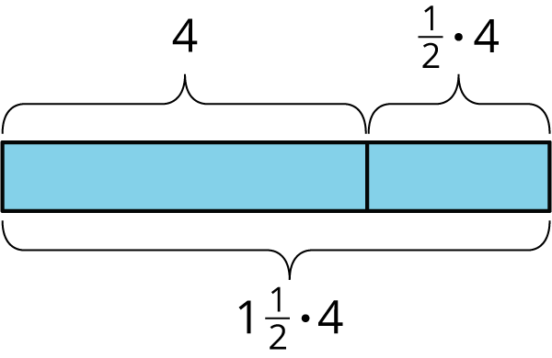
Tomorrow she will run 4 miles plus $\frac{1}{2}$ of 4 miles. We can use the distributive property to find this in one step: $1⋅4+\frac{1}{2}⋅4=\left(1+\frac{1}{2}\right)⋅4$
Clare plans to run $1\frac{1}{2}⋅4$, or 6 miles.
This works when we decrease by a fraction, too. If Tyler spent $x$ dollars on a new shirt, and Noah spent $\frac{1}{3}$ less than Tyler, then Noah spent $\frac{2}{3}x$ dollars since $x−\frac{1}{3}x=\frac{2}{3}x$.
© CC BY Open Up Resources. Adaptations CC BY IM.

