Lesson 8 Practice Problems
- In each pair, some of the angles of two triangles in degrees are given. Use the information to decide if the triangles are similar or not. Explain how you know.
  - Triangle A: 53, 71, ___; Triangle B: 53, 71, ___
  - Triangle C: 90, 37, ___; Triangle D: 90, 53, ___
  - Triangle E: 63, 45, ____; Triangle F: 14, 71, ____
  - Triangle G: 121, ___, ___; Triangle H: 70, ___, ___

  - Draw two equilateral triangles that are not congruent.
  - Measure the side lengths and angles of your triangles. Are the two triangles similar?
  - Do you think two equilateral triangles will be similar always, sometimes, or never? Explain your reasoning.
- In the figure, line $BC$ is parallel to line $DE$.
- 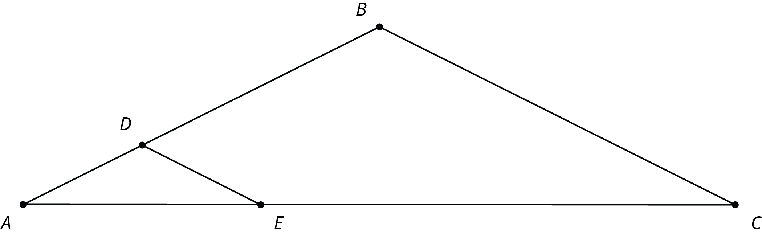
- Explain why $△ABC$ is similar to $△ADE$.
- The quadrilateral $PQRS$ in the diagram is a parallelogram. Let $P^{′}Q^{′}R^{′}S^{′}$ be the image of $PQRS$ after applying a dilation centered at a point O (not shown) with scale factor 3.
- 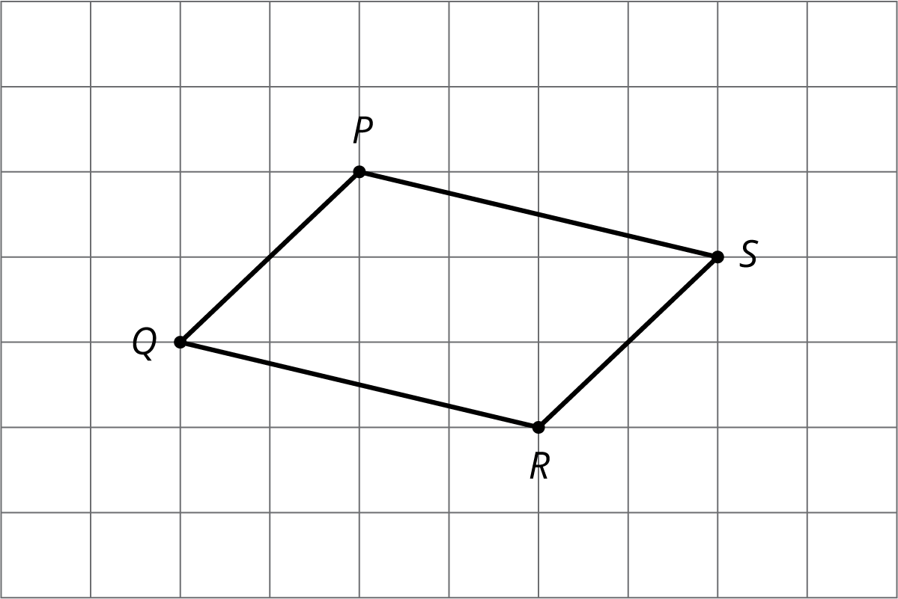
- Which of the following is true?
  - $P^{′}Q^{′}=PQ$
  - $P^{′}Q^{′}=3PQ$
  - $PQ=3P^{′}Q^{′}$
  - Cannot be determined from the information given
- (From Unit 2, Lesson 4.)
- Describe a sequence of transformations for which Quadrilateral P is the image of Quadrilateral Q.
- 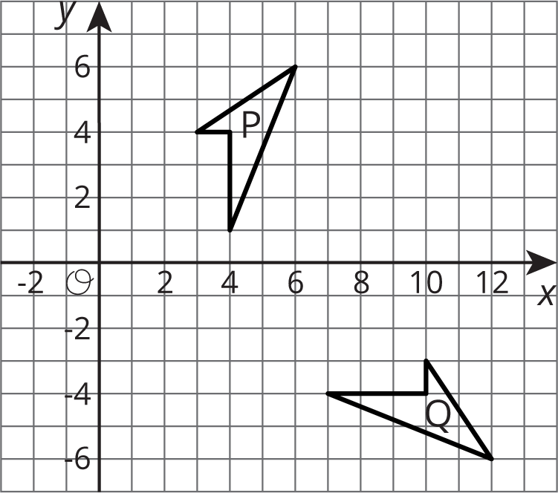
- (From Unit 1, Lesson 6.)
© CC BY Open Up Resources. Adaptations CC BY IM.

