Unit 8 Lesson 8: Conditional Probability

1 She Made Some Tarts (Warm up)

Images for Launch
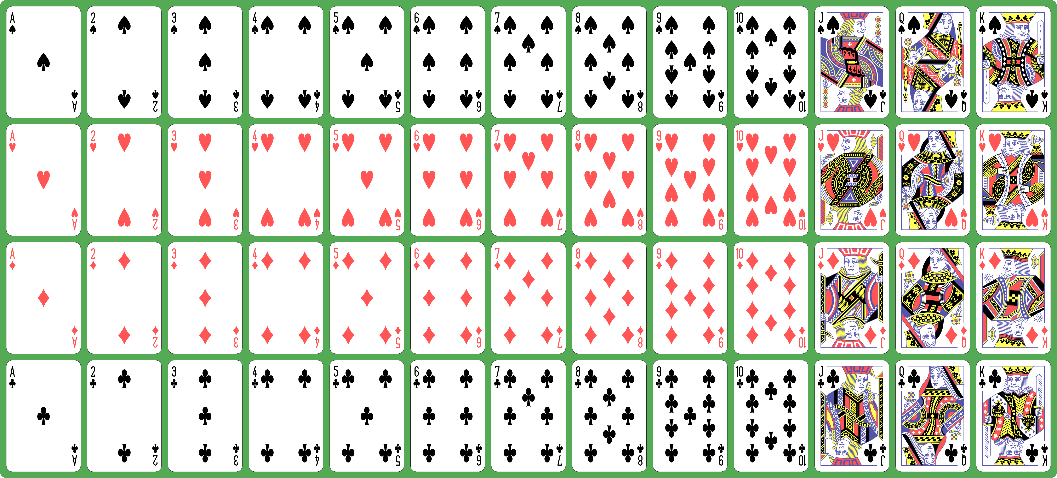

Student Task Statement
- Noah will select 1 card at random from a standard deck of cards. Find the probabilities. Explain or show your reasoning.
- 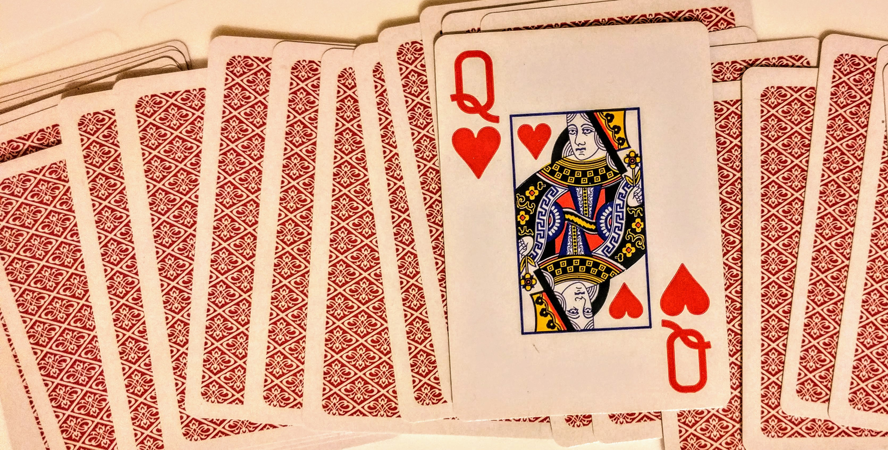
  - $P\left(\text{the card is a queen}\right)$
  - $P\left(\text{the card is a heart}\right)$
  - $P\left(\text{the card is a queen and heart}\right)$
- Elena pulls out only the hearts from the deck and sets the rest of the cards aside. She shuffles the hearts and draws one card. What is the probability she gets a queen?

2 Under One Condition

Student Task Statement
Kiran notices that the probabilities from the warm-up can be arranged into at least two equations.
$P\left(\text{the card is a queen and heart}\right)=P\left(\text{the card is a queen | the card is a heart}\right)⋅P\left(\text{the card is a heart}\right)$ since $\frac{1}{52}=\frac{1}{13}⋅\frac{13}{52}$.
$P\left(\text{the card is a queen and heart}\right)=P\left(\text{the card is a heart | the card is a queen}\right)⋅P\left(\text{the card is a queen}\right)$ since $\frac{1}{52}=\frac{1}{4}⋅\frac{4}{52}$.
Kiran wonders if it is always true that $P\left(\text{A and B}\right)=P\left(\text{A | B}\right)⋅P\left(B\right)$ for events A and B. He wants to check additional examples from drawing a card from a deck.
- If Event A is “the card is black” and Event B is “the card is a king,” does the equation hold? Explain or show your reasoning.
- If Event A is “the card is a face card” and Event B is “the card is a spade,” does the equation hold? Explain or show your reasoning.

3 Coin and Cube

Student Task Statement
A coin is flipped, then a standard number cube is rolled. Let A represent the event “the coin lands showing heads” and B represent “the standard number cube lands showing 4.”
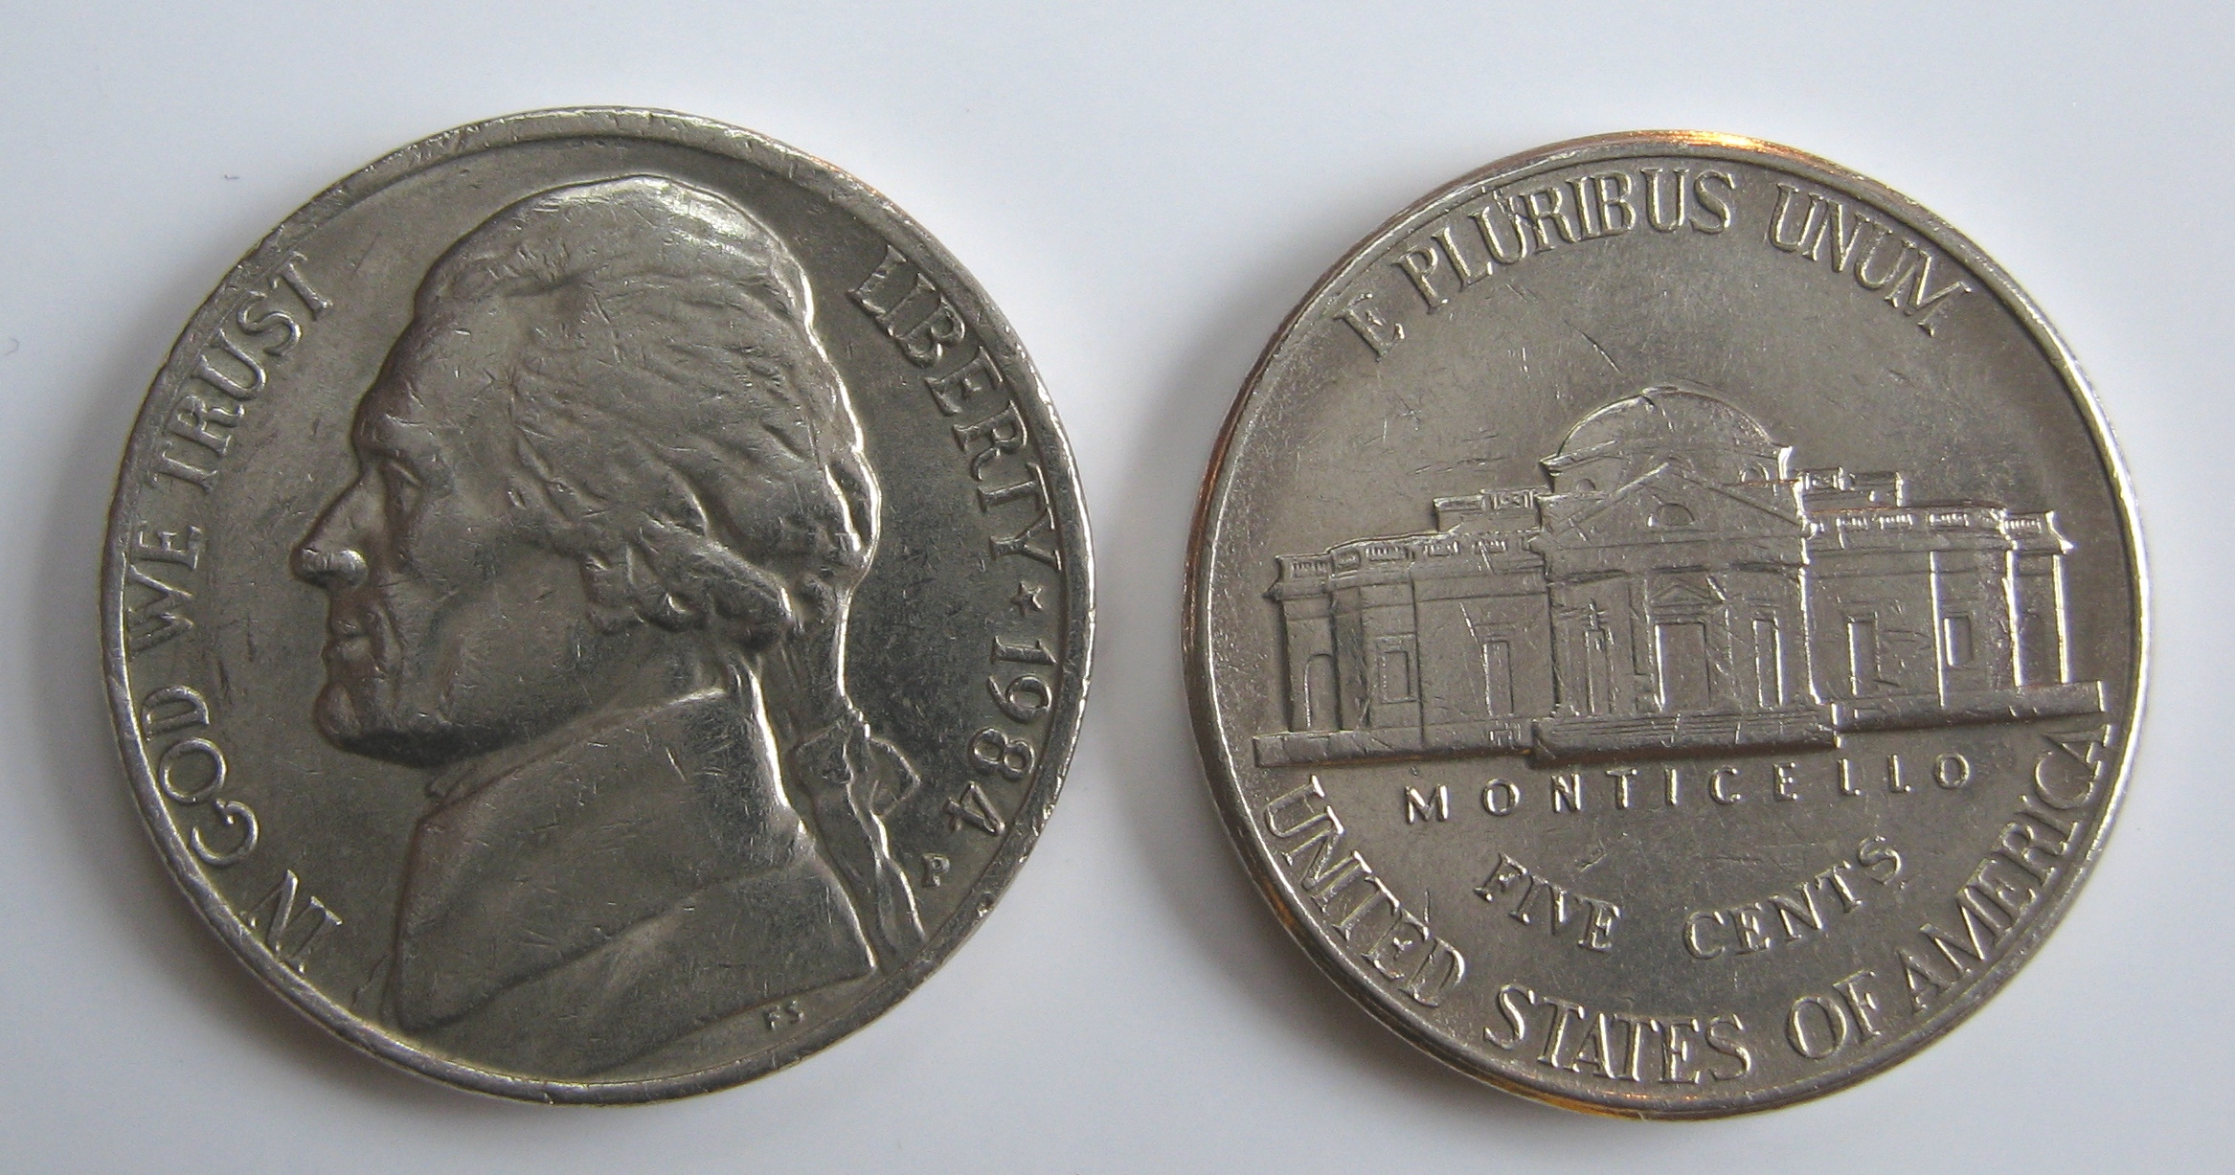
- Are events A and B independent or dependent? Explain your reasoning.
- Find the probabilities
  - $P\left(\text{A}\right)$
  - $P\left(\text{B}\right)$
  - $P\left(\text{A | B}\right)$
  - $P\left(\text{B | A}\right)$
- Describe the meaning of the events “not A” and “not B” in this situation, then find the probabilities.
  - $P\left(\text{A | not B}\right)$
  - $P\left(\text{B | not A}\right)$
- Are any of the probabilities the same? Is there a relationship between those situations? Explain your reasoning.
© CC BY 2019 by Illustrative Mathematics®

