Lesson 2 Practice Problems
- When Han makes chocolate milk, he mixes 2 cups of milk with 3 tablespoons of chocolate syrup. Here is a table that shows how to make batches of different sizes. Use the information in the table to complete the statements. Some terms are used more than once.
- 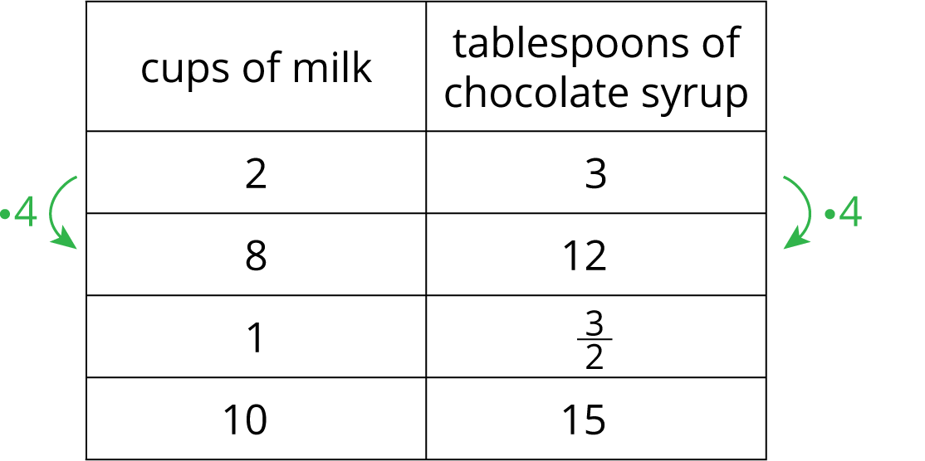
  - The table shows a proportional relationship between ______________ and ______________.
  - The scale factor shown is ______________.
  - The constant of proportionality for this relationship is______________.
  - The units for the constant of proportionality are ______________ per ______________.
- Bank of Terms: tablespoons of chocolate syrup, 4, cups of milk, cup of milk, $\frac{3}{2}$
- A certain shade of pink is created by adding 3 cups of red paint to 7 cups of white paint.
  - How many cups of red paint should be added to 1 cup of white paint?
- cups of white paint | - cups of red paint
  - 1
- 7 | - 3
  - What is the constant of proportionality?
- A map of a rectangular park has a length of 4 inches and a width of 6 inches. It uses a scale of 1 inch for every 30 miles.
  - What is the actual area of the park? Show how you know.
  - The map needs to be reproduced at a different scale so that it has an area of 6 square inches and can fit in a brochure. At what scale should the map be reproduced so that it fits on the brochure? Show your reasoning.
- (From Unit 1, Lesson 12.)
- Noah drew a scaled copy of Polygon P and labeled it Polygon Q.
- 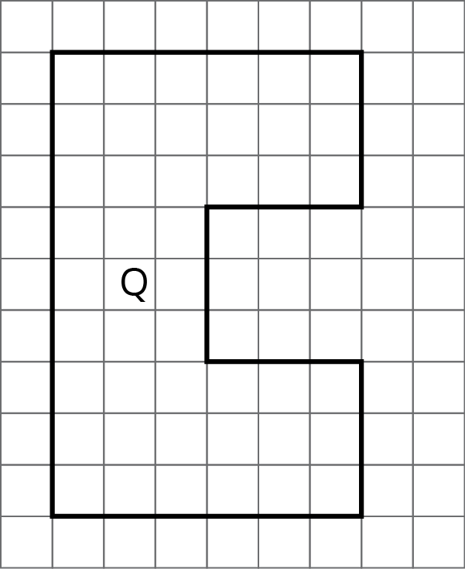
- If the area of Polygon P is 5 square units, what scale factor did Noah apply to Polygon P to create Polygon Q? Explain or show how you know.
- (From Unit 1, Lesson 6.)
- Select all the ratios that are equivalent to each other.
  - $4:7$
  - $8:15$
  - $16:28$
  - $2:3$
  - $20:35$
© CC BY Open Up Resources. Adaptations CC BY IM.

