Lesson 8 Practice Problems
- Noah is planning his birthday party. Here is a tree showing all of the possible themes, locations, and days of the week that Noah is considering.
  - How many themes is Noah considering?
  - How many locations is Noah considering?
  - How many days of the week is Noah considering?
  - One possibility that Noah is considering is a party with a space theme at the skating rink on Sunday. Write two other possible parties Noah is considering.
  - How many different possible outcomes are in the sample space?
- 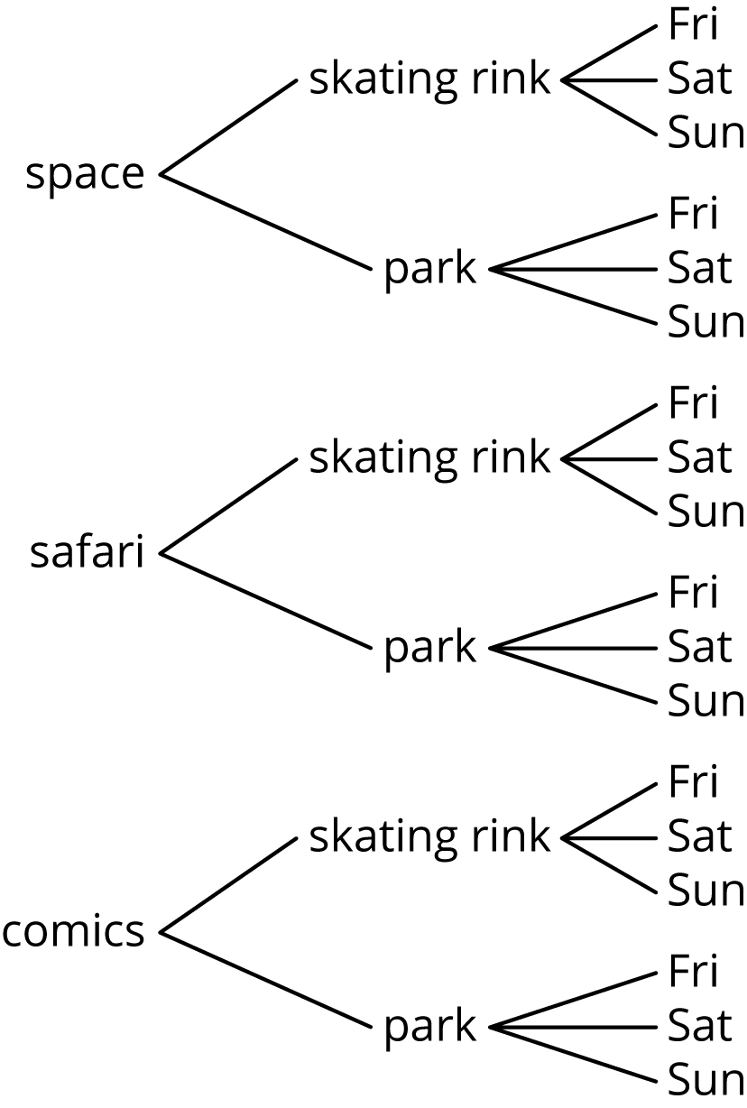
- For each event, write the sample space and tell how many outcomes there are.
  - Lin selects one type of lettuce and one dressing to make a salad.
  - Lettuce types: iceberg, romaine
Dressings: ranch, Italian, French
  - Diego chooses rock, paper, or scissors, and Jada chooses rock, paper, or scissors.
  - Spin these 3 spinners.
  - 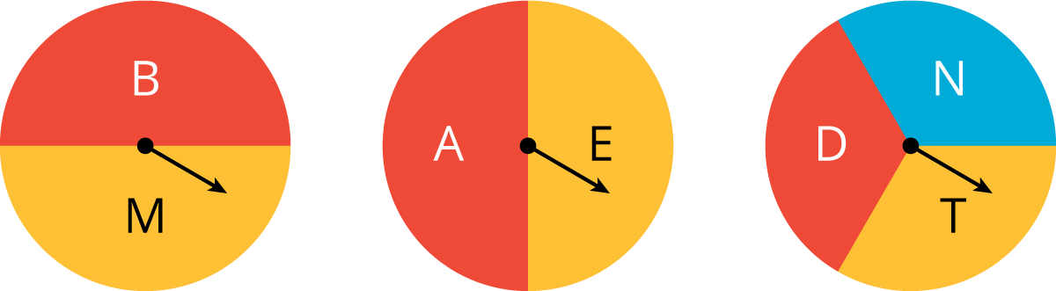
- A simulation is done to represent kicking 5 field goals in a single game with a 72% probability of making each one. A 1 represents making the kick and a 0 represents missing the kick.
- trial | - result
- 1 | - 10101
- 2 | - 11010
- 3 | - 00011
- 4 | - 11111
- 5 | - 10011
- Based on these results, estimate the probability that 3 or more kicks are made.
- (From Unit 8, Lesson 7.)
- There is a bag of 50 marbles.
  - Andre takes out a marble, records its color, and puts it back in. In 4 trials, he gets a green marble 1 time.
  - Jada takes out a marble, records its color, and puts it back in. In 12 trials, she gets a green marble 5 times.
  - Noah takes out a marble, records its color, and puts it back in. In 9 trials, he gets a green marble 3 times.
- Estimate the probability of getting a green marble from this bag. Explain your reasoning.
- (From Unit 8, Lesson 4.)
© CC BY Open Up Resources. Adaptations CC BY IM.

