Lesson 5: Points, Segments, and Zigzags
- Let’s figure out when segments are congruent.

5.1: What's the Point?
If $A$ is a point on the plane and $B$ is a point on the plane, then $A$ is congruent to $B$.
Try to prove this claim by explaining why you can be certain the claim must be true, or try to disprove this claim by explaining why the claim cannot be true. If you can find a counterexample in which the “if” part (hypothesis) is true, but the “then” part (conclusion) is false, you have disproved the claim.

5.2: What's the Segment?
Prove the conjecture: If $AB$ is a segment in the plane and $CD$ is a segment in the plane with the same length as $AB$, then $AB$ is congruent to $CD$.

Are you ready for more?
Prove or disprove the following claim: “If $EF$ is a piece of string in the plane, and $GH$ is a piece of string in the plane with the same length as $EF$, then $EF$ is congruent to $GH$.”

5.3: Zig Then Zag

$\overset{¯}{QR}≅\overset{¯}{XY},\overset{¯}{RS}≅\overset{¯}{YZ},∠R≅∠Y$
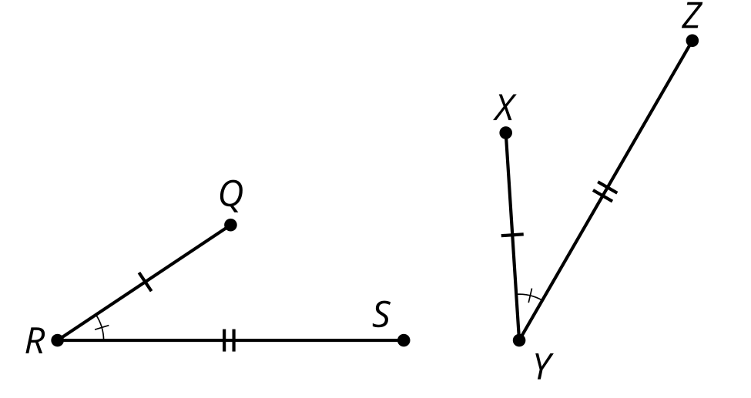
- Here are some statements about 2 zigzags. Put them in order to write a proof about figures $QRS$ and $XYZ$.
  - 1: Therefore, figure $QRS$ is congruent to figure $XYZ$.
  - 2: $S^{′}$ must be on ray $YZ$ since both $S^{′}$ and $Z$ are on the same side of $XY$ and make the same angle with it at $Y$.
  - 3: Segments $QR$ and $XY$ are the same length, so they are congruent. Therefore, there is a rigid motion that takes $QR$ to $XY$. Apply that rigid motion to figure $QRS$.
  - 4: Since points $S^{′}$ and $Z$ are the same distance along the same ray from $Y$, they have to be in the same place.
  - 5: If necessary, reflect the image of figure $QRS$ across $XY$ to be sure the image of $S$, which we will call $S^{′}$, is on the same side of $XY$ as $Z$.
- Take turns with your partner stating steps in the proof that figure $ABCD$ is congruent to figure $EFGH$.
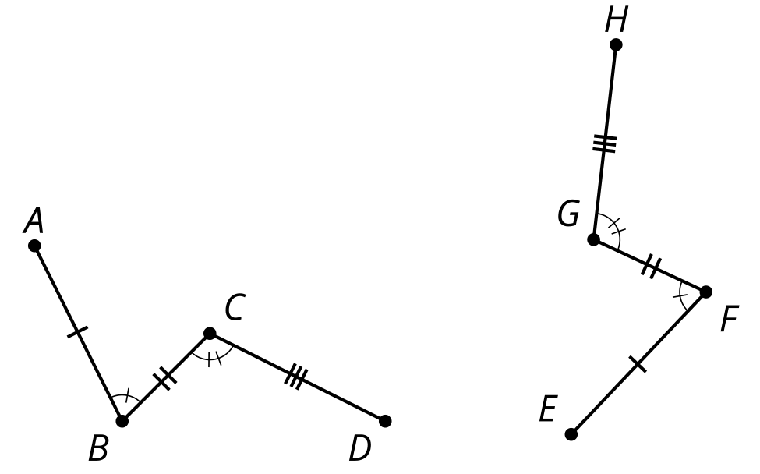

Lesson 5 Summary
If 2 figures are congruent, then there is a sequence of rigid motions that takes one figure onto the other. We can use this fact to prove that any point is congruent to another point. We can also prove segments of the same length are congruent. Finally, we can put together arguments to prove entire figures are congruent.
These statements prove $ABC$ is congruent to $XYZ$.
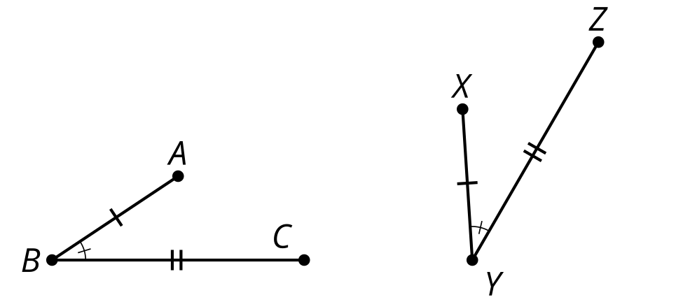
- Segments $AB$ and $XY$ are the same length, so they are congruent. Therefore, there is a rigid motion that takes $AB$ to $XY$. Apply that rigid motion to figure $ABC$.
- If necessary, reflect the image of figure $ABC$ across $XY$ to be sure the image of $C$, which we will call $C^{′}$, is on the same side of $XY$ as $Z$.
- $C^{′}$ must be on ray $YZ$ since both $C^{′}$ and $Z$ are on the same side of $XY$ and make the same angle with it at $Y$.
- Since points $C^{′}$ and $Z$ are the same distance along the same ray from $Y$, they have to be in the same place.
- Therefore, figure $ABC$ is congruent to figure $XYZ$.
© CC BY 2019 by Illustrative Mathematics®

