Unit 1 Lesson 12: Variability

1 Estimation: Average Book Length (Warm up)

Student Task Statement
The book in the center is 276 pages long. What is the mean number of pages of the 3 books?
- Record an estimate that is:
- too low | - about right | - too high
- Explain your reasoning.

2 The Better Option

Student Task Statement
Choose the best option based on the given data. Use a measure of center and measure of variability to justify your answers.
Participants’ ages at camp A
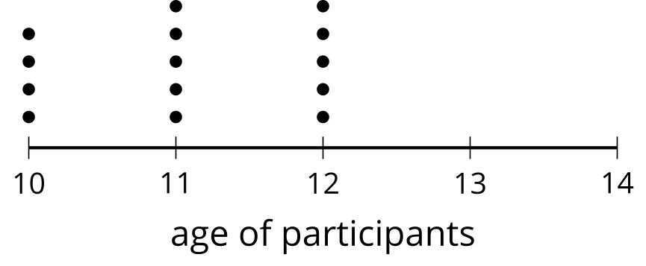
Participants’ ages at camp B
mean: 11.93 years, mean absolute deviation: 1.65 years
Servers’ tip amounts at restaurant A
mean: $15, mean absolute deviation: $1.5
Servers’ tip amounts at restaurant B
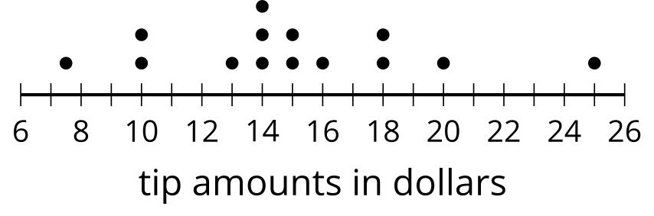
- ​​​​​​Which camp would you prefer to work for? Explain your reasoning.
- Which camp would you prefer to attend? Explain your reasoning.
- At which restaurant would you want to be a server? Explain your reasoning.

3 Notice and Wonder: Preschool Heights

Student Task Statement
Mai and Tyler both visit the same preschool classroom and measure the heights of people in the room in inches. The summary of their results are shown in the box plot and statistics.
What do you notice? What do you wonder?
Mai's results
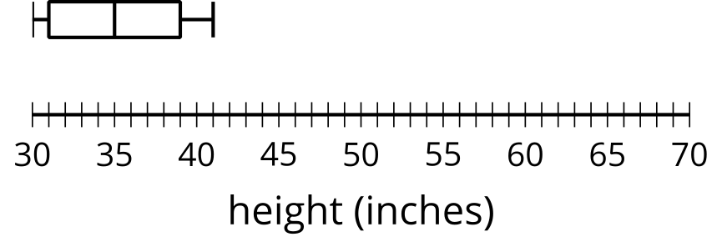
mean: 35.2 inches, mean absolute deviation: 3.24 inches
Tyler's results
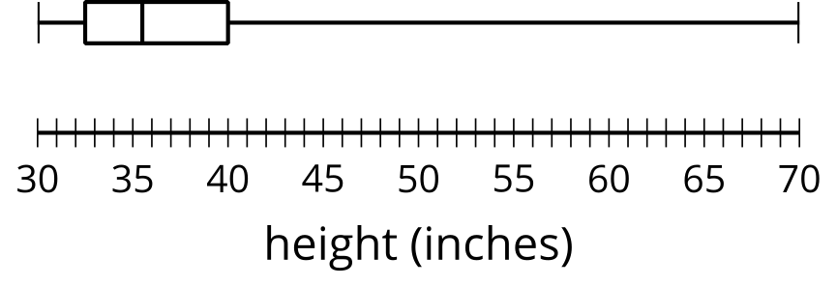
mean: 39.3 inches, mean absolute deviation: 7.19 inches
© CC BY 2019 by Illustrative Mathematics®

