Lesson 5: Representemos datos de medidas en diagramas de puntos

Standards Alignments
Addressing | 3.MD.B.4, 3.OA.C.7

Teacher-facing Learning Goals
- Create a line plot where the horizontal scale is marked off in appropriate units— whole numbers, halves, or quarters—to represent measurement data.
- Generate measurement data by measuring lengths using a ruler marked with halves and fourths of an inch.

Student-facing Learning Goals
- Recolectemos datos de medidas y mostrémoslos en un diagrama de puntos.

Lesson Purpose
The purpose of this lesson is for students to generate measurement data and represent them on a line plot.
In a previous lesson, students analyzed line plots that included measurements in halves and fourths of an inch. In this lesson, students collect measurement data, represent them on a line plot, and analyze line plots that represent different data sets (MP2).
This lesson may take more than one day if students need more time to collect data around the school and to create their line plots. If time permits and preferable, consider carrying out the activities across two days.
This lesson has a Student Section Summary.

Access for:

Students with Disabilities
- Representation (Activity 2)

English Learners
- MLR8 (Activity 1)

Instructional Routines
MLR7 Compare and Connect (Activity 2), Number Talk (Warm-up)

Materials to Gather
- Glue or tape: Activity 2
- Materials from a previous lesson: Activity 1
- Scissors: Activity 2
- Tools for creating a visual display: Activity 2

Materials to Copy
- Let's Make a Line Plot (groups of 2): Activity 2

Lesson Timeline
Warm-up | 10 min
Activity 1 | 20 min
Activity 2 | 20 min
Lesson Synthesis | 5 min
Cool-down | 5 min

Teacher Reflection Question
If you were to teach this lesson over again, what activity would you redo? How would your proposed changes support student learning?

Cool-down
(to be completed at the end of the lesson) 5min
Completa el diagrama de puntos

Standards Alignments
Addressing | 3.MD.B.4

Student-facing Task Statement
La lista muestra longitudes de hojas, en pulgadas. Usa las medidas para completar el diagrama de puntos.
$2\frac{3}{4}$ | 3 | 2 | $3\frac{1}{4}$ | $4\frac{1}{2}$ | $3\frac{1}{4}$ | $2\frac{3}{4}$ | $2\frac{1}{2}$

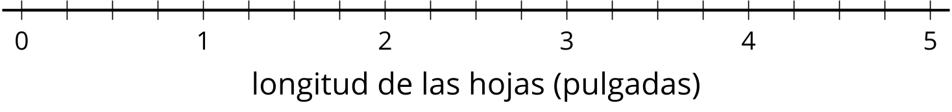

Student Responses
