Unit 6 Lesson 11: The Distributive Property, Part 3

1 The Shaded Region (Warm up)

Student Task Statement
A rectangle with dimensions 6 cm and $w$ cm is partitioned into two smaller rectangles.
Explain why each of these expressions represents the area, in cm², of the shaded region.
- $6w−24$
- $6\left(w−4\right)$
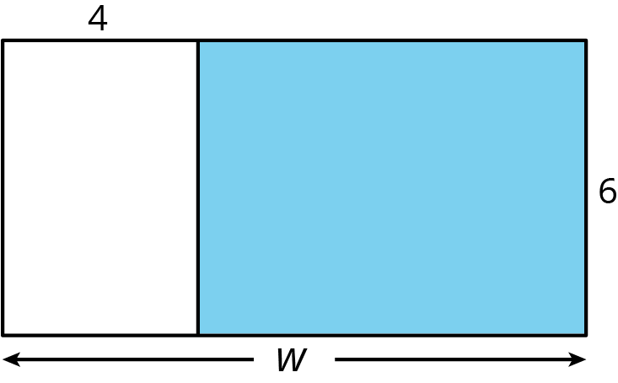

Activity Synthesis
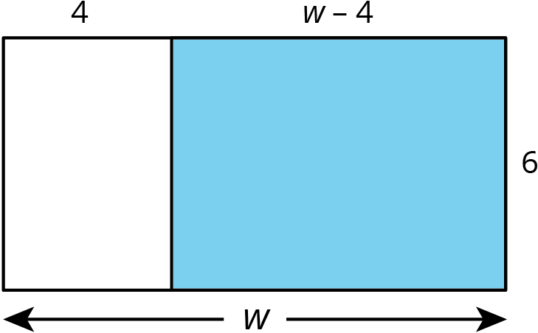

2 Matching to Practice Distributive Property (Optional)

Student Task Statement
Match each expression in column 1 to an equivalent expression in column 2. If you get stuck, consider drawing a diagram.
Column 1
- $a\left(1+2+3\right)$
- $2\left(12−4\right)$
- $12a+3b$
- $\frac{2}{3}\left(15a−18\right)$
- $6a+10b$
- $0.4\left(5−2.5a\right)$
- $2a+3a$
Column 2
- $3\left(4a+b\right)$
- $12⋅2−4⋅2$
- $2\left(3a+5b\right)$
- $\left(2+3\right)a$
- $a+2a+3a$
- $10a−12$
- $2−a$

3 Writing Equivalent Expressions Using the Distributive Property (Optional)

Student Task Statement
The distributive property can be used to write equivalent expressions. In each row, use the distributive property to write an equivalent expression. If you get stuck, consider drawing a diagram.
product | sum or difference
$3\left(3+x\right)$
 | $4x−20$
$\left(9−5\right)x$
 | $4x+7x$
$3\left(2x+1\right)$
 | $10x−5$
 | $x+2x+3x$
$\frac{1}{2}\left(x−6\right)$
$y\left(3x+4z\right)$
 | $2xyz−3yz+4xz$

© CC BY Open Up Resources. Adaptations CC BY IM.

