Unit 6 Lesson 6: Completing the Square

1 Fill in the Box (Warm up)

Student Task Statement
For each expression, what value would need to be in the box in order for the expression to be a perfect square trinomial?
- x2+10x+3
- x2−16x+3
- x2+40x+3
- x2+5x+3

2 Complete the Process

Student Task Statement
Here is the equation of a circle: $x^{2}+y^{2}−6x−20y+105=0$
Elena wants to find the center and radius of the circle. Here is what she’s done so far.
Step 1: $x^{2}−6x+y^{2}−20y=\text{-}105$
Step 2: $x^{2}−6x+9+y^{2}−20y+100=\text{-}105+9+100$
Step 3: $x^{2}−6x+9+y^{2}−20y+100=4$
- What did Elena do in the first step?
- Why did Elena add 9 and 100 to the left side of the equation in Step 2?
- Why did Elena add 9 and 100 to the right side of the equation in Step 2?
- What should Elena do next?
- What are the center and radius of this circle?
- Draw a graph of the circle.

3 Your Turn

Student Task Statement
Here is the equation of a circle: $x^{2}+y^{2}−2x+4y−4=0$
- Find the center and radius of the circle. Explain or show your reasoning.
- Draw a graph of the circle.

Activity Synthesis
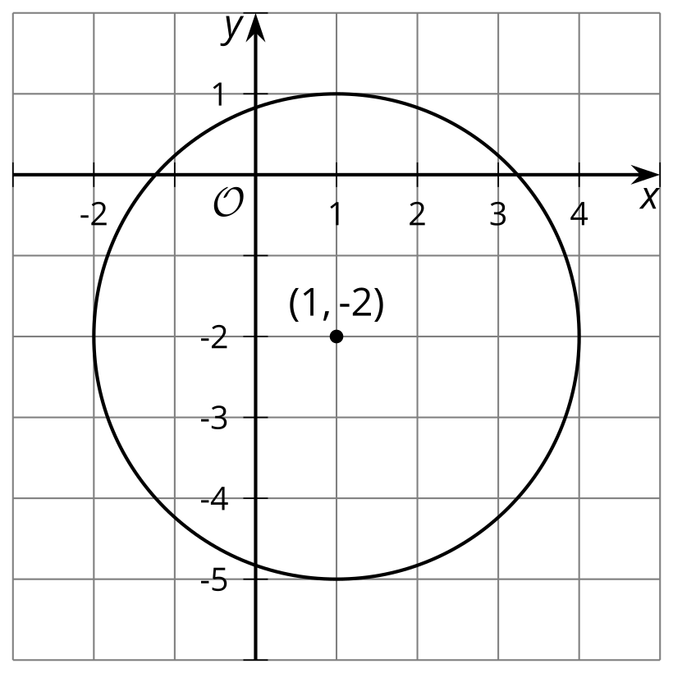
© CC BY 2019 by Illustrative Mathematics®

