Lesson 12: Center Day 2
- Let’s work with shapes and numbers.

Warm-up: How Many Do You See: 2 or 3 Parts
How many do you see?
How do you see them?
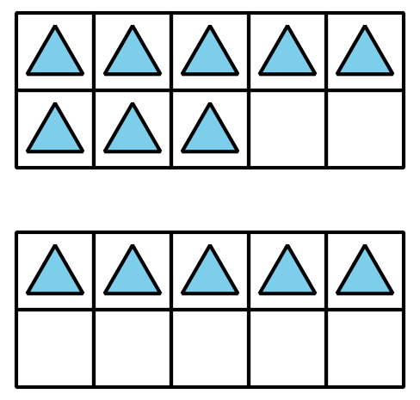
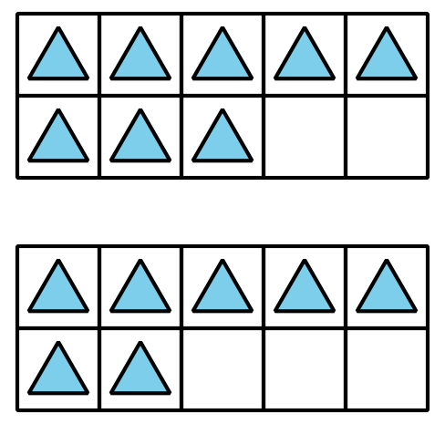
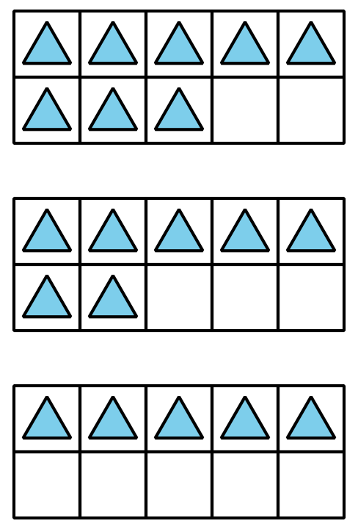

12.2: Centers: Choice Time
Choose a center.
Picture Books
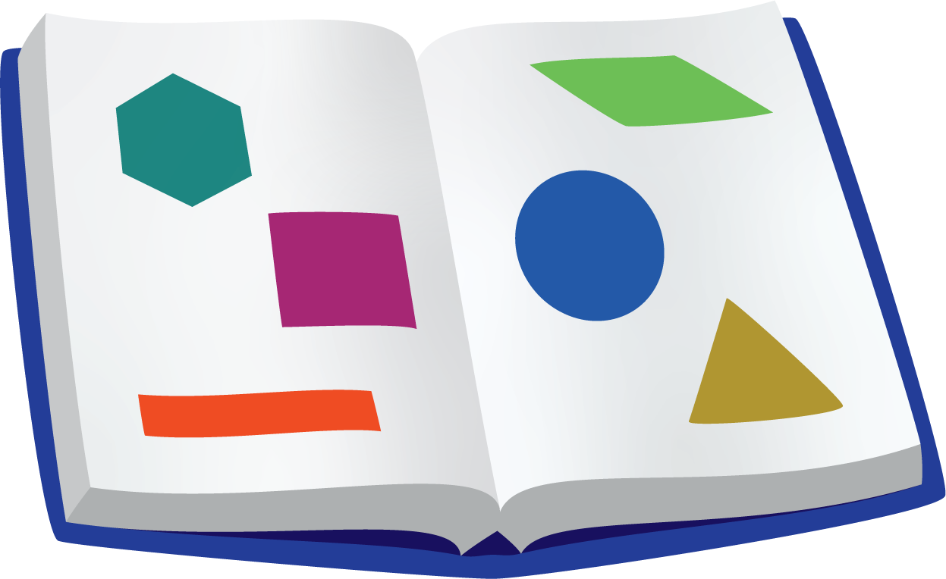
Match Mine
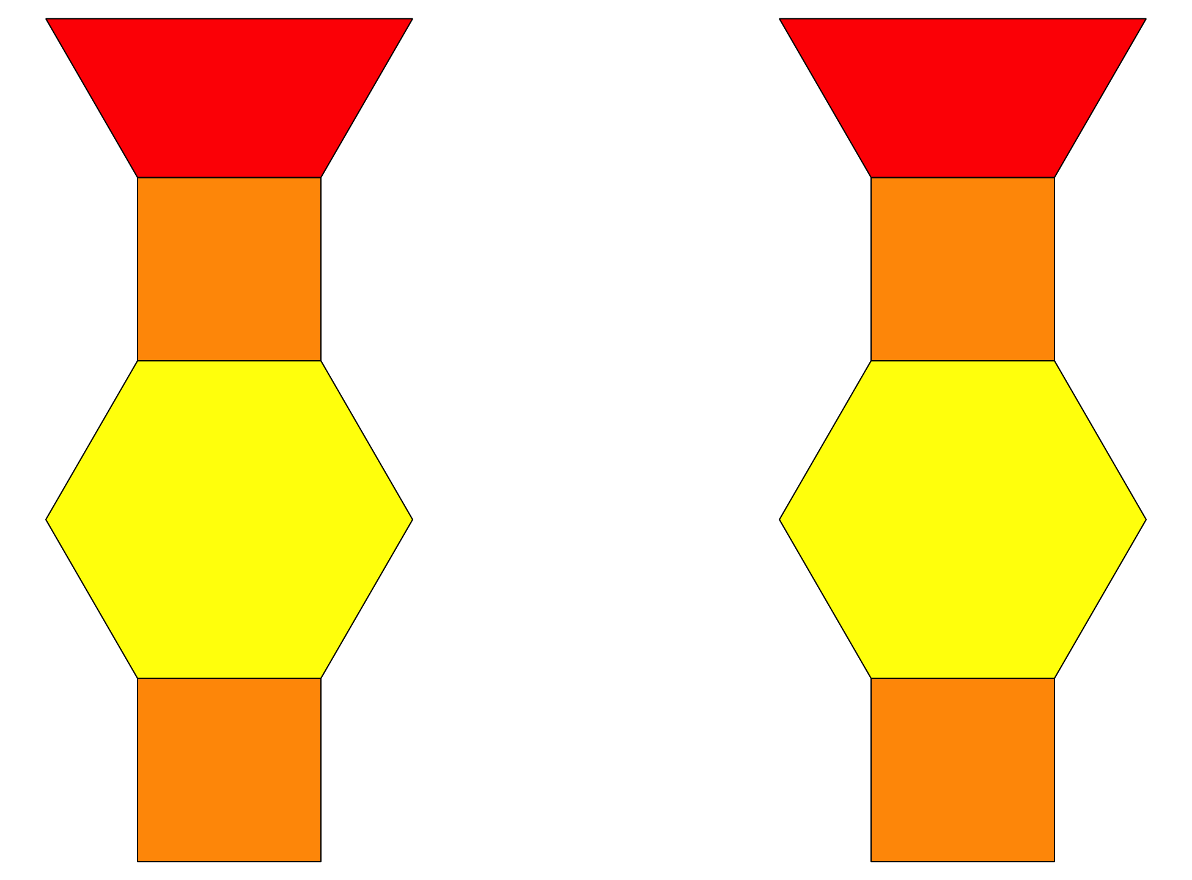
Capture Squares
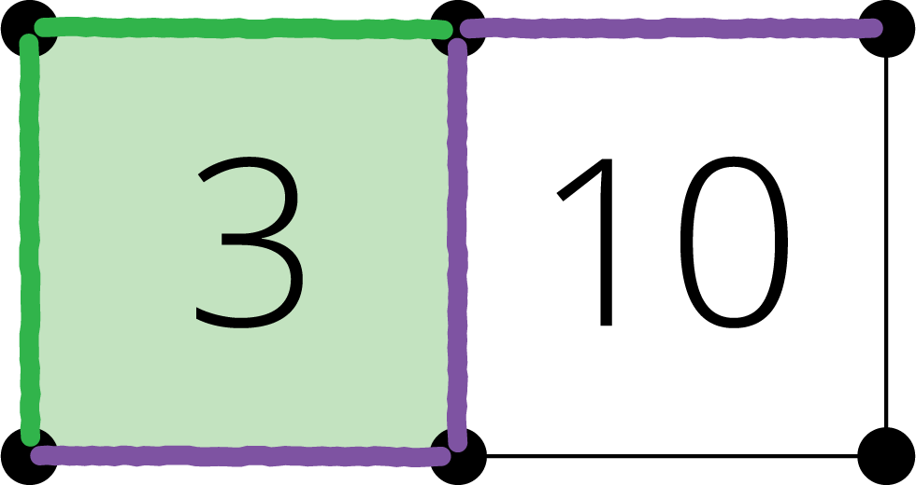
Target Numbers
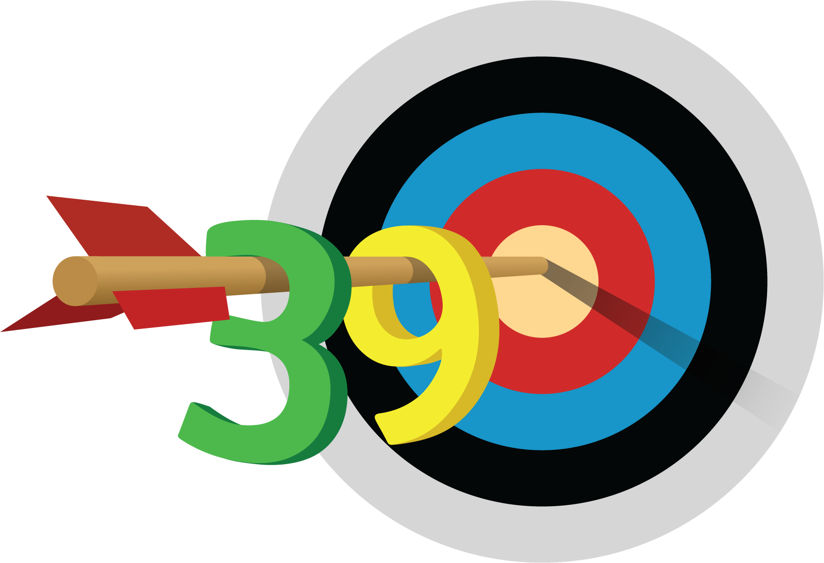
© CC BY 2021 Illustrative Mathematics®

