Unit 1 Lesson 10: Measures of Center

1 Estimation: Lamp Post (Warm up)

Student Task Statement
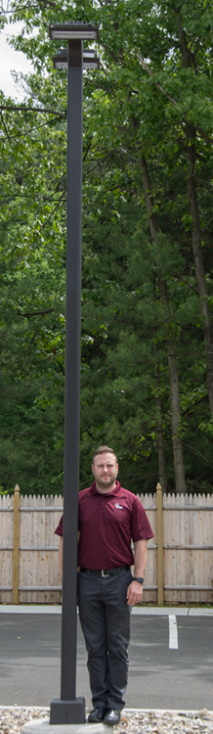
How tall is the lamp post?
- Record an estimate that is:
- too low | - about right | - too high
- Explain your reasoning.

2 Balance Point

Images for Launch
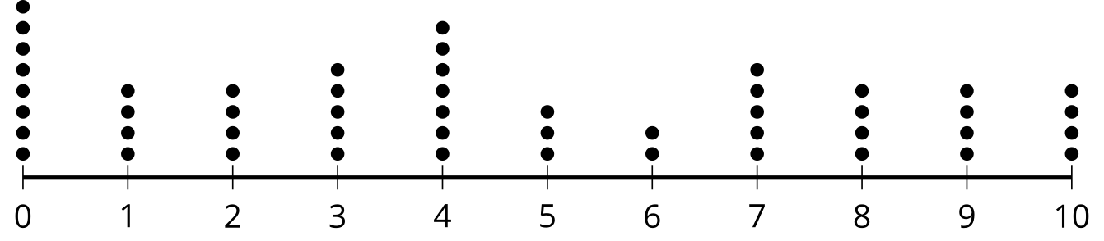

Student Task Statement
For each graph, estimate the balance point. The balance point is where you think the number line would balance. Record your balance point on the graph with a $Δ$ symbol. Then, calculate the mean and median for each data set.
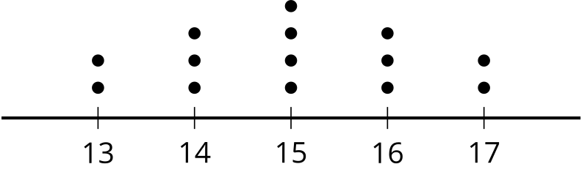

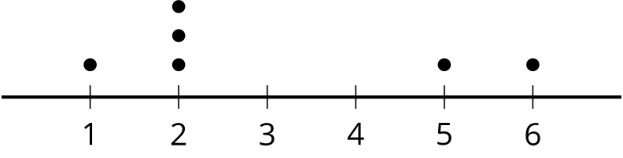
​​​​​​

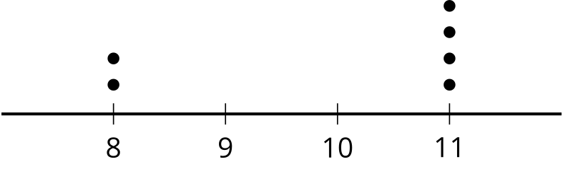
​​​​​​

3 Mean vs. Median

Student Task Statement
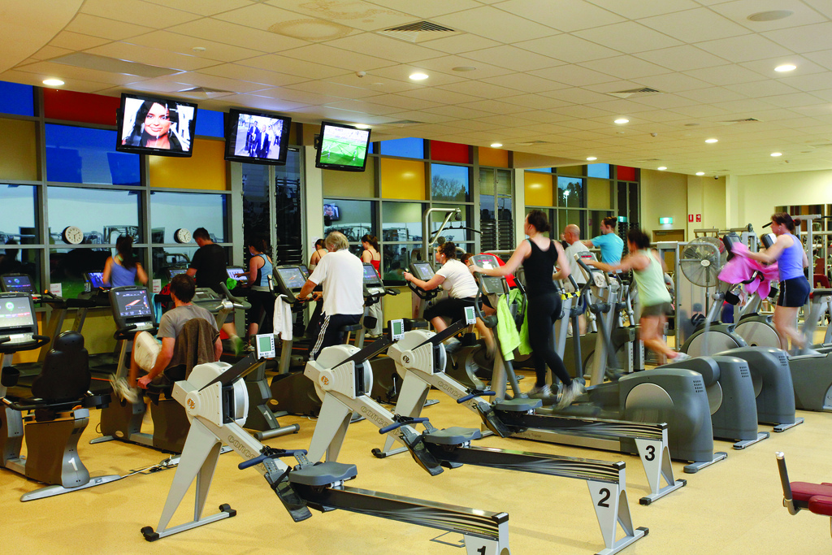
When people join a gym, they are assessed on their fitness by doing several exercises. The results are given as a score between 1 and 100 with 100 representing peak fitness for the person’s age. The gym claims they can improve scores for members after only 2 months.
After 2 months, 11 people are assessed again, and the number of points they improve on in the assessment is shown in the dot plot.
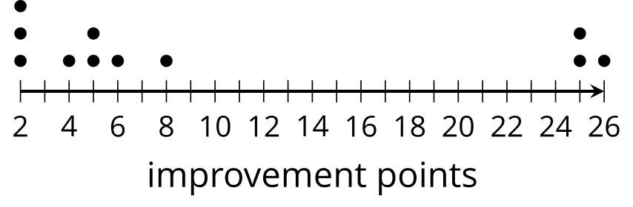
- What is the mean improvement among these members?
- What is the median?
- Which measure of center is a better representation of the members’ improvement? Explain your reasoning.
© CC BY 2019 by Illustrative Mathematics®

