Lesson 6: A Proof of the Pythagorean Theorem
Let’s prove the Pythagorean Theorem.

6.1: Notice and Wonder: A Square and Four Triangles
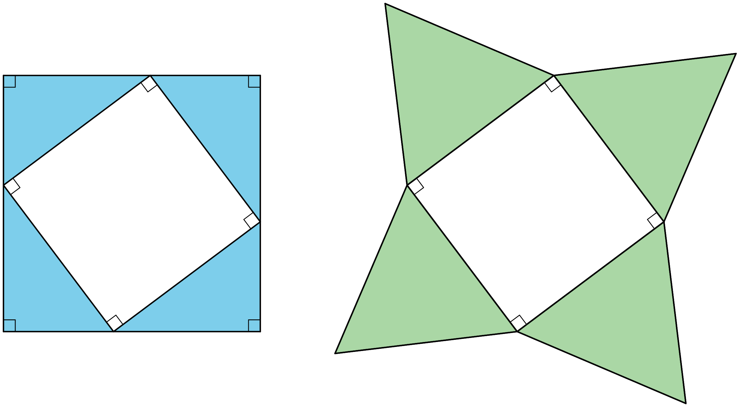
What do you notice? What do you wonder?

6.2: Adding Up Areas
Both figures shown here are squares with a side length of $a+b$. Notice that the first figure is divided into two squares and two rectangles. The second figure is divided into a square and four right triangles with legs of lengths $a$ and $b$. Let’s call the hypotenuse of these triangles $c$.
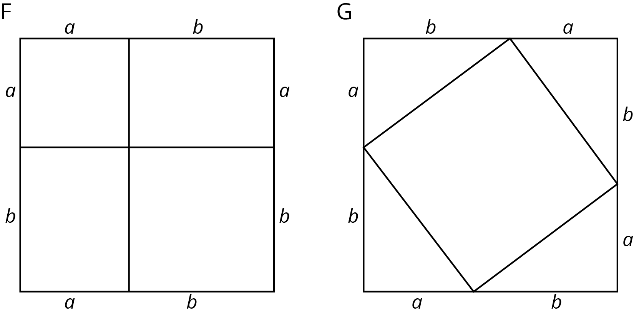
- What is the total area of each figure?
- Find the area of each of the 9 smaller regions shown the figures and label them.
- Add up the area of the four regions in Figure F and set this expression equal to the sum of the areas of the five regions in Figure G. If you rewrite this equation using as few terms as possible, what do you have?

Are you ready for more?
Take a 3-4-5 right triangle, add on the squares of the side lengths, and form a hexagon by connecting vertices of the squares as in the image. What is the area of this hexagon?
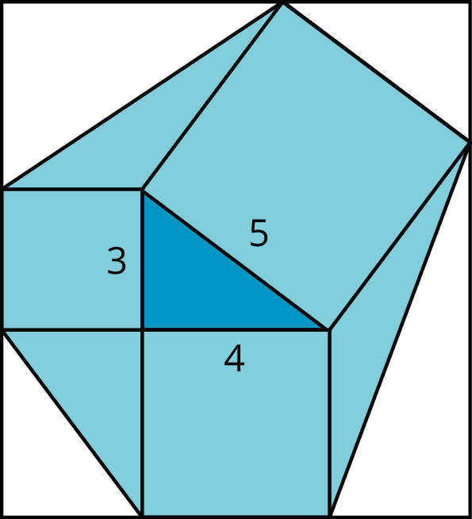

6.3: Find the Missing Side Lengths
- Find $c$.
- 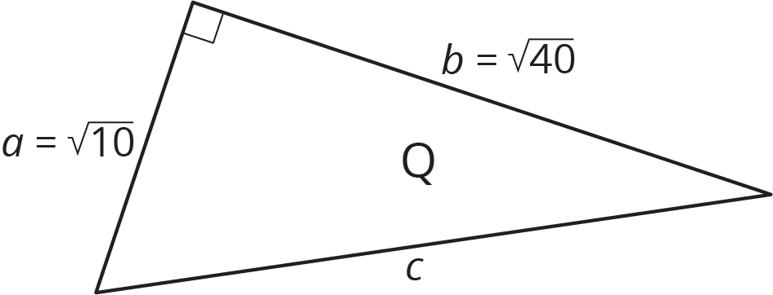

- Find $b$.
- 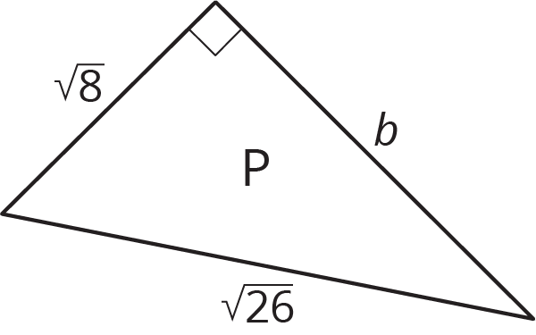
- A right triangle has sides of length 2.4 cm and 6.5 cm. What is the length of the hypotenuse?
- A right triangle has a side of length $\frac{1}{4}$ and a hypotenuse of length $\frac{1}{3}$. What is the length of the other side?
- Find the value of $x$ in the figure.
- 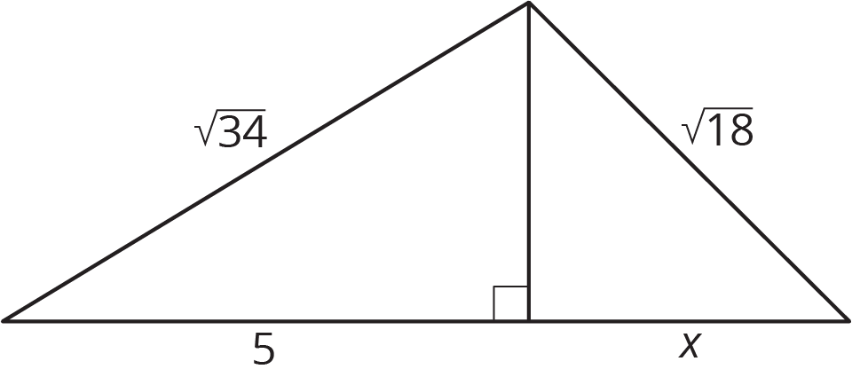

Are you ready for more?
The spiral in the figure is made by starting with a right triangle with both legs measuring one unit each. Then a second right triangle is built with one leg measuring one unit, and the other leg being the hypotenuse of the first triangle. A third right triangle is built on the second triangle’s hypotenuse, again with the other leg measuring one unit, and so on.
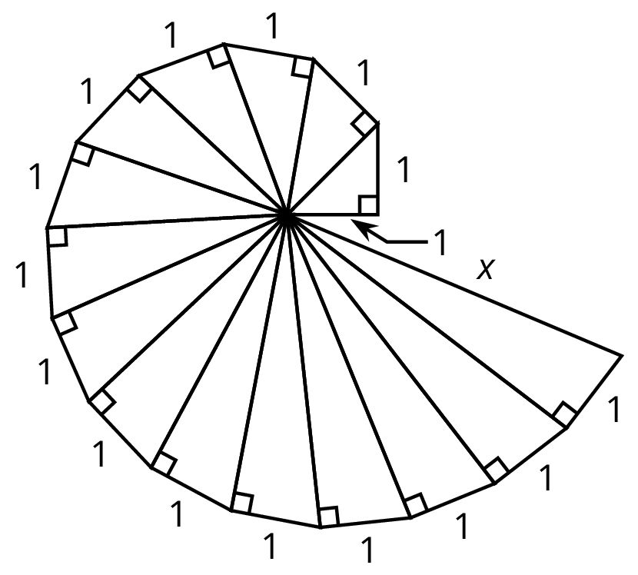
Find the length, $x$, of the hypotenuse of the last triangle constructed in the figure.

6.4: A Transformational Proof
Your teacher will give your group a sheet with 4 figures and a set of 5 cut out shapes labeled D, E, F, G, and H.
- Arrange the 5 cut out shapes to fit inside Figure 1. Check to see that the pieces also fit in the two smaller squares in Figure 4.
- Explain how you can transform the pieces arranged in Figure 1 to make an exact copy of Figure 2.
- Explain how you can transform the pieces arranged in Figure 2 to make an exact copy of Figure 3.
- Check to see that Figure 3 is congruent to the large square in Figure 4.
- If the right triangle in Figure 4 has legs $a$ and $b$ and hypotenuse $c$, what have you just demonstrated to be true?

Lesson 6 Summary
The figures shown here can be used to see why the Pythagorean Theorem is true. Both large squares have the same area, but they are broken up in different ways. (Can you see where the triangles in Square G are located in Square F? What does that mean about the smaller squares in F and H?) When the sum of the four areas in Square F are set equal to the sum of the 5 areas in Square G, the result is $a^{2}+b^{2}=c^{2}$, where $c$ is the hypotenuse of the triangles in Square G and also the side length of the square in the middle. Give it a try!
There are many examples where the lengths of two legs of a right triangle are known and can be used to find the length of the hypotenuse with the Pythagorean Theorem. The Pythagorean Theorem can also be used if the length of the hypotenuse and one leg is known, and we want to find the length of the other leg. Here is a right triangle, where one leg has a length of 5 units, the hypotenuse has a length of 10 units, and the length of the other leg is represented by $g$.
Start with $a^{2}+b^{2}=c^{2}$, make substitutions, and solve for the unknown value. Remember that $c$ represents the hypotenuse: the side opposite the right angle. For this triangle, the hypotenuse is 10.
$\begin{matrix}a^{2}+b^{2} & =c^{2} \\ 5^{2}+g^{2} & ={10}^{2} \\ g^{2} & ={10}^{2}−5^{2} \\ g^{2} & =100−25 \\ g^{2} & =75 \\ g & =\sqrt{75}\end{matrix}$
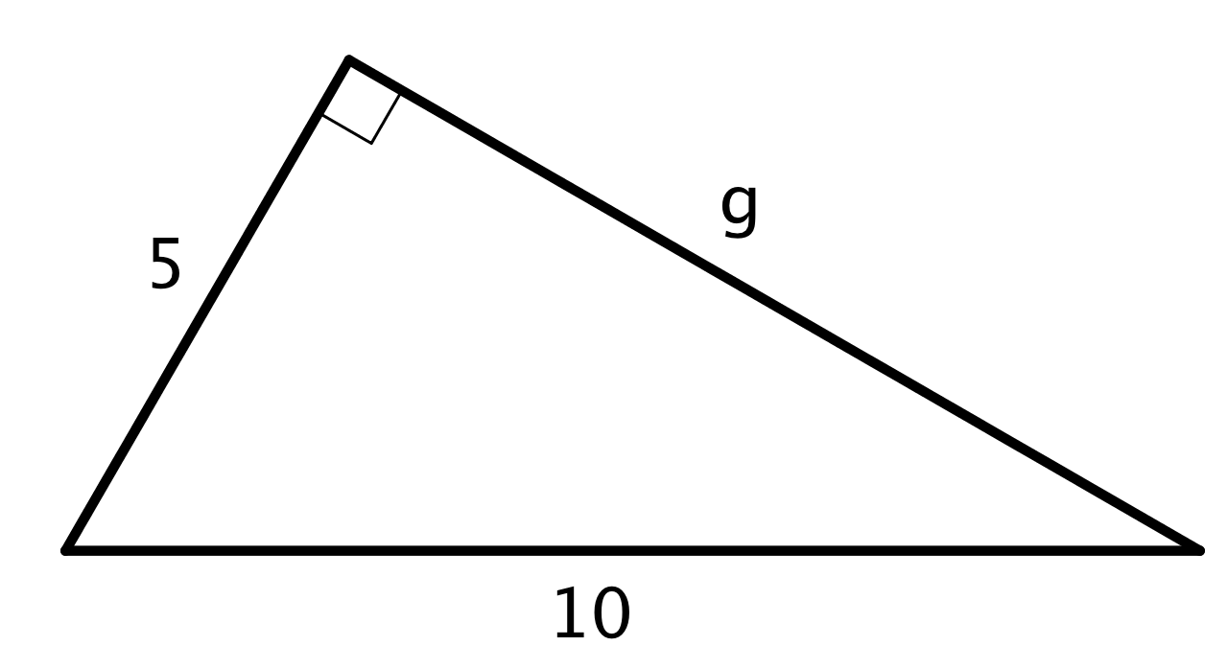
Use estimation strategies to know that the length of the other leg is between 8 and 9 units, since 75 is between 64 and 81. A calculator with a square root function gives $\sqrt{75}≈8.66$.
© CC BY Open Up Resources. Adaptations CC BY IM.

