Lesson 9: Measurement Error
Let’s use percentages to describe how accurately we can measure.

9.1: Measuring to the Nearest
Your teacher will give you two rulers and three line segments labeled A, B, and C.
- Use the centimeter ruler to measure each line segment to the nearest centimeter. Record these lengths in the first column of the table.
- Use the millimeter ruler to measure each line segment to the nearest tenth of a centimeter. Record these lengths in the second column of the table.
line segment | length (cm) as measured  with the first ruler | length (cm) as measured  with the second ruler
A
B
C

9.2: Measuring a Soccer Field
A soccer field is 120 yards long. Han measures the length of the field using a 30-foot-long tape measure and gets a measurement of 358 feet, 10 inches.
- What is the amount of the error?
- Express the error as a percentage of the actual length of the field.

9.3: Measuring Your Classroom
Your teacher will tell you which three items to measure. Keep using the paper rulers from the earlier activity.
- Between you and your partner, decide who will use which ruler.
- Measure the three items assigned by your teacher and record your measurements in the first column of the appropriate table.
- Using the cm ruler:
- item | - measured  length (cm) | - actual  length (cm) | - difference | - percentage
- Using the mm ruler:
- item | - measured  length (cm) | - actual  length (cm) | - difference | - percentage
- After you finish measuring the items, share your data with your partner. Next, ask your teacher for the actual lengths.
- Calculate the difference between your measurements and the actual lengths in both tables.
- For each difference, what percentage of the actual length is this amount? Record your answers in the last column of the tables.

Are you ready for more?
Before there were standard units of measurement, people often measured things using their hands or feet.
- Measure the length of your foot to the nearest centimeter with your shoe on.
- How many foot-lengths long is your classroom? Try to determine this as precisely as possible by carefully placing your heel next to your toe as you pace off the room.
- Use this information to estimate the length of your classroom in centimeters.
- Use a tape measure to measure the length of your classroom. What is the difference between the two measurements? Which one do you think is more accurate?

Lesson 9 Summary
When we are measuring a length using a ruler or measuring tape, we can get a measurement that is different from the actual length. This could be because we positioned the ruler incorrectly, or it could be because the ruler is not very precise. There is always at least a small difference between the actual length and a measured length, even if it is a microscopic difference!
Here are two rulers with different markings.
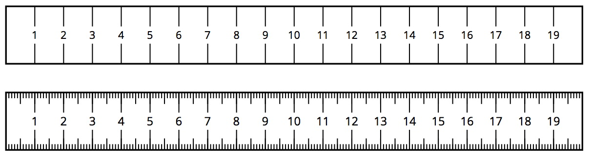
The second ruler is marked in millimeters, so it is easier to get a measurement to the nearest tenth of a centimeter with this ruler than with the first. For example, a line that is actually 6.2 cm long might be measured to be 6 cm long by the first ruler, because we measure to the nearest centimeter.
The measurement error is the positive difference between the measurement and the actual value. Measurement error is often expressed as a percentage of the actual value. We always use a positive number to express measurement error and, when appropriate, use words to describe whether the measurement is greater than or less than the actual value.
For example, if we get 6 cm when we measure a line that is actually 6.2 cm long, then the measurement error is 0.2 cm, or about 3.2%, because $0.2÷6.2≈0.032$.
© CC BY Open Up Resources. Adaptations CC BY IM.

