Lesson 4: Parallelograms
Let’s investigate the features and area of parallelograms.

4.1: Features of a Parallelogram
Figures A, B, and C are parallelograms. Figures D, E, and F are not parallelograms.
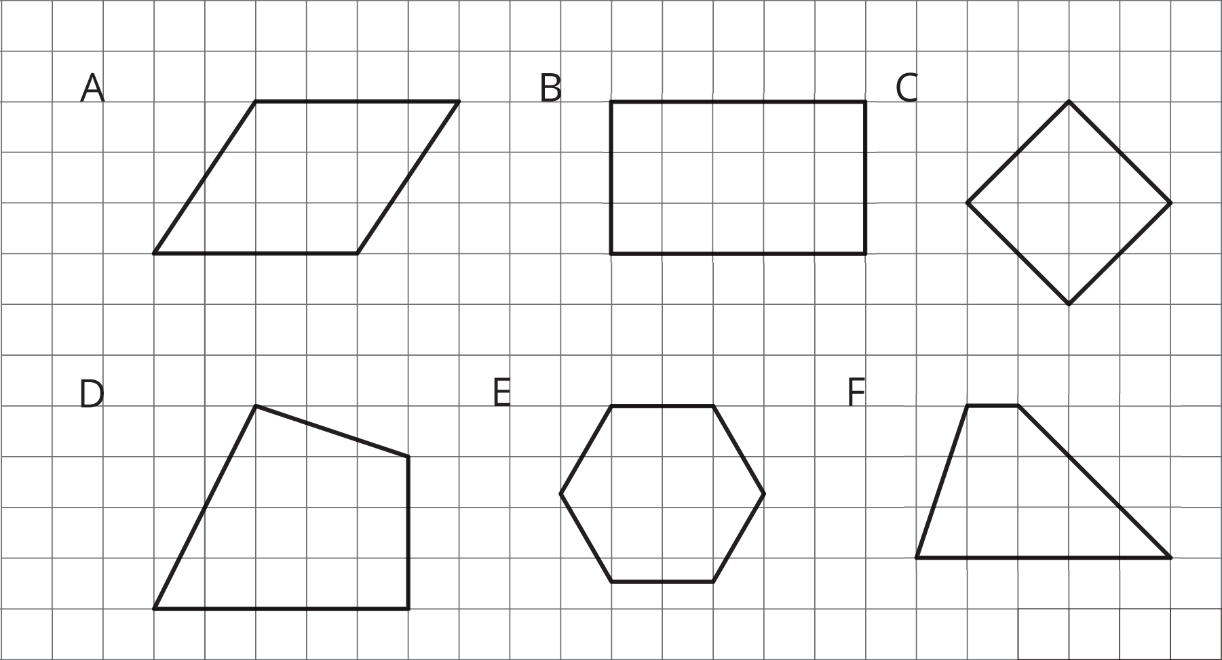
Study the examples and non-examples. What do you notice about:
- the number of sides that a parallelogram has?
- opposite sides of a parallelogram?
- opposite angles of a parallelogram?

4.2: Area of a Parallelogram
Find the area of each parallelogram. Show your reasoning.
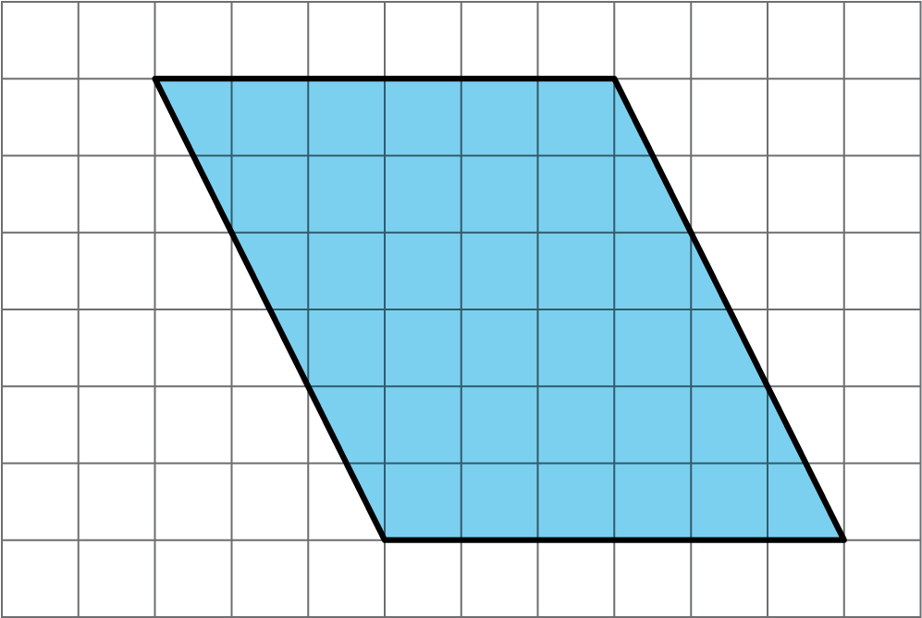
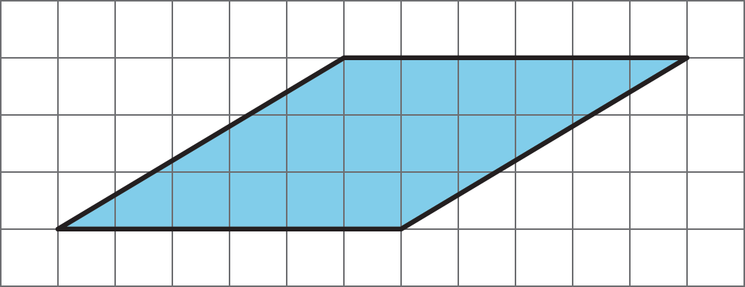

4.3: Lots of Parallelograms
Find the area of each parallelogram. Show your reasoning.
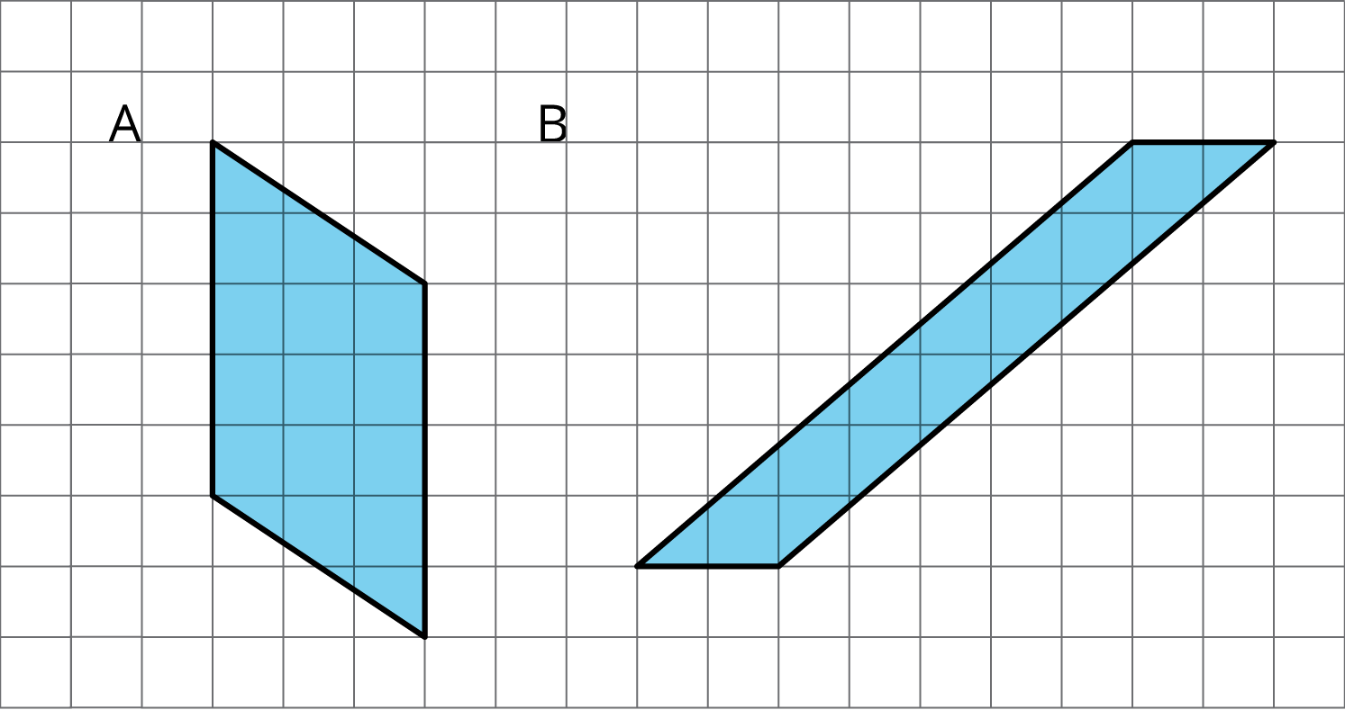
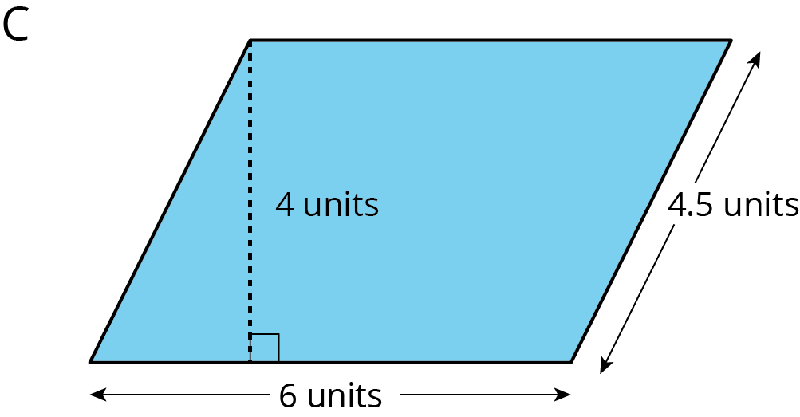

Lesson 4 Summary
A parallelogram is a quadrilateral (it has four sides). The opposite sides of a parallelogram are parallel. It is also true that the opposite sides of a parallelogram have equal length, and the opposite angles of a parallelogram have equal measure.
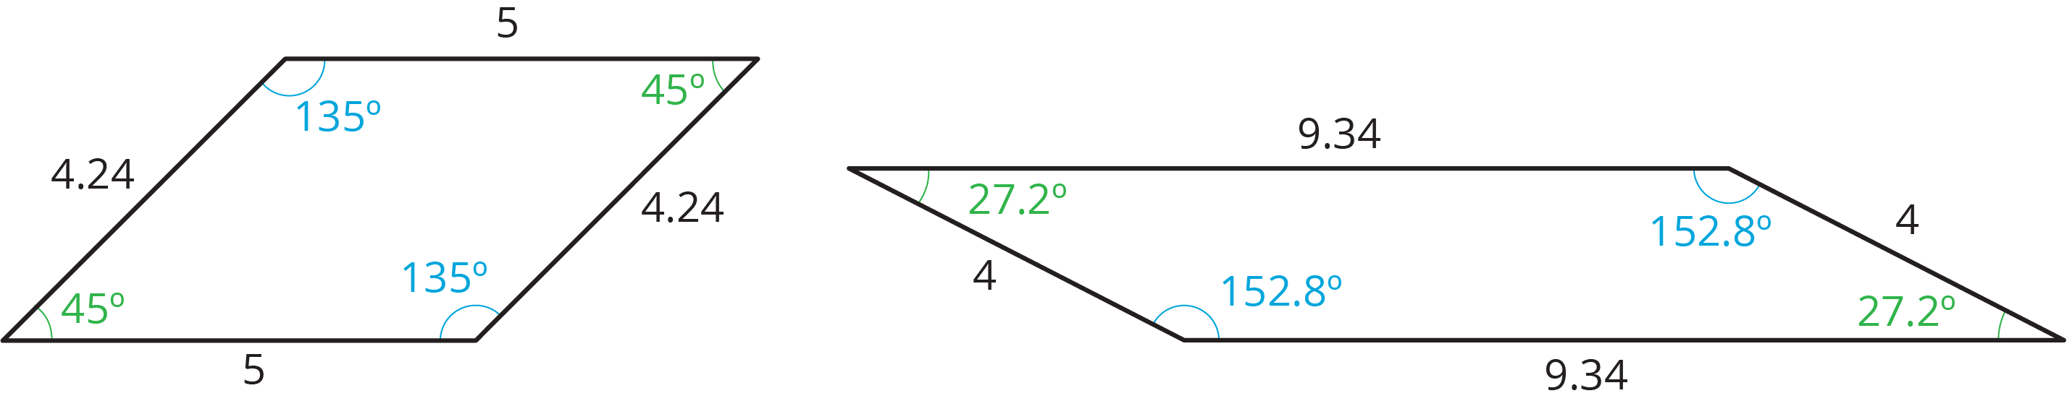
There are several strategies for finding the area of a parallelogram.
- We can decompose and rearrange a parallelogram to form a rectangle. Here are three ways:
- 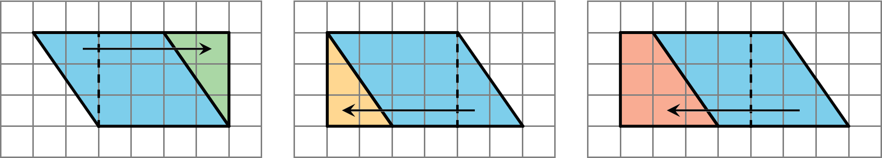
- We can enclose the parallelogram and then subtract the area of the two triangles in the corner.
- 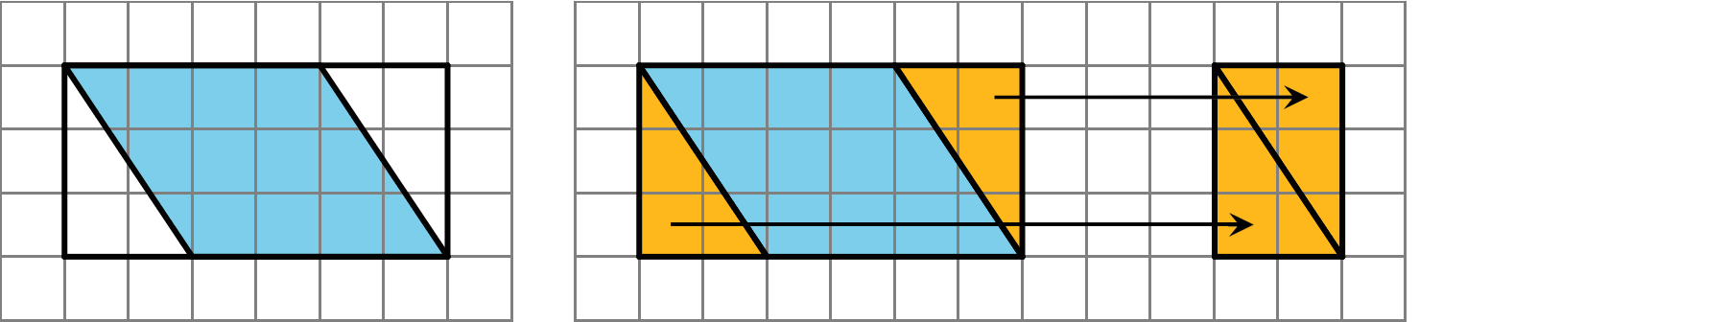
Both of these ways will work for any parallelogram. However, for some parallelograms the process of decomposing and rearranging requires a lot more steps than if we enclose the parallelogram with a rectangle and subtract the combined area of the two triangles in the corners.
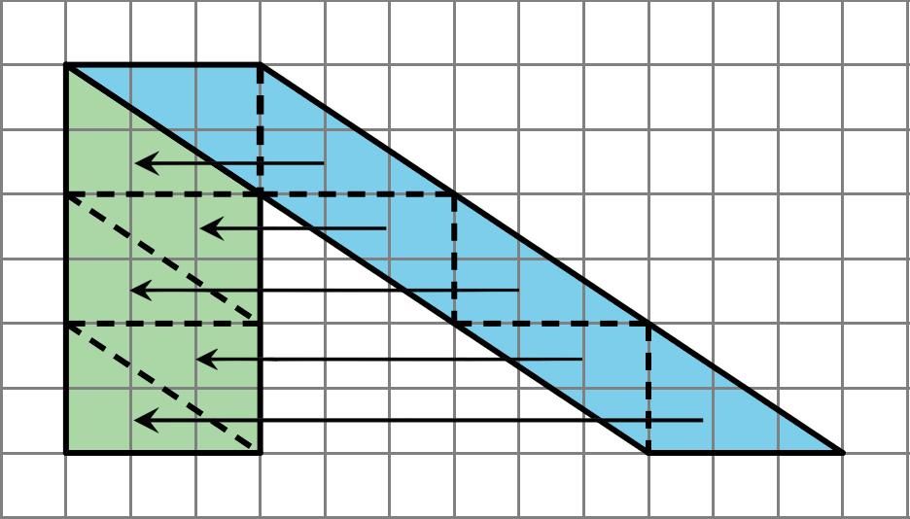
© CC BY Open Up Resources. Adaptations CC BY IM.

