Lesson 16 Practice Problems
- These solids all have the same volume. Which has the least surface area?

- Solid A
- 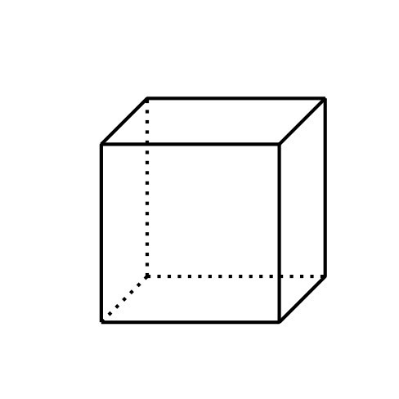

- Solid B
- 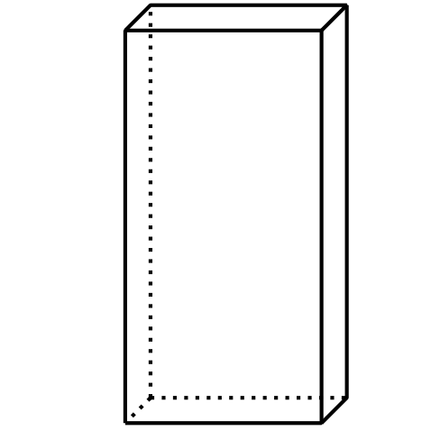

- Solid C
- 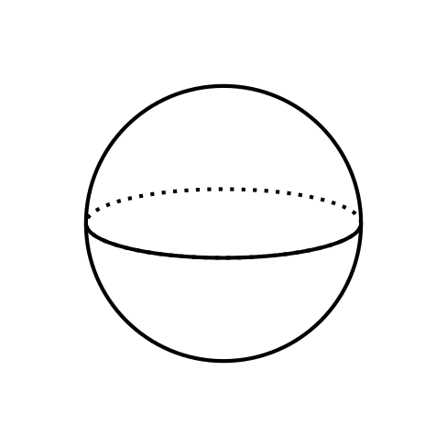

- Solid D
- 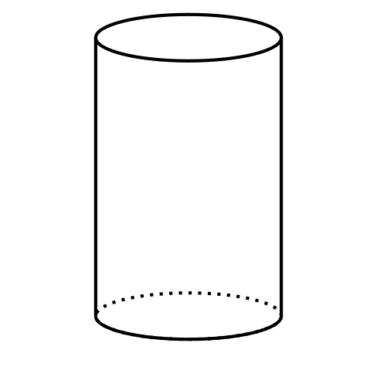
  - Solid A
  - Solid B
  - Solid C
  - Solid D
- Rectangular prism $A$ measures 3 inches by 4 inches by 8 inches. Rectangular prism $B$ measures 5 inches by 5 inches by 6 inches.
  - Before doing any calculations, predict which prism has greater surface area to volume ratio.
  - Calculate the surface area, volume, and surface area to volume ratio for each prism.
- Suppose you have 2 pieces of ice with the same volume but in different shapes. If one of the pieces has a greater surface area than the other, it will cool a beverage faster than the ice with less surface area.
  - Describe 2 different pieces of ice that have the same volume, but have different surface areas.
  - Which piece of ice will cool a beverage faster?
- Suppose this two-dimensional figure is rotated 360 degrees using the vertical axis shown. Each small square on the grid represents 1 square inch. What is the volume of the three-dimensional figure?
- 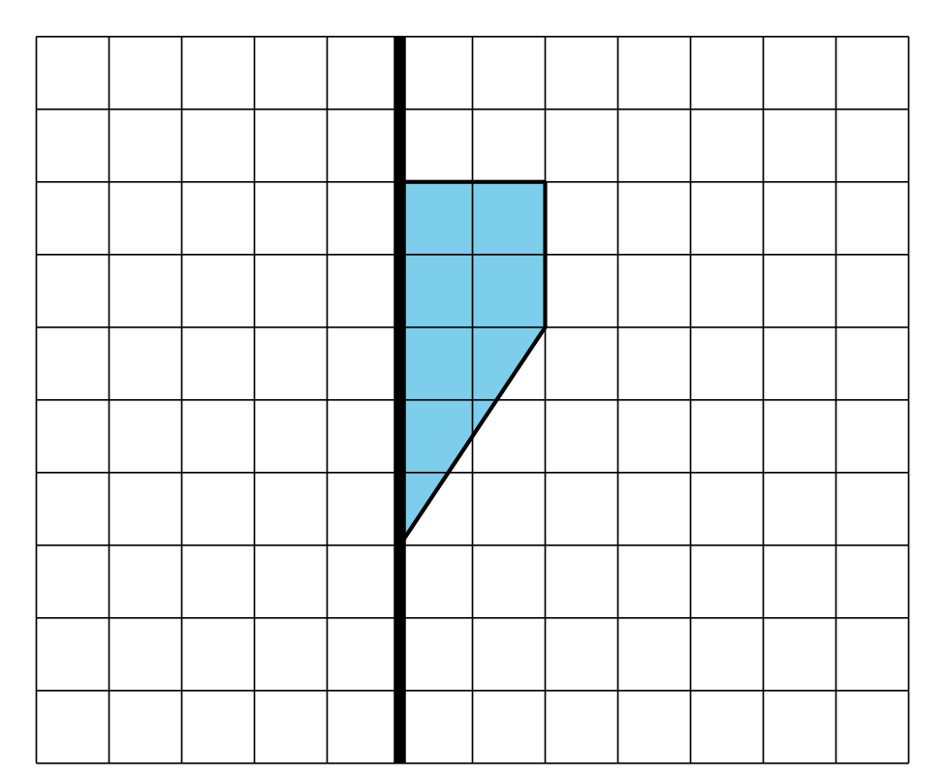
- (From Unit 5, Lesson 15.)
- Technology required. A triangular prism has height 8 units. The base of the prism is shown in the image. What is the volume of the prism? Round your answer to the nearest tenth.
- 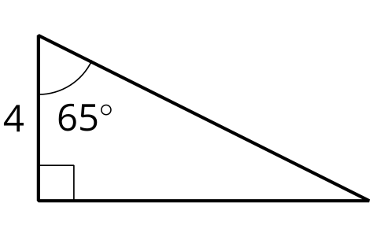
- (From Unit 5, Lesson 15.)
- A cone-shaped container is oriented with its circular base on the top and its apex at the bottom. It has a radius of 12 inches and a height of 8 inches. The cone starts filling up with water. What fraction of the volume of the cone is filled when the water reaches a height of 2 inches?
- (From Unit 5, Lesson 14.)
- Find the volume of a pyramid whose base is a square with sides of length 4 units and which has a height of 10 units.
- (From Unit 5, Lesson 13.)
- A solid has volume 4 cubic units and surface area 10 square units. The solid is dilated, and the image has volume 108 cubic units. What is the surface area of the image?
- (From Unit 5, Lesson 8.)
© CC BY 2019 by Illustrative Mathematics®

