Lesson 12: Using Equations for Lines
Let’s write equations for lines.

12.1: Missing center
A dilation with scale factor 2 sends $A$ to $B$. Where is the center of the dilation?

12.2: Writing Relationships from Two Points
Here is a line.
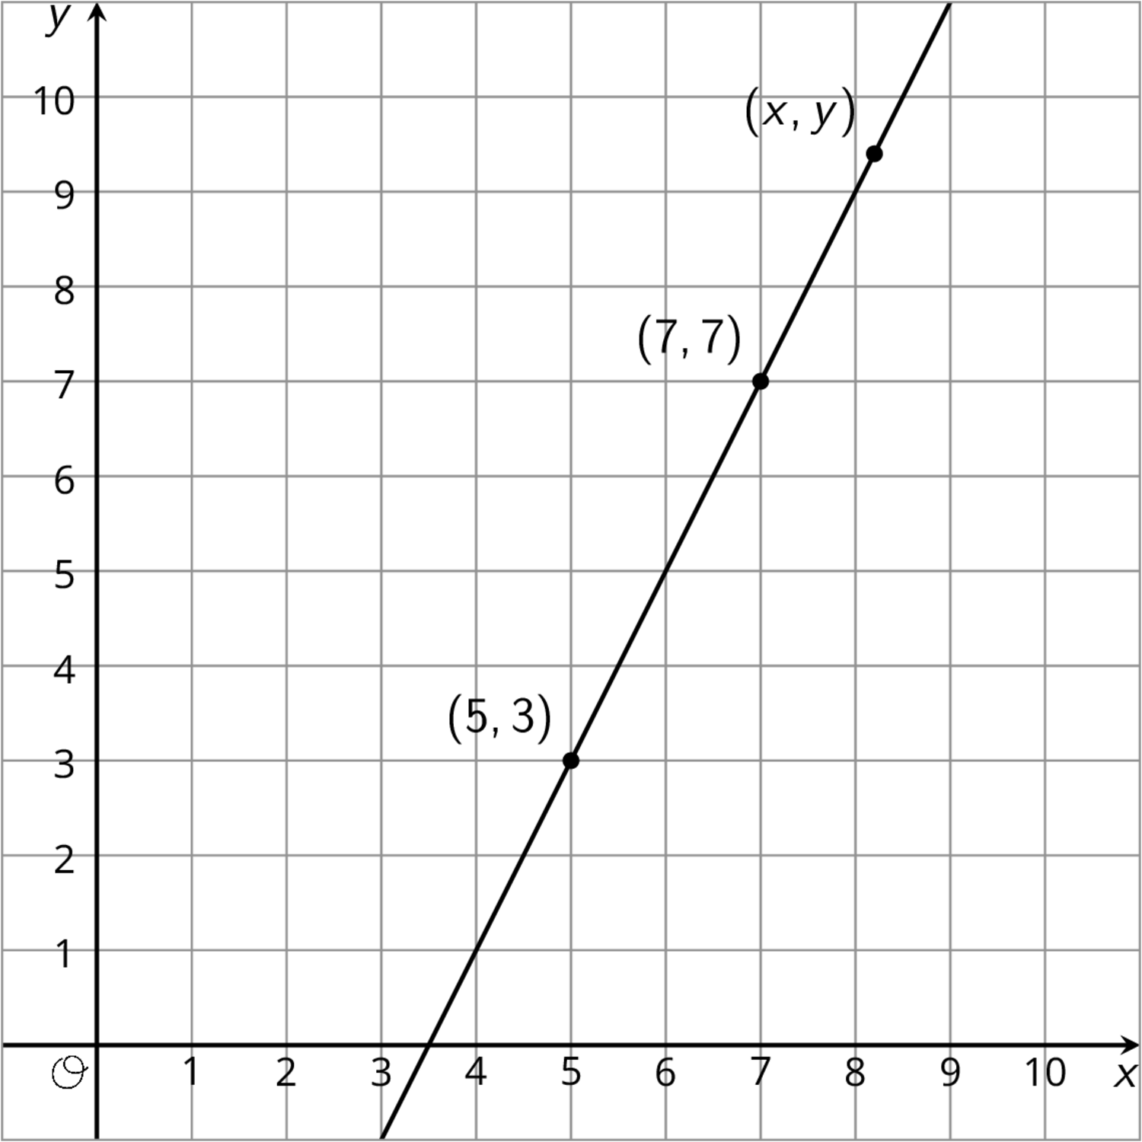
- Using what you know about similar triangles, find an equation for the line in the diagram.
- What is the slope of this line? Does it appear in your equation?
- Is $\left(9,11\right)$ also on the line? How do you know?
- Is $\left(100,193\right)$ also on the line?

Are you ready for more?
There are many different ways to write down an equation for a line like the one in the problem. Does $\frac{y−3}{x−6}=2$ represent the line? What about $\frac{y−6}{x−4}=5$? What about $\frac{y+5}{x−1}=2$? Explain your reasoning.

12.3: Dilations and Slope Triangles
Here is triangle $ABC$.
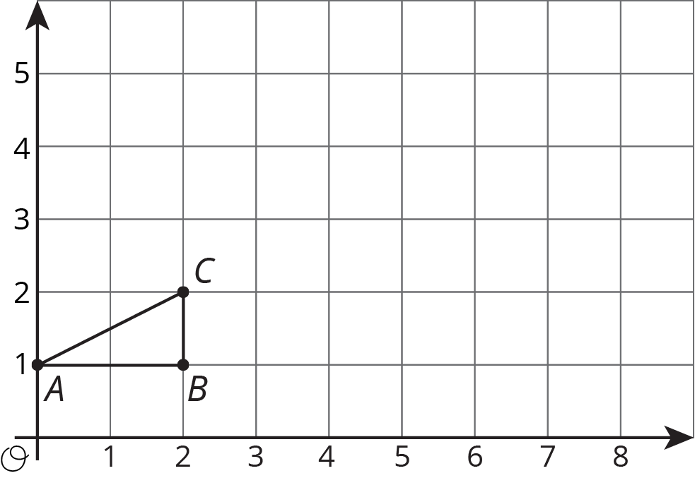
- Draw the dilation of triangle $ABC$ with center $\left(0,1\right)$ and scale factor 2.
- Draw the dilation of triangle $ABC$ with center $\left(0,1\right)$ and scale factor 2.5.
- Where is $C$ mapped by the dilation with center $\left(0,1\right)$ and scale factor $s$?
- For which scale factor does the dilation with center $\left(0,1\right)$ send $C$ to $\left(9,5.5\right)$? Explain how you know.

Lesson 12 Summary
We can use what we know about slope to decide if a point lies on a line. Here is a line with a few points labeled.
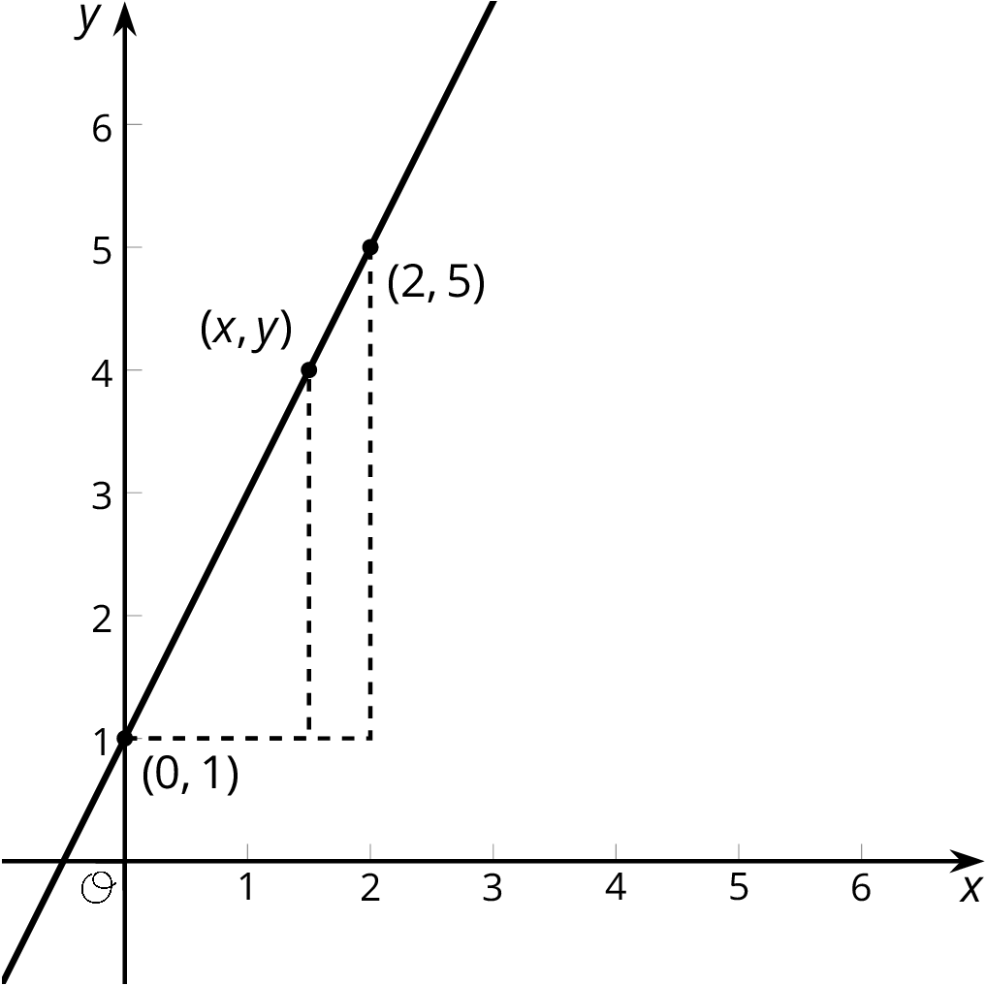
The slope triangle with vertices $\left(0,1\right)$ and $\left(2,5\right)$ gives a slope of $\frac{5−1}{2−0}=2$. The slope triangle with vertices $\left(0,1\right)$ and $\left(x,y\right)$ gives a slope of $\frac{y−1}{x}$. Since these slopes are the same, $\frac{y−1}{x}=2$ is an equation for the line. So, if we want to check whether or not the point $\left(11,23\right)$ lies on this line, we can check that $\frac{23−1}{11}=2$. Since $\left(11,23\right)$ is a solution to the equation, it is on the line!
© CC BY Open Up Resources. Adaptations CC BY IM.

