Unit 6 Lesson 2: Transformations as Functions

1 Math Talk: Transforming a Point (Warm up)

Student Task Statement
Mentally find the coordinates of the image of $A$ under each transformation.
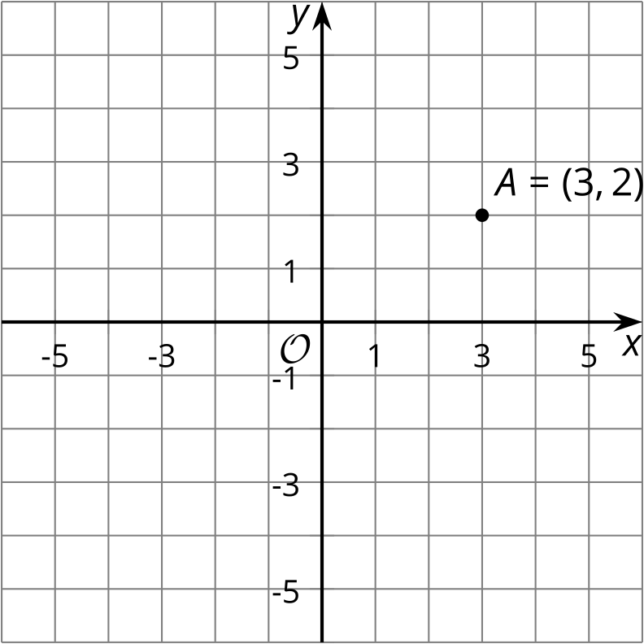
- Translate $A$ by the directed line segment from $\left(0,0\right)$ to $\left(0,2\right)$.
- Translate $A$ by the directed line segment from $\left(0,0\right)$ to $\left(\text{-}4,0\right)$.
- Reflect $A$ across the $x$-axis.
- Rotate $A$ 180 degrees clockwise using the origin as a center.

2 Inputs and Outputs

Student Task Statement
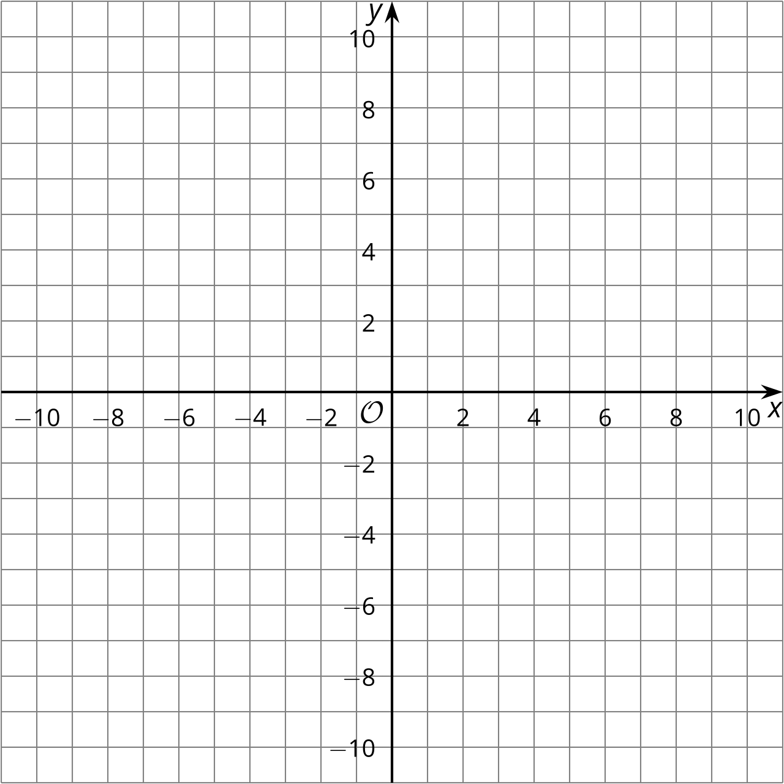
- For each point $\left(x,y\right)$, find its image under the transformation $\left(x+12,y−2\right)$.
  - $A=\left(\text{-}10,5\right)$
  - $B=\left(\text{-}4,9\right)$
  - $C=\left(\text{-}2,6\right)$
- Next, sketch triangle $ABC$ and its image on the grid. What transformation is $\left(x,y\right)→\left(x+12,y−2\right)$?
- For each point $\left(x,y\right)$ in the table, find $\left(2x,2y\right)$.
- $\left(x,y\right)$ | - $\left(2x,2y\right)$
- $\left(\text{-}1,\text{-}3\right)$
- $\left(\text{-}1,1\right)$
- $\left(5,1\right)$
- $\left(5,\text{-}3\right)$
- Next, sketch the original figure (the $\left(x,y\right)$ column) and image (the ($2x,2y)$ column). What transformation is $\left(x,y\right)→\left(2x,2y\right)$?

3 What Does it Do?

Student Task Statement
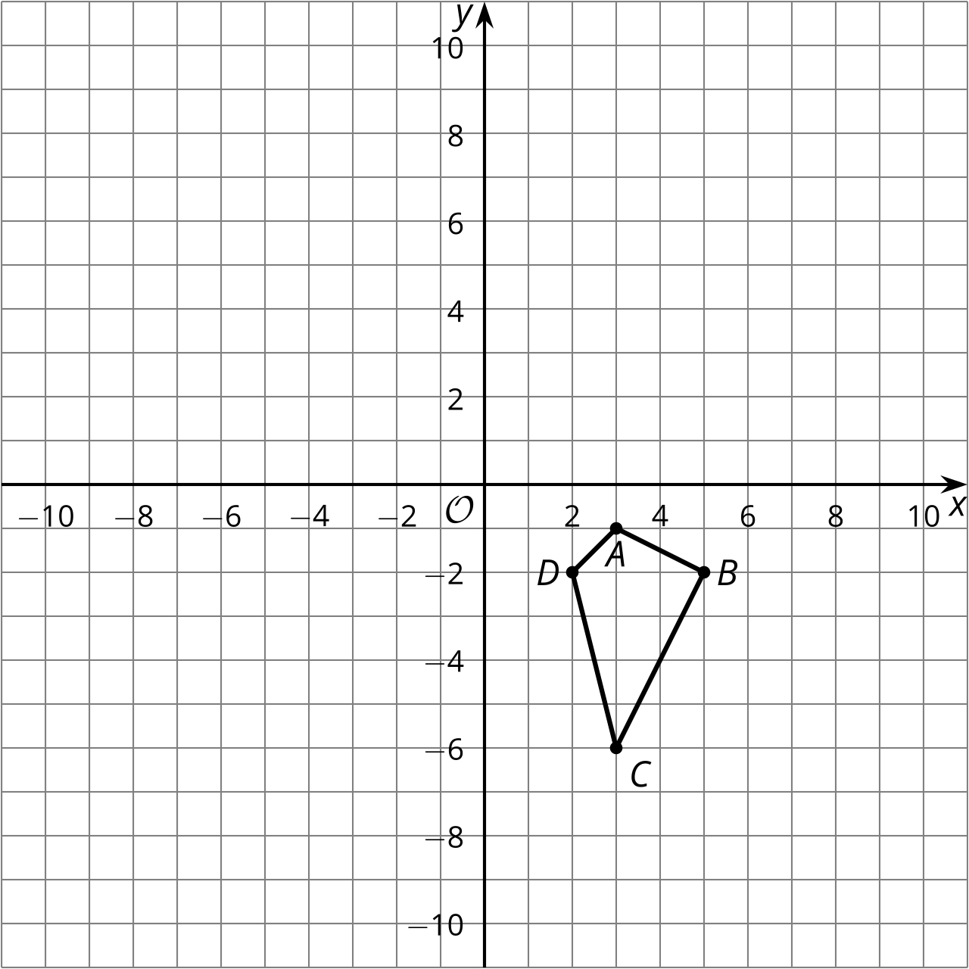
- Here are some transformation rules. Apply each rule to quadrilateral $ABCD$ and graph the resulting image. Then describe the transformation.
  - Label this transformation $Q$: $\left(x,y\right)→\left(2x,y\right)$
  - Label this transformation $R$: $\left(x,y\right)→\left(x,\text{-}y\right)$
  - Label this transformation $S$: $\left(x,y\right)→\left(y,\text{-}x\right)$
© CC BY 2019 by Illustrative Mathematics®

